Y12-2
Yamaha R1 2009-

Kit for the left side |  |  |  |  | Kit for the right side
No. | Description | Cat.no. | Pcs |  |  | No. | Description | Cat.no. | Pcs
1 | Steel box M12 | X2 | 1 |  |  | 1 | Steel box M12 | X2 | 1
2 | Bolt M12x125x1,25mm | 952 | 1 |  |  | 2 | Bolt M12x85x1,25mm | 899 | 1
3 | Dural. cylinder d=18mm | 413 | 1 |  |  | 3 | Dural. cylinder d=18mm | 414 | 1

ILLUSTRATIVE PHOTO

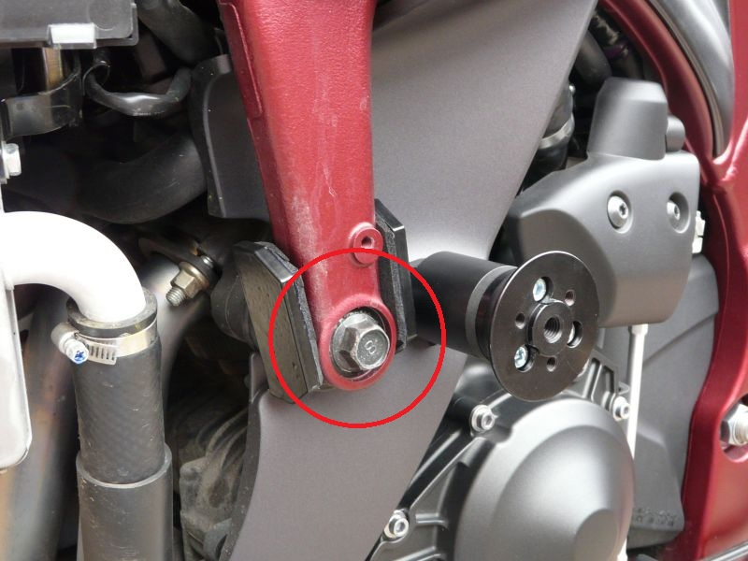

Installation:

Installation of the left and right protector make in gripping about the attached photo above. Give the steel box M12 (No. 1) on both bolts. Put the duralumin cylinder (No. 3) under the protector on the left side and use the bolt (No. 2) for tightening. Put the duralumin cylinder (No. 3) under the protector on the right side and use the bolt (No. 2) for tightening. At first finish the one side and then mount the second side.

Warning – we recommend to use safety glue on threads of all bolts (moderate strong – blue colour).

