Y12SDM
Yamaha R1 2009-2011

Kit for the left side | Kit for the right side

Note | Description | Cat.No | Quant.
1 | Slider RDmoto | SLDM | 1
2 | Holder for SLDM | 537/B | 1
3 | Dural cylinder d=70mm | 15 | 1
4 | Bolt M10x85mm | 981 | 1
5 | Bolt M6x20 | 1024 | 2
6 | Washer M6 | 1023 | 2
7 | Dural. cylinder d=32,3mm | 225 | 1
8 | Steel adapter | 585 | 1
9 | 3M stickers |  | 1
Note | Description | Cat. No | Quant
1 | Slider RDmoto | SLDM | 1
2 | Holder for SLDM | 537/B | 1
3 | Dural. cylinder d=40mm | 12 | 1
4 | Bolt M10x55mm | 1002 | 1
5 | Bolt M12x60x1,25mm | 916 | 1
6 | Steel adapter | 584 | 1
7 | Bolt M6x20 | 1024 | 2
8 | Washer M12 | 803 | 1
9 | 3M sticker |  | 1
10 | Washer M6 | 1023 | 2
Installation – the left side:

- remove the original bolt
- use the original bolt for fitting steel adapter (note 8) Check the correct form of the adapter by photo for this side. Use tape 3M to avoid direct contact of adapter with the frame of the motorcycle.
- insert into the frame duralumin cylinder d=32,3mm (note 7) stick 3M tape on between the frame and bolt
- by bolt (no.4) fixed duralumin adapter (no. 3) and SLD holder (no. 2)
5. used bolt M8 (no.5) and washer (no. 6) mounting slider SLD

Warning – we recommend to use safety glue on threads of all bolts (moderate strong – blue colour).
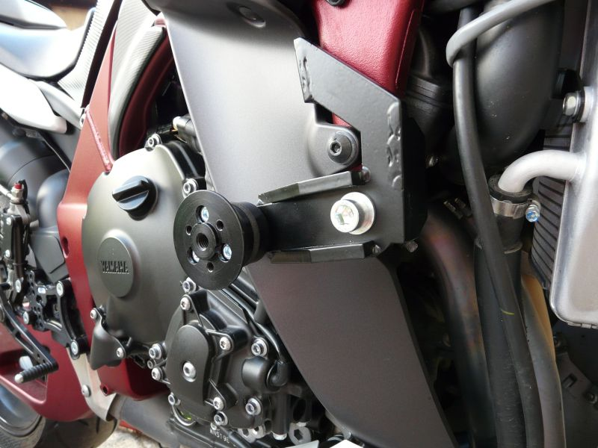
(ilustrated foto, mounting kit SL01)

Mounting instruction- right side :
1. remove original bolt
2. used bolt (note 5) and washer (note 8) mounting adapter (note 6 – check the correct steel holder by photo), on the frame stick 3M stickers
3. used bolt (note 4) mounting duralumin cylinder (no 3) and SLD holder (note 2)
4. used bolt (note 7) and washer M8 (note 10) for mounting SLD

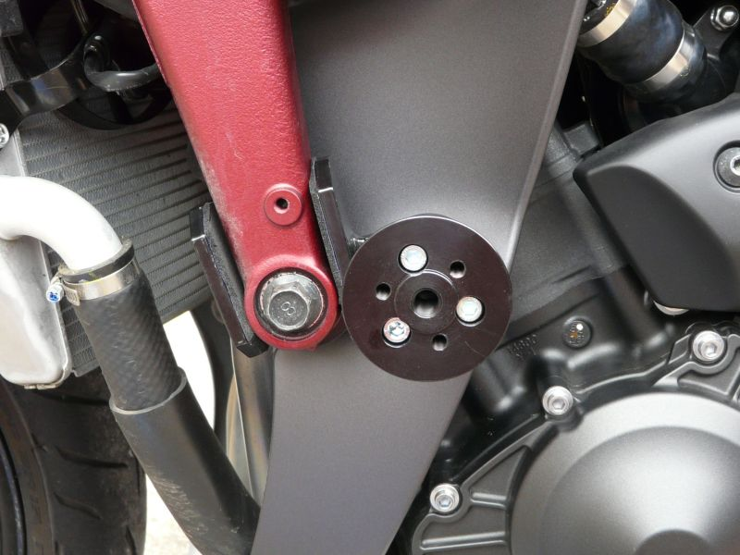
(ilustrated foto, mounting kit SL01)

Warning – we recommend to use safety glue on threads of all bolts (moderate strong – blue colour).

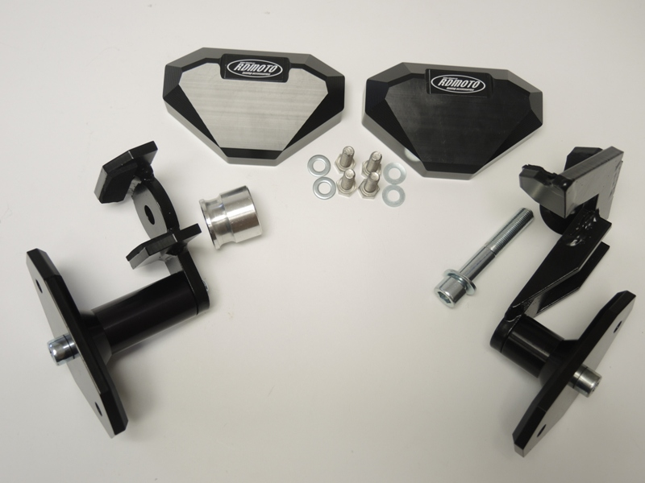
1
1

8
5,6
7,10
7
9
8
3
4
2
9
6
2
4
3
5

