Y12S
Yamaha R1 2009-2011

 | Kit left side |  |  |  | Kit for right side
ID | Description | Cat.no | QTY
1 | Slider | SL01 | 1
2 | Cover | SLcap | 1
3 | Adapter for SL01 | DV 318 | 1
4 | Dural.cylinder d=10mm | DV 1 | 1
5 | Bolt M10x30 | 882 | 1
6 | Bolt M6x25 | 877 | 3
7 | Bolt M4x16 | 876 | 2
8 | Dural.cylinder d=32,3 | 225 | 1
9 | Steel adapter | 585 | 1
10 | 3M tape |  | 2
10
ID | Description | Cat.no | QTY
1 | Slider | SL01 | 1
2 | Cover | SLcap | 1
3 | Adapter for SL01 | DV 317 | 1
4 | Bolt M12x60x1,25 | 916 | 1
5 | Bolt M10x20 | 819 | 1
6 | Bolt M6x25 | 877 | 3
7 | Bolt M4x16 | 876 | 2
8 | Washer M12 | 803 | 1
9 | Steel adapter | 584 | 1
10 | 3M tape |  | 2
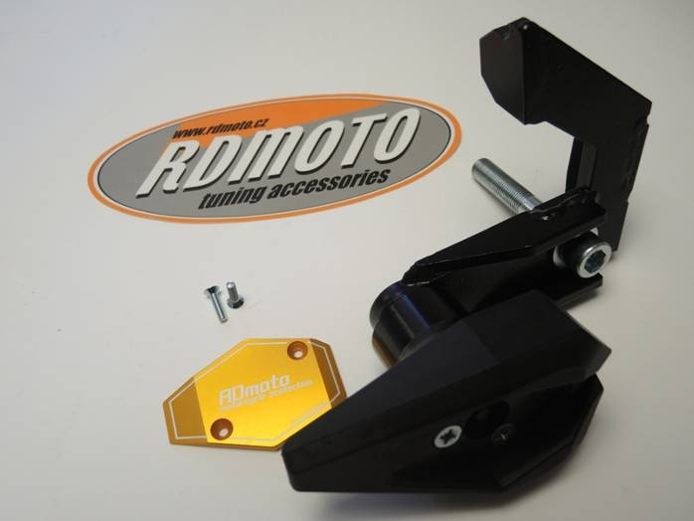
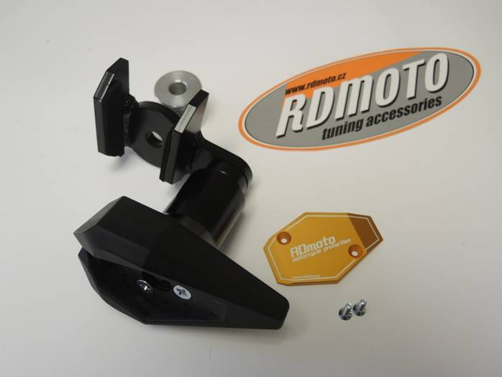
10
9
8
9
10

3
8
5.inside the adapt.
4
3
7
4
2

1
7

2
6

5.inside the adpt.

6
1

Instruction to assembly-right side :

1. Take off fariring and original bolt from frame.
2. Use bolt ID4 and washer ID8 and fixed steel adapter ID9 on the frame, stick on 3M tape on the adapter,wher it is touch in frame.
3. Use bolt ID5 and mounting dural. adapter ID3
4. Mounting slider ID1 use bolts M6x25 ID6.
5. Put cover into the slider ID2 and mouting by bolts M4x16 ID7

Warning- use the glue of all threads.

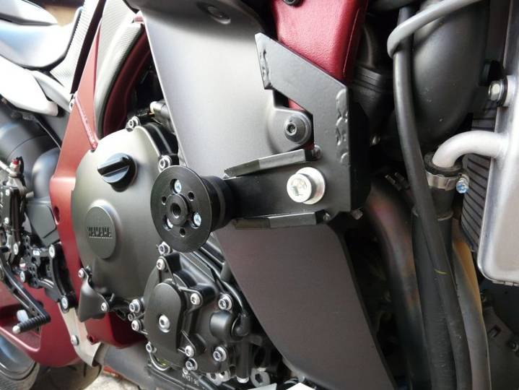

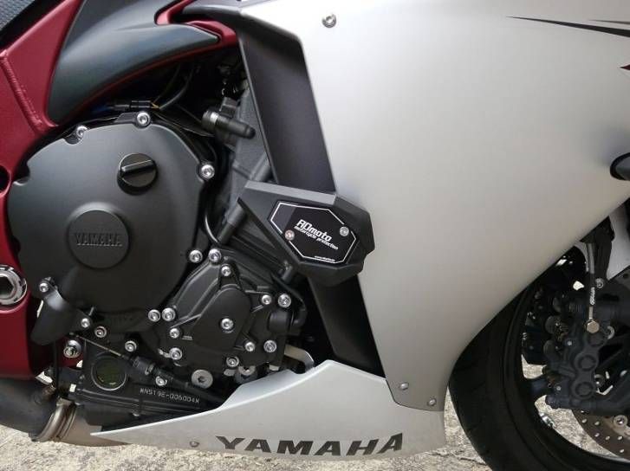

Instruction- left side :

1. Take off fariring and original bolt from frame.
2. Use original bolt and mounting steel adapter ID9, insert the dural. cylinder between the frame and engine ID8 =32,3mm, stick on 3M tape.
3. Put on the bolt M10x30 ID5 dural.adapter for SL01 ID3 and dural.cylinder ID4,this set mounting on the bike
4. mounting slider ID1 and use bolts ID6
5. Put cover into the slider ID2 and mouting by bolts M4x16 ID7

Warning- use the glue of all threads.

