Y12
Yamaha R1 2009-

Kit for the left side |  |  |  |  | Kit for the right side
No. | Description | Cat.no. | Pcs |  |  | No. | Description | Cat.no. | Pcs
1 | Steel box M10 | X1 | 1 |  |  | 1 | Steel box M10 | X1 | 1
2 | Dural. cylinder d=32mm | 225 | 1 |  |  | 2 | Bolt M12x60x1,25mm | 916 | 1
3 | Bolt M10x70mm | 851 | 1 |  |  | 3 | Bolt M10x40mm | 854 | 1
4 | Steel adapter | 585 | 1 |  |  | 4 | Steel adapter | 584 | 1
5 | Tape 3M |  | 1 |  |  | 5 | Tape 3M |  | 1
6 | Dural. cylinder d=40mm | 4 | 1 |  |  | 6 | Dural. cylinder d=10mm | 1 | 1
 |  |  |  |  |  | 7 | Pad M12 (plane) | 803 | 1

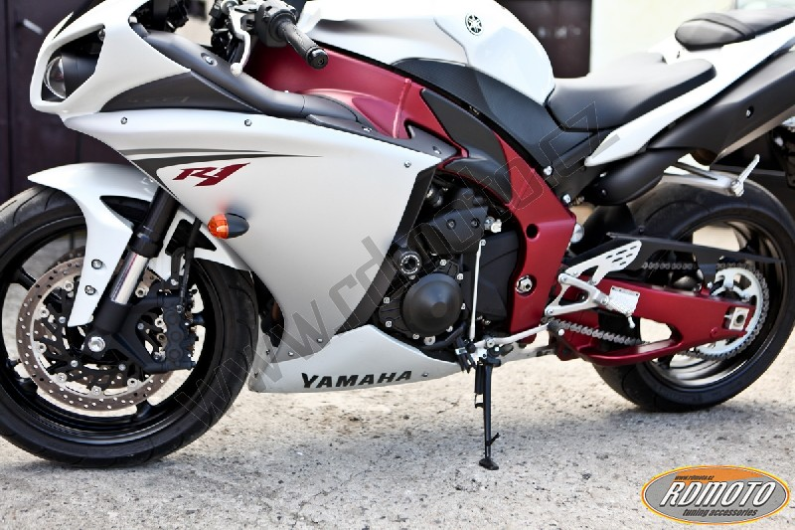
Installation – the left side:

- remove the original side plastic and bolt M12 in frame of the motorcycle
- stick on reverse side of adapter tape 3M (No. 5)
- put duralumin cylinder (No. 2) under adapter, use the original bolt and screw up adapter to frame of the motorcycle
- check all and then you can mount the original side plastic back
- put steel box (No. 1) in protector together with bolt (No. 3), give duralumin cylinder (No. 6) under protector, the cylinder give on bolt
- all this set mount to thread on adapter

Warning – we recommend to use safety glue on threads of all bolts (moderate strong – blue colour).

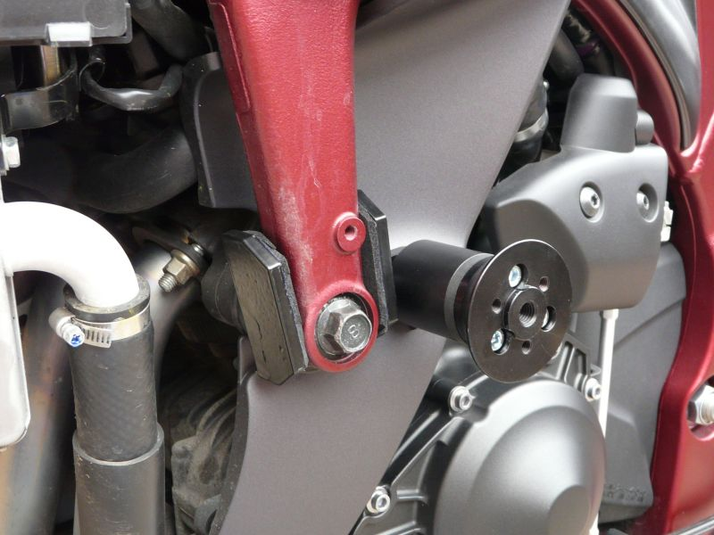
the illustrative photo from mounting kit Y12S

Installation – the right side:

- remove the original side plastic and bolt M12 in frame of the motorcycle
- stick on reverse side of adapter tape 3M (No. 5)
- use the bolt (No. 2) with pad (No. 7) and screw up adapter to frame of the motorcycle
- check all and then you can mount the original side plastic back
- put steel box (No. 1) in protector together with bolt (No. 3), give duralumin cylinder (No. 6) under protector, the cylinder give on bolt
- all this set mount to thread on adapter

Warning – we recommend to use safety glue on threads of all bolts (moderate strong – blue colour).

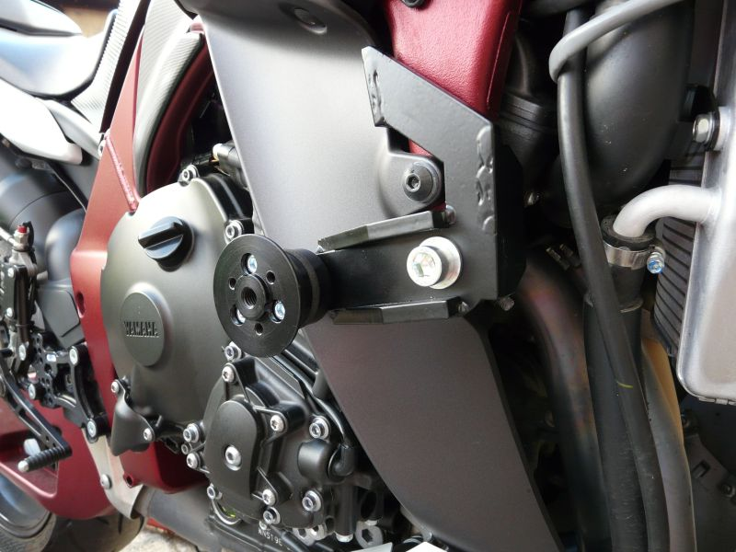
the illustrative photo from mounting kit Y12S

