Y13S
Yamaha XJR 1300 1998-

Fitting kit:
ID | Description | Cat.N | Qt
1 | Stainless steel rod M10x1,25x515x30x30 | - | 1
2 | Slider holder | 317 | 2
3 | Alu. spacer | 33 | 2
4 | Special nut | X11 | 2
5 | Bolt M6x25 | 877 | 6
6 | Bolt M4x12 | 876 | 4

2
4
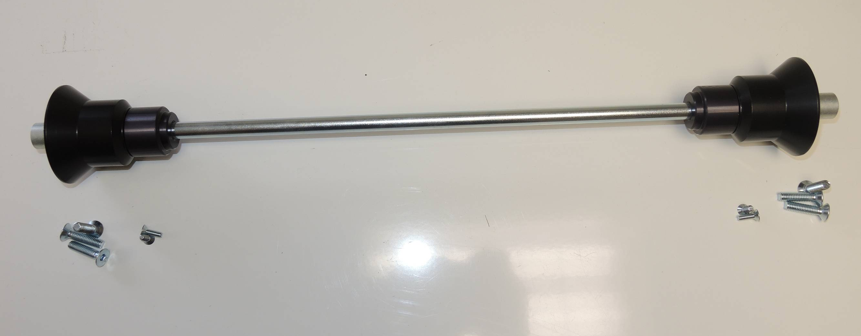
4
2
3
1

5

5
3
6

6

Fitting instruction:

- Dismantl original bolt from chassi and engine.
- Place steel rod ID.1. Insert alu. spacer ID.3 from left and right side.
- Place slider holder ID.2 from left and right side.
- Tighten it by nuts ID.4.
- Place slide rand use bolts ID.5. Insert cover and use bolts ID.6

Note: we recommande use glue of threads. Medim strong.

