Y13
Yamaha XJR 1300 1998-

Fitting kit:
ID | Description | Cat.N | Qt
1 | Stainless steel rod M10x1,25x535x30x30 | - | 1
2 | Steel box | X1 | 2
3 | Alu. spacer | 33 | 2
4 | Special nut | X11 | 2

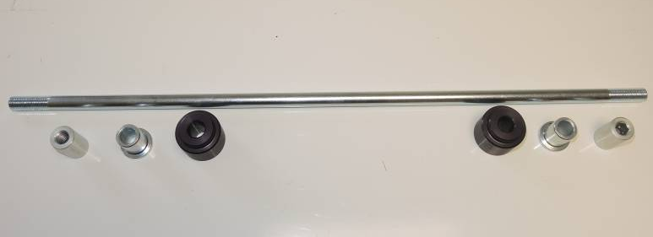

1

4
4

3
2
2
3

Fitting instruction:

- Dismantl original bolt from chassi and engine.
- Place steel rod ID.1. Insert alu. spacer ID.3 from left and right side.
- Insert steel box ID.2 into teh protector. Place protectors on the rod.
- Tighten it by nuts ID.4.

Note: we recommande use glue of threads. Medim strong.

