Y14SD
Yamaha FZ-1 2006-

Kit for the left side |  |  |  |  | Kit for the right side
No. | Description | Cat.no | Pcs |  |  | No. | Description | Cat.no | Pcs
1 | SLD adapter | 537 | 1 |  |  | 1 | SLD adapter | 537 | 1
2 | Bolt M10x100x1,25mm | 892 | 1 |  |  | 2 | Bolt M10x100x1,25mm | 892 | 1
3 | Dural. cylinder d=32mm | 55 | 1 |  |  | 3 | Dural. cylinder d=32mm | 55 | 1
4 | Dural. cylinder (adapter) | 10 | 1 |  |  | 4 | Dural. cylinder (adapter) | 10 | 1
5 | Spring washer M10 | 801 | 1 |  |  | 5 | Spring washer M10 | 801 | 1
6 | Bolt M8x25 | 815 | 2 |  |  | 6 | Bolt M8x25 | 815 | 2
7 | Washer M8 | 800 | 2 |  |  | 7 | Washer M8 | 800 | 2
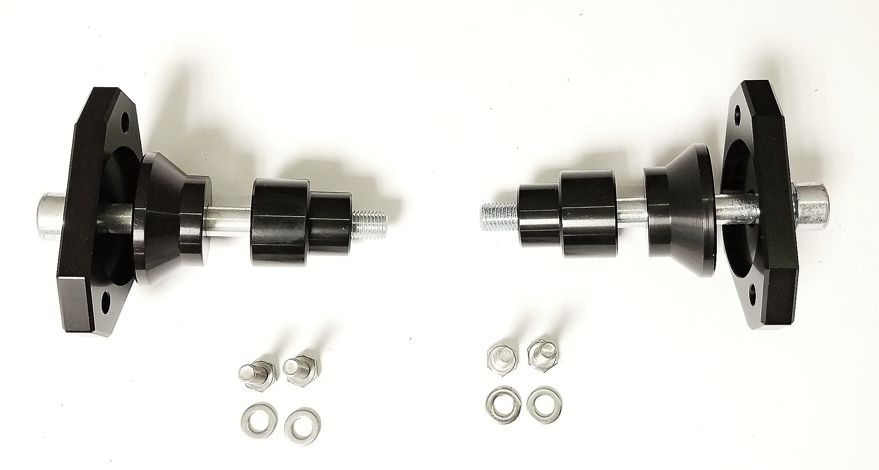
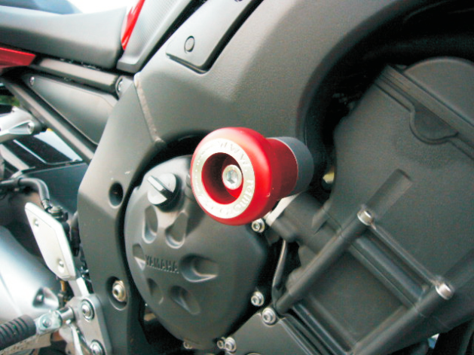
INSTRUCTIONS

- We recommend to use medium strong glue on all threads.
- Unbolt original bolt M10 from the frame of motorcycle.
- Put washer ID5, SLD adapter ID1, cylinder ID3 and cylinder adapter ID4 on bolt ID2.
- Mount this kit into the frame of motorcycle.
- Fit slider using two bolts ID6 and washers ID7.

