Y14S
Yamaha FZ-1 2006-
Yamaha FZ-8 2010-

Fitting kit:
ID. | Description | Cat.N | Qt
1 | Slider adapter | DV304 | 2
2 | Bolt M6x25 | 877 | 6
3 | Bolt M4x16 | 876 | 4
4 | Bolt M10x75x1,25mm | 938 | 2
5 | Washer M10 | 801 | 2

Assembly is same for booth side. We recommande to finish left side first and after make assembly right side.

- Dismantle original bolt M10 from chassi as you can see on the picture.
- Insert bolt ID.4 into the alu adpater ID.1 this kit assembly on the chassi.
- Place slider and use bolts ID.2. Place alu. cover and use bolts ID.3

Note: Use medium strong glue on the bolts

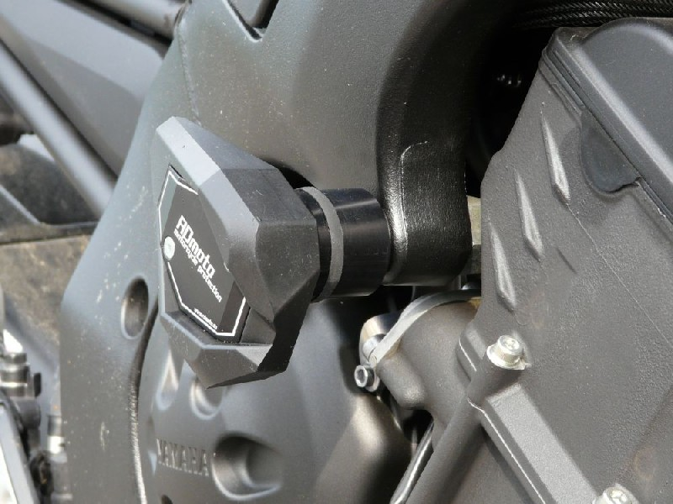
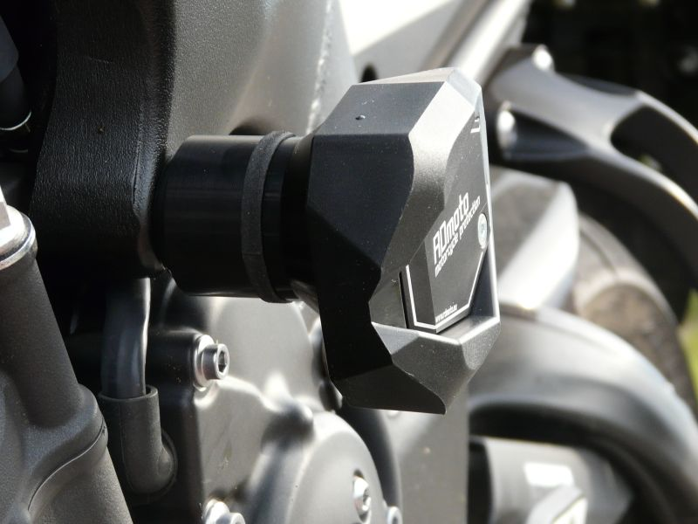

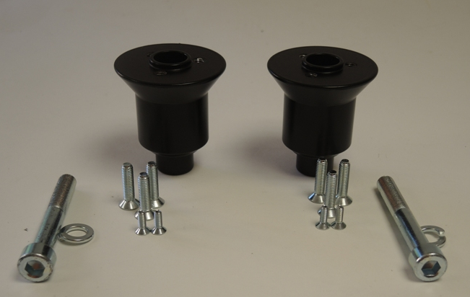
4
4
3
2
2
1
5
5

