Y15-2
Yamaha YZF R6´06-´13

Fitting kit left side: Fitting kit right side:
ID | Description | Cat.N | Qty
1 | Steel box M10 | X1 | 1
2 | Bolt M10x100x1,25 | 892 | 1
3 | Dural.cylinder d=40 | 486 | 1
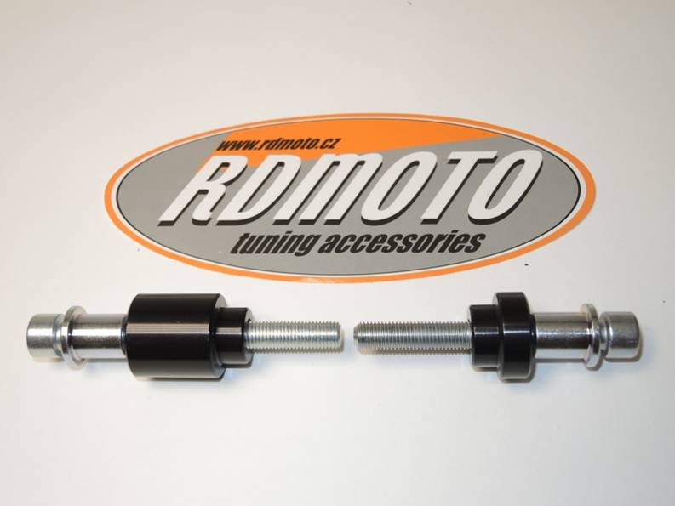
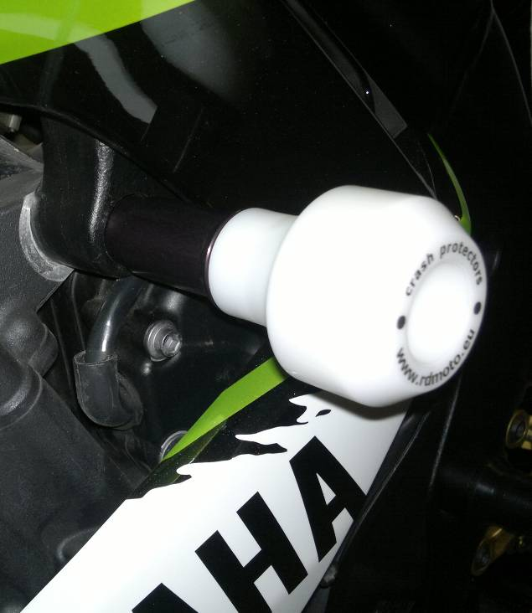
ID | Description | Cat.N | Qty
1 | Steel box M10 | X1 | 1
2 | Bolt M10x85x1,25 | 934 | 1
3 | Dural.cylinder d=19 | 485 | 1

Assembly left side:
- Insert steel box ID.1 and bolt ID.2 into the protector.
- Under the protector put dural.cylinder ID.3.
- This kit assembly, replace original bolt.

Assembly right side:
- Insert steel box ID.1 and bolt ID.2 into the protector.
- Under the protector put dural.cylinder ID.3.
- This kit assembly, replace original bolt.

Warning: We recommend use the glue of all threads. Medium strong.

