Y15SDM
Yamaha R6 2006-

Fitting kit left side: Fitting kit right side:

ID | Description | Cat.N | Qt.
1 | Steel adapter | 579 | 1
2 | Alu. spacer d=10mm | 108 | 1
3 | Bolt M10x60x1,25 | 896 | 1
4 | Washer spring M10 | 801 | 1
5 | Alu. spacer d=60mm | 14 | 1
6 | Alu. bracket for SLDM | 537/B | 1
7 | Bolt M10x90 | 880 | 1
8 | Washer M10 | 804 | 1
9 | Lock Nut M10 | 810 | 1
10 | Bolt M6x20 | 1024 | 2
11 | Washer M6 | 1023 | 2
12 | Plastic cover | X4 | 1
13 | 3M Tape | 3M | 1

ID | Description | Cat.N | Qt.
1 | Bolt M10x105x1,25 | 893 | 1
2 | Washer M10 spring | 801 | 1
3 | Alu. bracket for SLDM | 537/B | 1
4 | Alu. cone adapter | 9 | 1
5 | Alu. spacer d=40mm | 19 | 1
6 | Bolt M6x20 | 1024 | 2
7 | Washer M6 | 1023 | 2

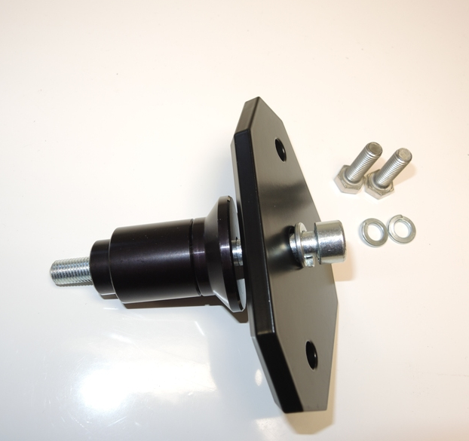
(No.1)
6
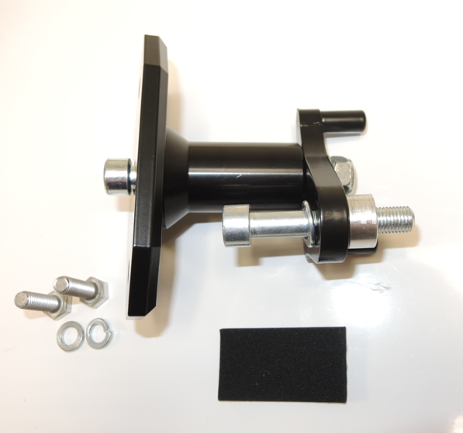
(No.2)
7
5
1
3
6
7
4
8,9
5
4
3
2
1
2
10
11
12
Fitting kit left side:
- Dismantle original bolt M10 from frame.
- Assembly mounting kit for SLD as shown on the picture (no.1).
- Stick 3M tape on the frame, where is steel adapter touching with chassis.
- Place alu. spacer ID.2 and tighten fitting kit on the frame.
- Place slide and tighten it by bolts ID.10 and washers ID.11.

Fitting kit right side:
- Dismantle original bolt M10 from frame.
- Assembly mounting kit for SLD as shown on the picture (no.2).
- Don´t forget place washer ID.2 under the bolt ID.1.
- Mounting this kit on the chassis.
- Place slide and tighten it by bolts ID.6 and washers ID.7.

We recommande use glue of bolts during assembly. Medium strong.

