Y15S

**Yamaha R6 2006-2011**

**Kit for the left side:** **Kit for the right side:**

|  |  |  |  |
| --- | --- | --- | --- |
| **ID** | **Description** | **Cat.N.** | **Qt.** |
| 1 | Dural.adapter for SL01 | 315 | 1 |
| 2 | Bolt M10x60x1,25 | 896 | 1 |
| 3 | Bolt M6x25 | 877 | 3 |
| 4 | Bolt M4x16 | 876 | 2 |
| 5 | Bolt M10x40 | 854 | 1 |
| 6 | Dural.spacer d=10mm | 108 | 1 |
| 7 | Steel adapter | 579 | 1 |
| 8 | Washer M10 | 804 | 1 |
| 9 | Nut M10-lock | 810 | 1 |
| 10 | Plastic cover | X4 | 1 |
| 11 | 3M Tape | 3M | 1 |

|  |  |  |  |
| --- | --- | --- | --- |
| **ID** | **Description** | **Cat.N.** | **Qt.** |
| 1 | Dural.adapter for SL01 | 311 | 1 |
| 2 | Bolt M10x60x1,25 | 896 | 1 |
| 3 | Bolt M6x25 | 877 | 3 |
| 4 | Bolt M4x16 | 876 | 2 |

**Installation – the left side:**

1. Take off fairing from the bike.
2. Remove the original bolt M10 from frame.
3. Use the bolt ID.2 for mounting of the steel adapter ID.7. Give the duralumin spacer ID.6 on the bolt during installation. Stick the 3M tape ID.11 on the frame of the motorcycle at the point of touching frame with steel adapter.
4. Give the plastic cover ID.10 into the head of screw.
5. If you mounted duralumin adapter, you can mount gripping for slider. Use bolt with pad (ID.5 and ID.8) and nut (ID.9) for mounting of duralumin adapter ID.1 on the steel adapter. Check the photo for right position of slider.
6. Screws ID.3 mounting slider on the dural. adapter. Insert alu. cover into the slider and tighten it by bolt ID.4
7. Put fairing on.

**Installation – the right side:**

1. Take off fairing from the bike.
2. Remove the original bolt M10.
3. Use the bolt ID.2 for gripping of duralumin cylinder ID.1 Check the photo for right position of slider.
4. Screws ID.3 mounting slider on the dural. adapter. Insert alu. cover into the slider and tighten it by bolt ID.4
5. Put fairing on.

**Warning – we recommend to use safety glue on threads of all bolts (moderate strong – blue colour).**

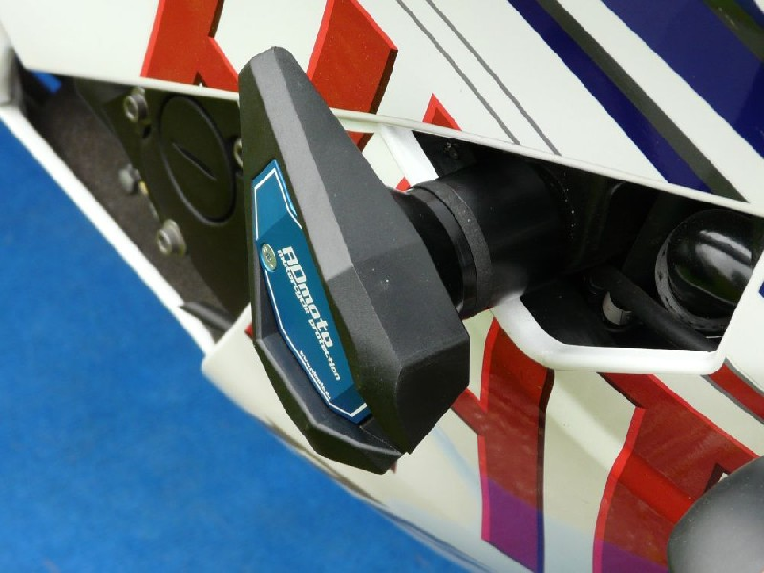 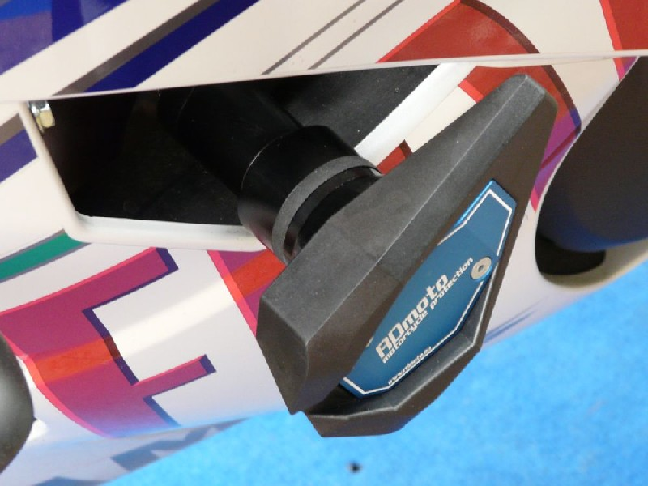

11

10

1

5

9

7

2

6

8

4

3

4

3

2

1

