Y15
Yamaha R6 2006-

Kit for the left side |  |  |  |  | Kit for the right side
No. | Description | Cat.no | Pcs |  |  | No. | Description | Cat.no | Pcs
1 | Steel box M10 | X1 | 1 |  |  | 1 | Steel box M10 | X1 | 1
2 | Bolt M10x60x1,25mm | 896 | 1 |  |  | 2 | Bolt M10x105x1,25mm | 893 | 1
3 | Dural. cylinder d=10mm | 108 | 1 |  |  | 3 | Dural. cylinder d=40mm | 19 | 1
4 | Dural. cylinder d=50mm | 5 | 1
5 | Bolt M10x100mm | 885 | 1
6 | Pad M10 (spring) | 801 | 1
7 | Steel adapter | 579 | 1
8 | Nut M10 (safety) | 810 | 1
9 | Pad M10 (plane) | 804 | 1
10 | Tape 3M |  | 1
Installation – the left side:

- remove the original side plastic and bolt M10 in frame of the motorcycle
- stick tape 3M (No. 10) on frame of the motorcycle in place of mounting
- put duralumin cyclinder (No. 3) under adapter, use the bolt (No. 2) with pad (No. 6) and screw up adapter to frame of the motorcycle
- put steel box (No. 1) together with a bolt (No. 5) in protector, under protector give duralumin cylinder (No. 4), which give on bolt too
- give all this set in adapter and use nut (No. 8) together with pad (No. 9) for ensuring on reverse side of adapter
- check all and then you can mount the original side plastic back

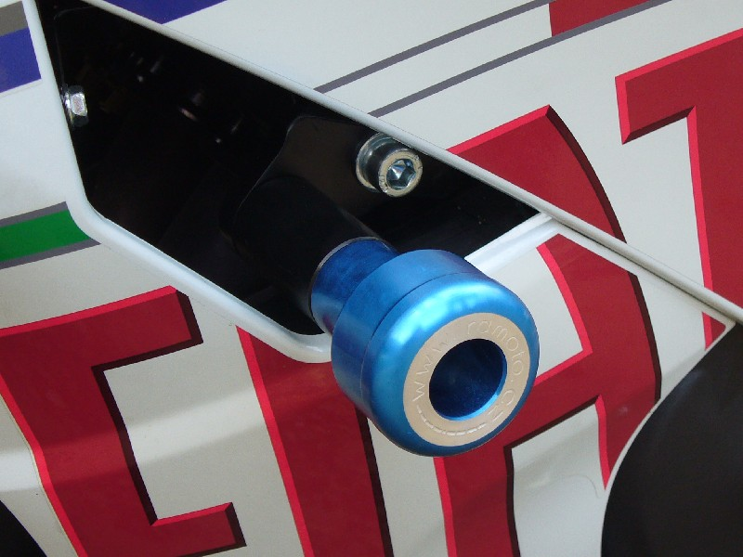

Installation – the rigth side:

- remove the original bolt M10 in frame of the motorcycle
- put steel box (No. 1) together with a bolt (No. 2) in protector, under protector give duralumin cylinder (No. 3), which give on bolt too
- all this set mount to thread in frame of the motorcycle

Warning – we recommend to use safety glue on threads of all bolts (moderate strong – blue colour).
