Y16SDM
Yamaha R1 2007-2008

Fitting kit left side: Fitting kit right side:
ID | Description | Cat.N | QTY
1 | Diamond adapter | 537/B | 1
2 | Bolt M10x70x1,25mm | 898 | 1
3 | Dural. cylinder d=7mm | 137 | 1
4 | Dural. cylinder d=55mm | 20 | 1
5 | Bolt M10x95 | 822 | 1
6 | Washer M10 (spring) | 801 | 2
7 | Steel adapter | 597 | 1
8 | Tape 3M | - | 1
9 | Bolt M6x20 | 1024 | 2
10 | Washer M6 | 1023 | 2
11 | Dural adapter | DV10 | 1
2,6
ID | Description | Cat.N | QTY
1 | Diamond adapter | 537/B | 1
2 | Bolt M10x60x1,25mm | 896 | 1
3 | Dural. cylinder d=5mm | 16 | 1
4 | Dural.cylinder d=55mm | 20 | 1
5 | Bolt M10x95 | 822 | 1
6 | Washer M10 (spring) | 801 | 2
7 | Steel adapter | 598 | 1
8 | Tape 3M | - | 1
9 | Bolt M6x20 | 1024 | 2
10 | Washer M6 | 1023 | 2
11 | Dural adapter | DV10 | 1
Picture 1
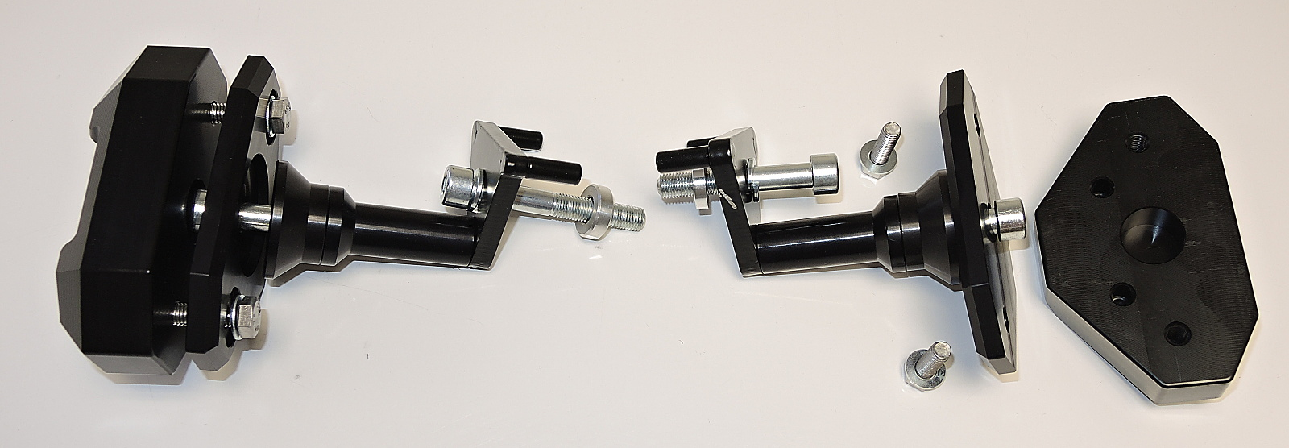

ID1
ID2+6
ID11

ID5

ID9+10

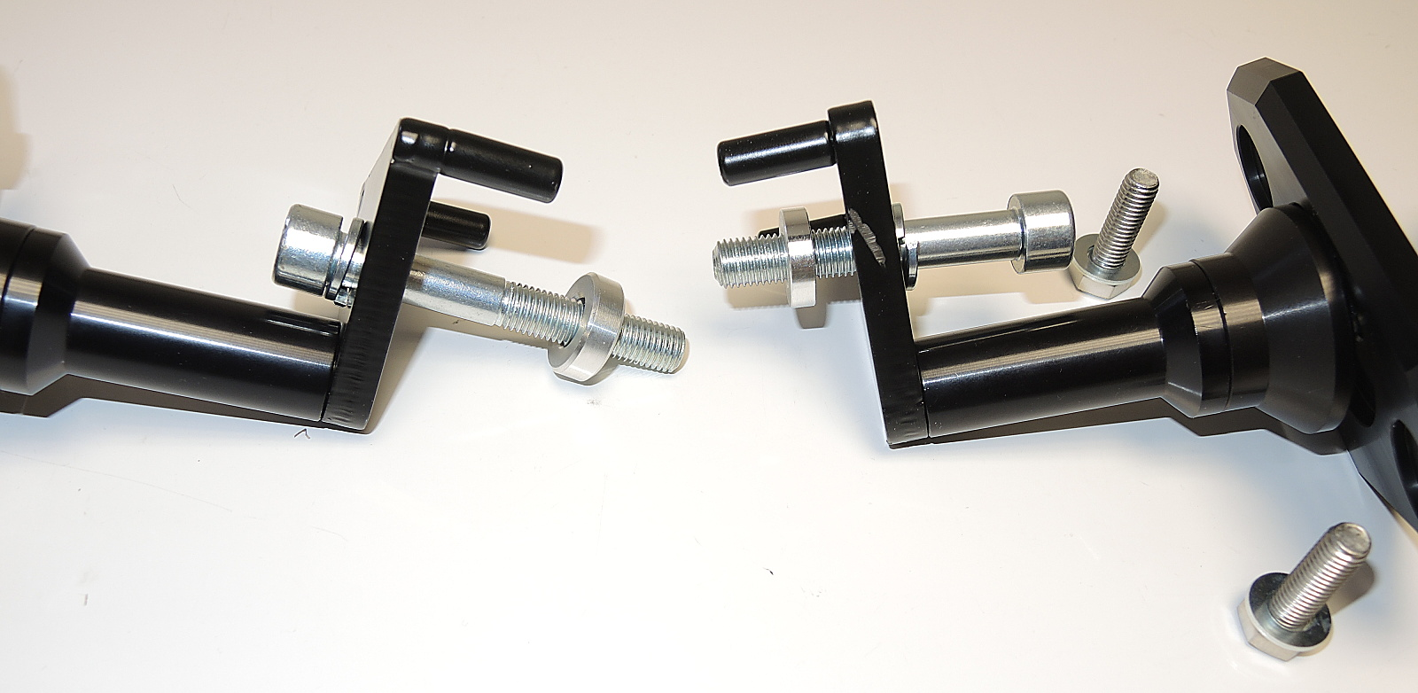
Picture 2
ID7

ID5+6

ID3

ID3
ID4

Instructions:
- Remove fairing from both sides
- Remove original bolts from the frame of motorcycle.
- Place 3M tape under the adapter (ID7).
- Mount fitting kits according to the picture 1 and 2.
- Put fairing back.
- In the end, mount protectors according to the picure 3.

Warning – we recommend to use safety glue on threads of all bolts (moderate strong – blue colour).
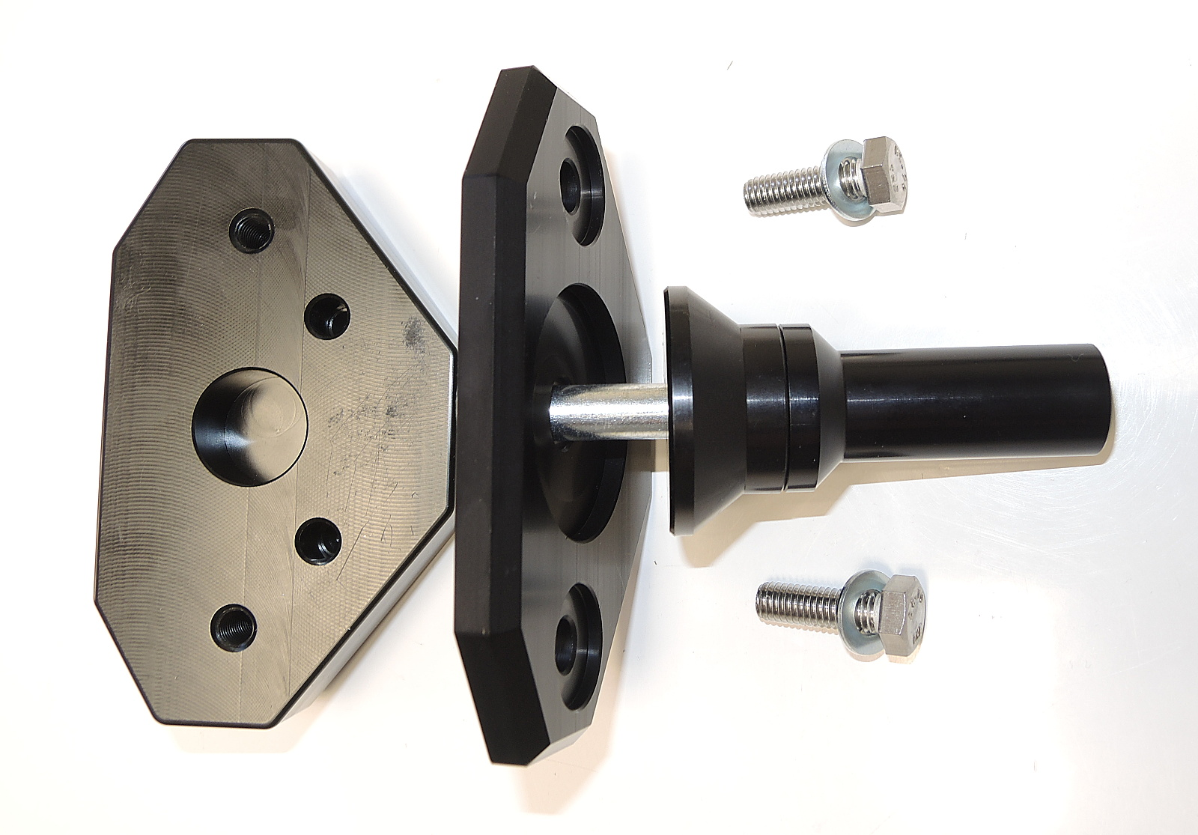
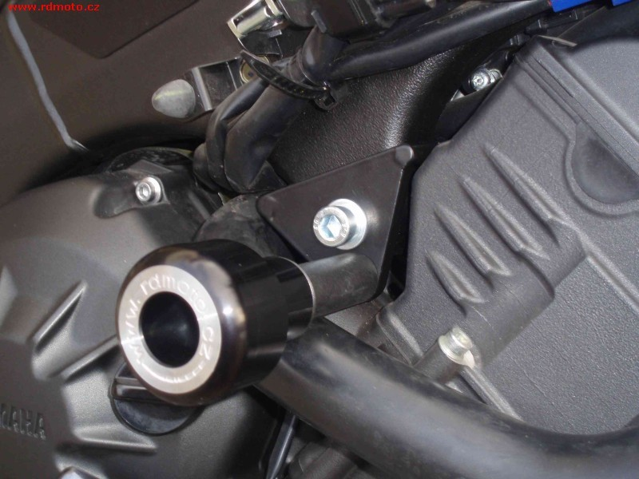
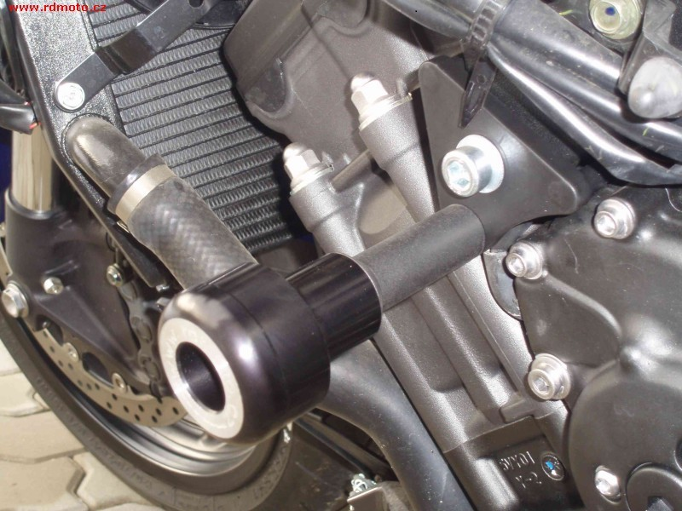
Picture 3

