Y16S
Yamaha R1 2007-2008

Left side fitting kit: Right side fitting kit:
ID. | Description | Cat.N | Qt
1 | Alu. slider holder | DV-317 | 1
2 | Bolt M10x75mm | 1007 | 1
3 | Bolt M6x25 | 877 | 3
4 | Bolt M4x16 | 876 | 2
5 | Bolt M10x70x1,25mm | 898 | 1
6 | Alu. spacer d=7mm | 137 | 1
7 | Alu. spacer d=55mm | 20 | 1
8 | Washer M10 (spring) | 801 | 1
9 | Steel adapter | 597 | 1
10 | Tape 3M | - | 1
ID. | Description | Cat.N | Qt
1 | Alu. slider holder | DV-317 | 1
2 | Bolt M10x75mm | 1007 | 1
3 | Bolt M6x25 | 877 | 3
4 | Bolt M4x16 | 876 | 2
5 | Bolt M10x60x1,25mm | 896 | 1
6 | Alu. spacer d=5mm | 16 | 1
7 | Alu. spacer d=55mm | 20 | 1
8 | Washer M10 (spring) | 801 | 1
9 | Steel adapter | 598 | 1
10 | Tape 3M | - | 1

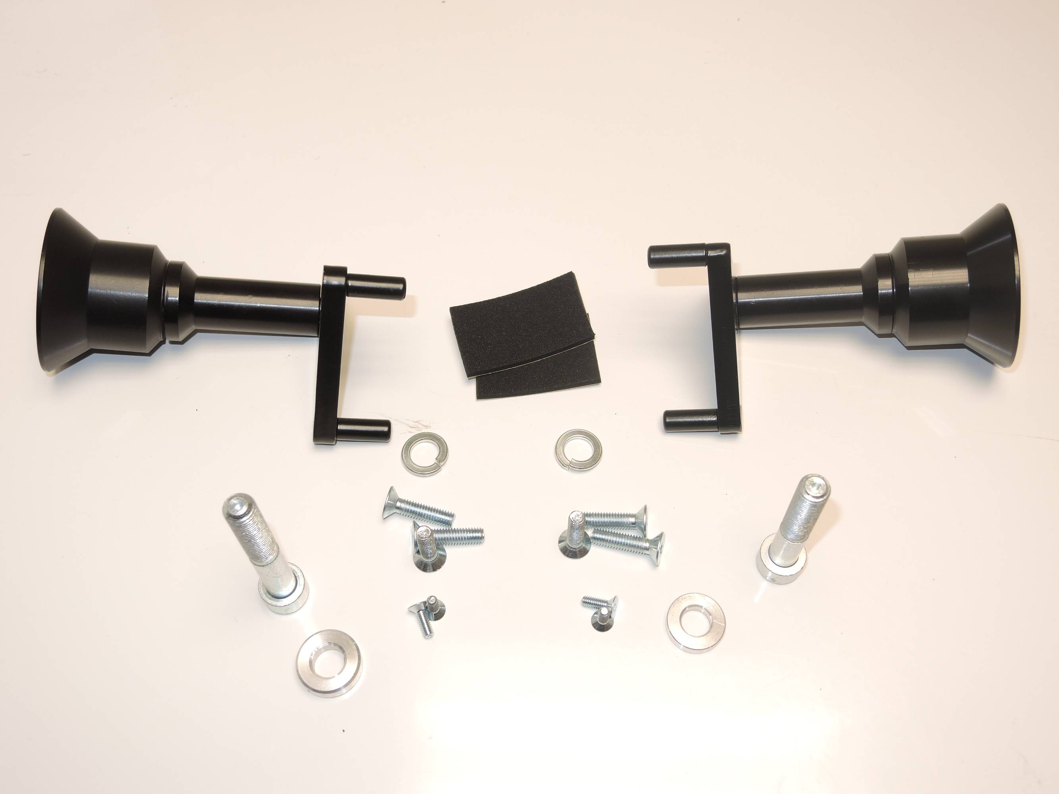

1
10
1
7
7
2
2

8
8

9
9

5
3

5
3

4
4
6
6

Left side instruction:

- Dismantle orig. bolt M10 from chassi.
- Stick 3M tape on the chassi, where is steel adapter touching with chassi.
- Insert ID.6 into the chassi. Place steel adapter and gripped it by bolt ID.5 with washer ID.8.
- Place fairing back the bike.
- Place bolt ID.2 into alu. adapter ID.1 and under the adapter ID.1 insert ID.7 on the bolt.This kit assembly on the steel adapter.
- By bolts ID.3 is mounting crash sliders. Place alu.cover and use bolts ID.4.

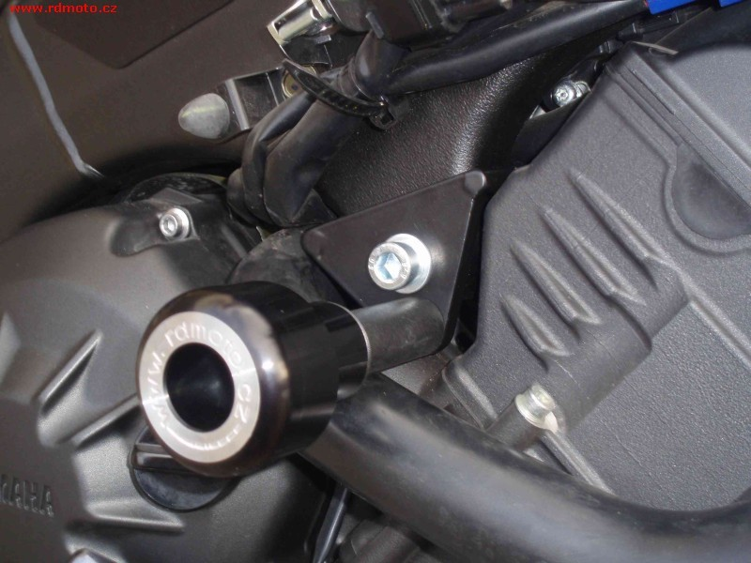
Assembly place
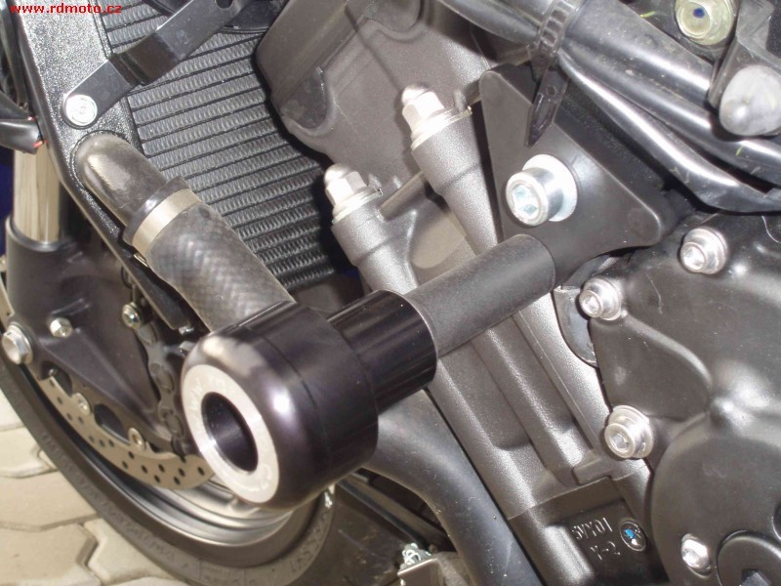

Assembly- right side:

- Dismantle orig. bolt M10 from chassi.
- Stick 3M tape on the chassi, where is steel adapter touching with chassi.
- Insert ID.6 into the chassi. Place steel adapter and gripped it by bolt ID.5 with washer ID.8.
- Place fairing back the bike.
- Place bolt ID.2 into alu. adapter ID.1 and under the adapter ID.1 insert ID.7 on the bolt.This kit assembly on the steel adapter.
- By bolts ID.3 is mounting crash sliders. Place alu.cover and use bolts ID.4.

Note: During assembly use medium strong glue of all threads.

