Y16
Yamaha R1 2007-2008

Fitting kit left side: Fitting kit right side:
2,6
ID | Description | Cat.N | QTY
1 | Steel box M10 | X1 | 1
2 | Bolt M10x70x1,25mm | 898 | 1
3 | Dural. cylinder d=7mm | 137 | 1
4 | Dural. cylinder d=55mm | 20 | 1
5 | Bolt M10x90mm | 880 | 1
6 | Washer M10 (spring) | 801 | 2
7 | Steel adapter | 597 | 1
8 | Tape 3M |  | 1
5
6
8
7
3
4
3
2,6
ID | Description | Cat.N | QTY
1 | Steel box M10 | X1 | 1
2 | Bolt M10x60x1,25mm | 896 | 1
3 | Dural. cylinder d=5mm | 16 | 1
4 | Dural.cylinder d=55mm | 20 | 1
5 | Bolt M10x90mm | 880 | 1
6 | Washer M10 (spring) | 801 | 2
7 | Steel adapter | 598 | 1
8 | Tape 3M |  | 1
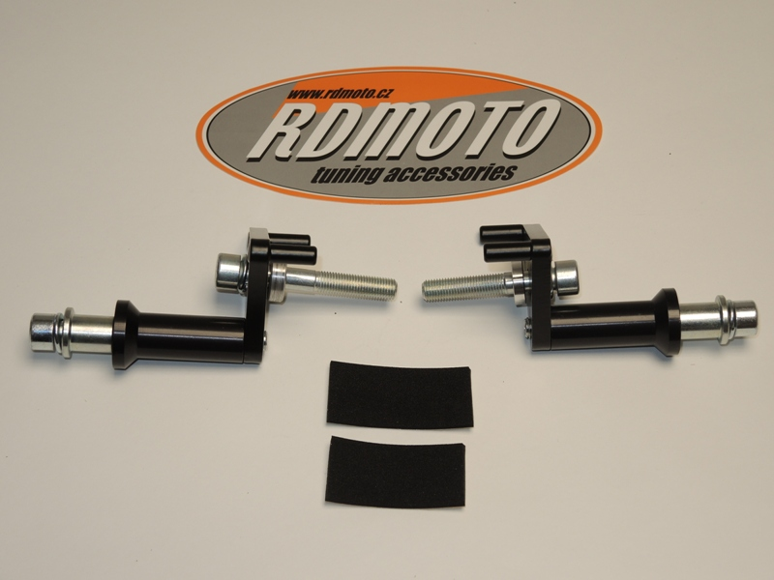
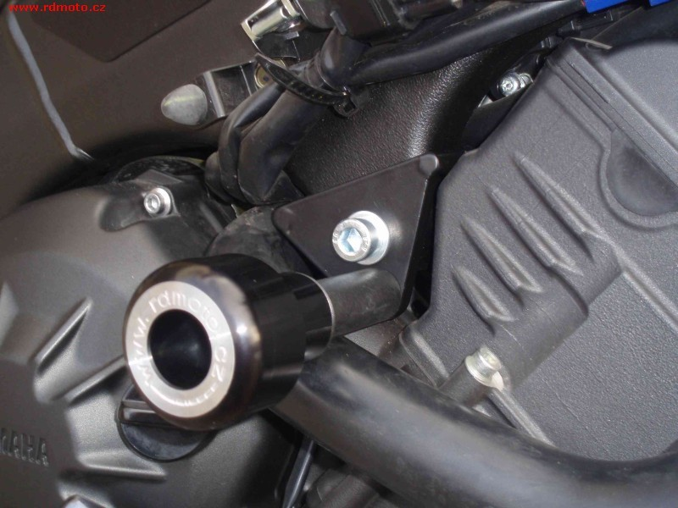
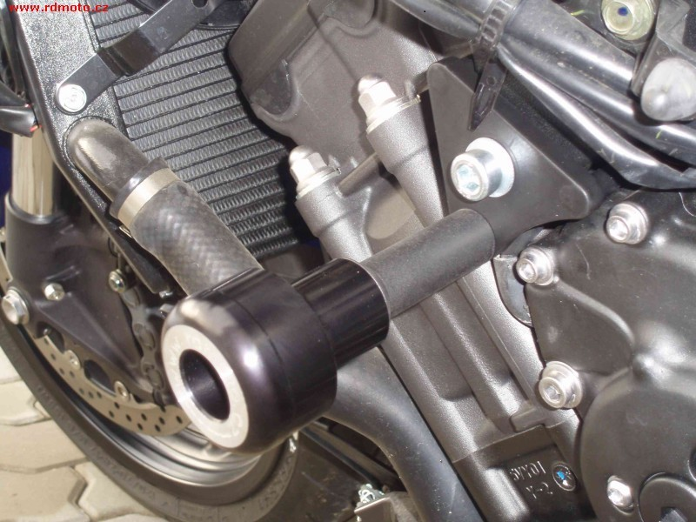
5
5
4
6
8
7
1
1
2,6
7
3
6
4
2,6
3
2,6
2,6

Instruction to assembly, left side:
- Take off fairing and orig. bolt M10 from frame.
- Stick 3M ID.8 on the frame, under the adapter ID.7.
- Under the adapter ID.7 insert dural.cylinder ID.3 and use bolt ID.2 and washer ID.6 tighten adapter on frame.
- Check all kit and after put fairing on the bike.
- Put steel box ID.1 with bolt. ID.5 and washer ID.6 into the protector. Under the protector put dural.cylinder ID.4.
- This set mount on the steel adapter ID.7.

Instruction to assembly, right side:
- Take off fairing and orig. bolt M10 from frame.
- Stick 3M ID.8 on the frame, under the adapter ID.7.
- Under the adapter ID.7 insert dural.cylinder ID.3 and use bolt ID.2 and washer ID.6 tighten adapter on frame.
- Check all kit and after put fairing on the bike.
- Put steel box ID.1 with bolt. ID.5 and washer ID.6 into the protector. Under the protector put dural.cylinder ID.4.
- This set mount on the steel adapter ID.7.

Warning – we recommend to use safety glue on threads of all bolts (moderate strong – blue colour).

