Y17SD
Yamaha XJ6/Diversion 2009-

Kit for left side: |  |  |  |  | Kit for right side:
ID. | Description | Cat.No | QTY |  |  | ID. | Description | Cat.No | QTY
1 | Steel adapter | 603 | 1 |  |  | 1 | Steel adapter | 604 | 1
2 | Bolt M10x40x1,25 | 941 | 1 |  |  | 2 | Bolt M10x40x1,25 | 941 | 1
3 | Washer M10 | 801 | 2 |  |  | 3 | Washer M10 | 801 | 2
4 | Dural.adapter 40mm | DV12 | 1 |  |  | 4 | Dural.adapter 40mm | DV12 | 1
5 | Bracket for SLD | 537 | 1 |  |  | 5 | Bracket for SLD | 537 | 1
6 | Bolt M10x60 | 850 | 1 |  |  | 6 | Bolt M10x60 | 850 | 1
7 | Bolt M8x25 | 815 | 2 |  |  | 7 | Bolt M8x25 | 815 | 2
8 | Washer M8 | 800 | 2 |  |  | 8 | Washer M8 | 800 | 2
9 | 3M Tape |  | 1 |  |  | 9 | 3M Tape |  | 1

Instruction to assembly-left side :
- Take out original plast cover and bolt M10 from frame.
- Stick on the frame 3M tape ID.5 under the steel adapter ID.1.
- Use bolt M10x40x1,25 ID.2 and washer M10 ID.3 and thighten adapter ID.1 on the frame.
- Insert bolt ID.6 through the washer ID.3, holder for SLD ID.5 and dural.cylinder ID.4.
- This kit mount on the steel adapter.
- Gripping slider use bolts M8x25 ID.7 and washer ID.8.

Instruction to assembly-right side:
On the right side is recommended to cut plastic, it isn´t necessary. If fairing is to fit on steel adapter.
- Take out original plast cover and bolt M10 from frame.
- Stick on the frame 3M tape ID.5 under the steel adapter ID.1.
- Use bolt M10x40x1,25 ID.2 and washer M10 ID.3 and thighten adapter ID.1 on the frame.
- Insert bolt ID.6 through the washer ID.3, holder for SLD ID.5 and dural.cylinder ID.4.
- This kit mount on the steel adapter.
- Gripping slider use bolts M8x25 ID.7 and washer ID.8.

Warning - the threads of the screws is recommended to use premium adhesive of medium strength (blue).

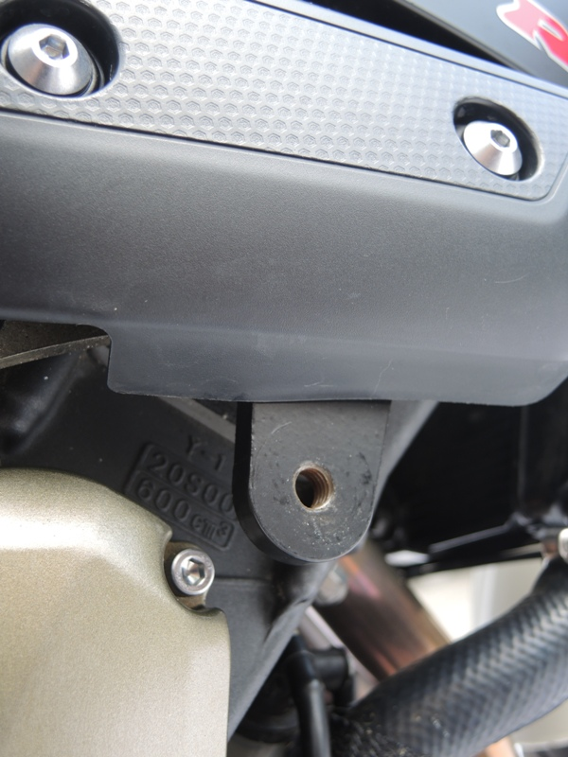
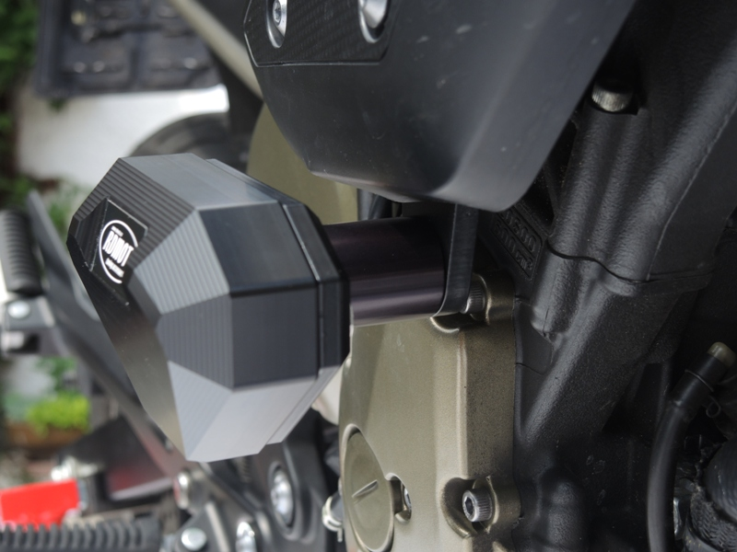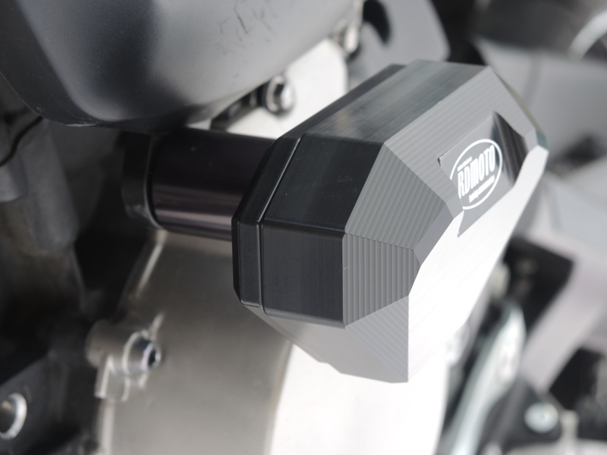
cut, 8mm
