Y17S
Yamaha XJ6/Diversion 2009-

Kit for left side |  |  |  |  | Kit for right side
ID | Description | Cat.no | Qty |  |  | ID | Description | Cat.no | Qty
1 | Dural.adapter | DV-317 | 1 |  |  | 1 | Dural.adapter | DV-317 | 1
2 | Bolt M10x40x1,25mm | 941 | 1 |  |  | 2 | Bolt M10x40x1,25mm | 941 | 1
3 | Washer M10-spring | 801 | 1 |  |  | 3 | Washer M10-spring | 801 | 1
4 | Steel adapter | 603 | 1 |  |  | 4 | Steel adapter | 604 | 1
5 | Tape 3M | 3M | 1 |  |  | 5 | Tape 3M | 3M | 1
6 | Bolt M10x30 | 882 | 1 |  |  | 6 | Bolt M10x25 | 868 | 1
7 | dural. cylinder d=10mm | 1 | 1 |  |  | 7 | Slider | SL01 | 1
8 | Slider | SL01 | 1 |  |  | 8 | Cover | SLcap. | 1
9 | Cover | SLcap. | 1 |  |  | 9 | Bolt M6x25 | 877 | 3
10 | Bolt M6x25 | 877 | 3 |  |  | 10 | Bolt M4x16 | 876 | 2
11 | Bolt M4x16 | 876 | 2
Instruction to assembly-left side :
- Take out original plast cover and bolt M10 from frame.
- Stick on the frame 3M tape ID.5 under the steel adapter ID.4.
- Use bolt M10x40x1,25 ID.2 and washer M10 ID.3 and thighten adapter ID.4 k on the frame.
- Insert bolt ID.6 through the dural.adapter ID.1 and dural.cylinder ID.7.
- This kit mount on the adapter
- Gripping slider ID.8 use bolts M6x25.
- Insert cover into the slide rand use bolts M4x16 ID.11

Instruction to assembly-right side:
on the right side is recommended to cut plastic
- Take out original plast cover and bolt M10 from frame.
- Stick on the frame 3M tape ID.5 under the steel adapter ID.4.
- Use bolt M10x40x1,25 ID.2 and washer M10 ID.3 and thighten adapter ID.4 k on the frame.
- Insert bolt ID.6 through the dural.adapter ID.1.
- This kit mount on the adapter
- Gripping slider ID.7 use bolts M6x25.
- Insert cover into the slide rand use bolts M4x16 ID.10

Warning - the threads of the screws is recommended to use premium adhesive of medium strength (blue).

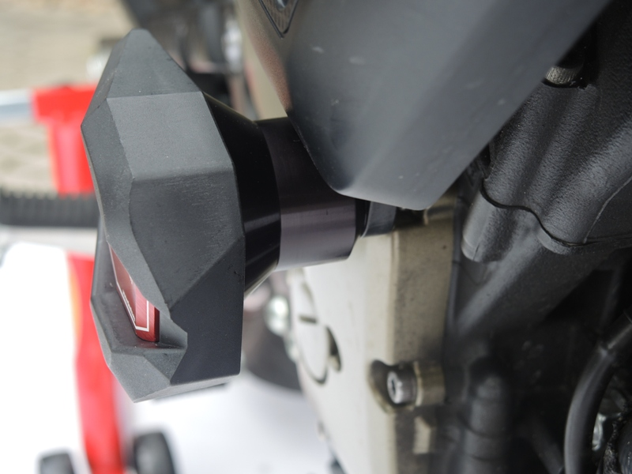
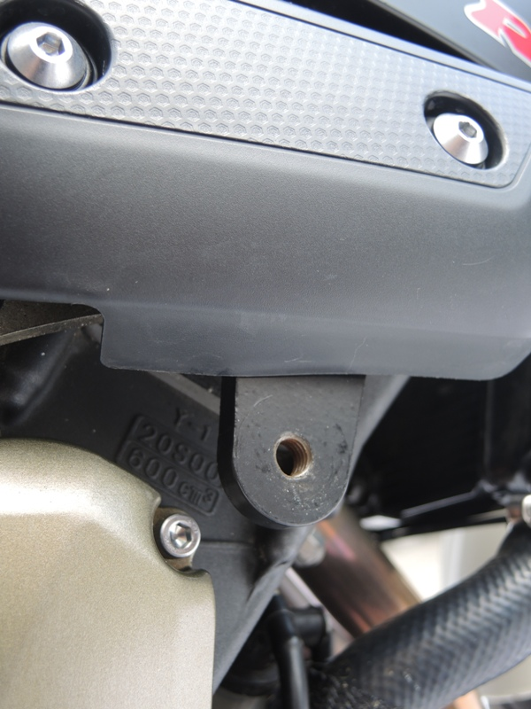
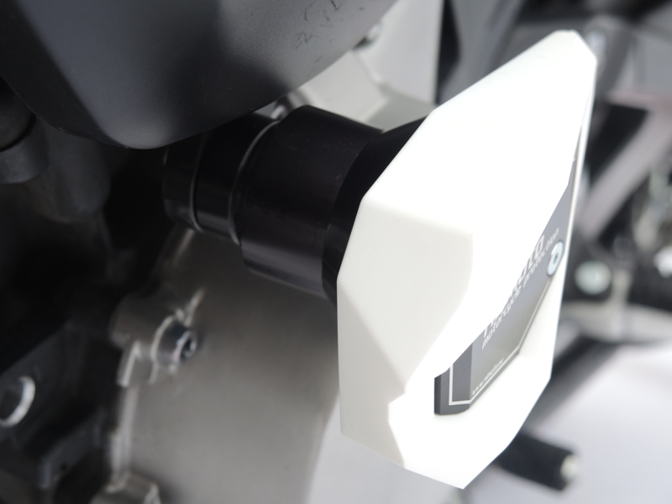
ŘEZ, 8mm

