Y17
Yamaha XJ6/Diversion 2009-

Kit for the left side |  |  |  |  | Kit for the right side
No. | Description | Cat.no. | Pcs |  |  | No. | Description | Cat.no. | Pcs
1 | Steel box M10 | X1 | 1 |  |  | 1 | Steel box M10 | X1 | 1
2 | Bolt M10x40x1,25mm | 941 | 1 |  |  | 2 | Bolt M10x40x1,25mm | 941 | 1
3 | Dural. cylinder d=10mm | 1 | 1 |  |  | 3 | Dural. cylinder d=10mm | 1 | 1
4 | Bolt M10x45mm | 848 | 1 |  |  | 4 | Bolt M10x45mm | 848 | 1
5 | Pad M10 - spring | 801 | 1 |  |  | 5 | Pad M10 - spring | 801 | 1
6 | Steel adapter | 603 | 1 |  |  | 6 | Steel adapter | 604 | 1
7 | Tape 3M |  |  |  |  | 7 | Tape 3M
Installation – the left side:

- remove the original side plastic and the bolt M10 in the frame of motorcycle
- stick the tape 3M (No. 7) on the frame of motorcycle in the place of mounting
- use the bolt (No. 2) with pad (No. 5) and screw up the adapter (No. 6) to frame of the motorcycle
- insert the steel box (No. 1) together with the bolt (No. 4) into protector, give the duralumin cylinder (No. 3) under protector. The cylinder give on bolt.
- mount all this set on adapter

Warning – we recommend to use safety glue on threads of all bolts (moderate strong – blue colour).

Installation – the right side:
Recommande- cut the fairing on the right side, but it may not be neceséry.

- remove the original side plastic and the bolt M10 in the frame of motorcycle
- stick the tape 3M (No. 7) on the frame of motorcycle in the place of mounting
- use the bolt (No. 2) with pad (No. 5) and screw up the adapter (No. 6) to frame of the motorcycle
- insert the steel box (No. 1) together with the bolt (No. 4) into protector, give the duralumin cylinder (No. 3) under protector. The cylinder give on bolt.
- mount all this set on adapter.

Warning – we recommend to use safety glue on threads of all bolts (moderate strong – blue colour).

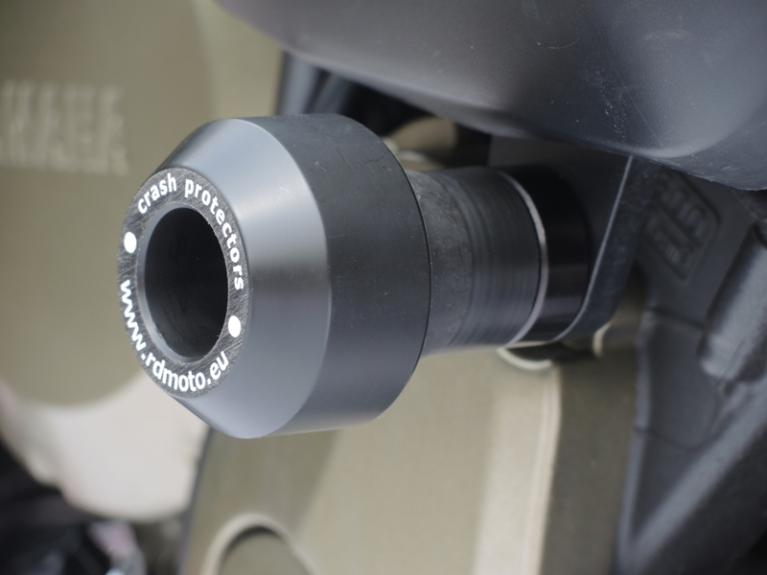
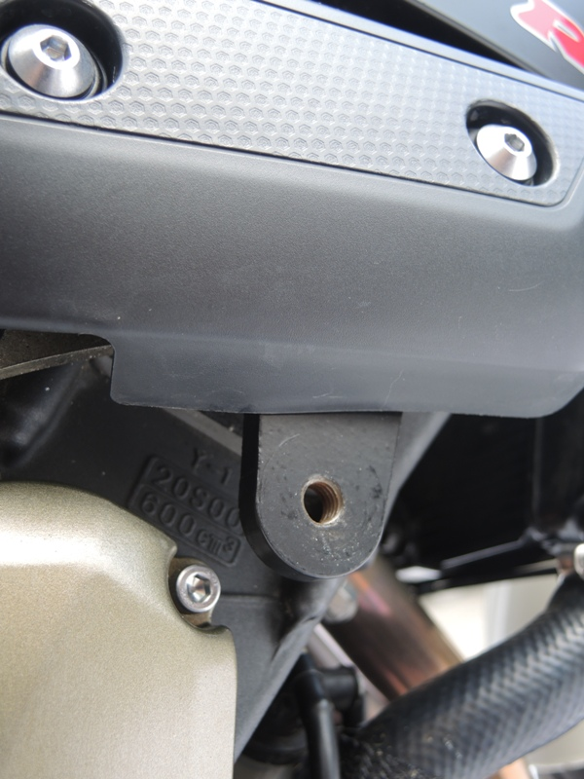
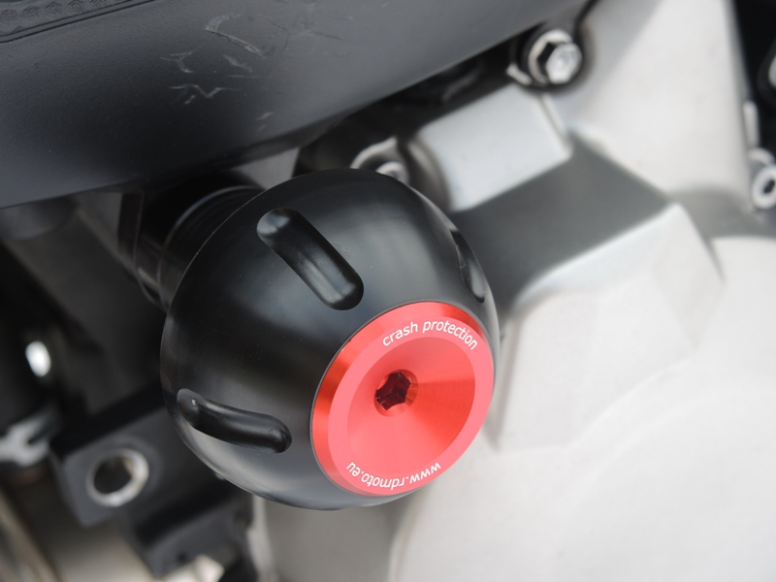
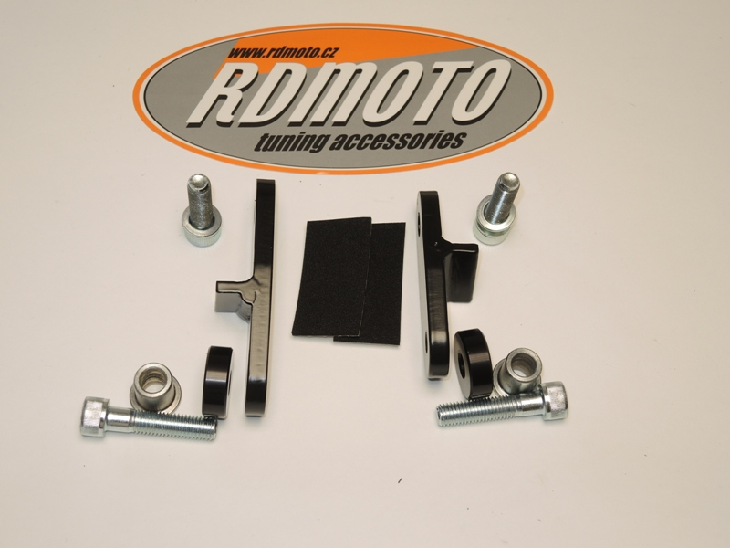
CUT,8mm

