Y20
Yamaha YZF R125 2008-
Kit for the left side
ID | Description | Cat.no. | pcs
1 | Steel insert | X2 | 1
2 | Screw M12x45 | 859 | 1
3 | Dural. roller 60mm | 237 | 1
4.1 | Dural roller 74,5mm | 218 | 1
5 | Dural. roller 5mm | 16 | 1
6.1 | Dural adapter | 576 | 1
7 | Washer M10 | 804 | 1
8 | Nut M10 | 810 | 1
9 | Steel rod 10x310x30x30 |  | 1
10 | Screw M12x50mm | 869 | 1
13 | 3M tape |  | 1
Instructions:
Kit for the right side
ID | Description | Cat.no. | pcs
1 | Steel insert | X2 | 1
2 | Screw M12x45 | 859 | 1
3 | Dural roller 60mm | 237 | 1
4.2 | Dural roller 77mm | 217 | 1
5 | Dural. roller 5mm | 16 | 1
6.2 | Dural. adapter | 575 | 1
7 | Washer M10 | 804 | 1
8 | Nut M10 | 810 | 1
10 | Screw M12x50mm | 869 | 1
11 | Nut M16 | 994 | 1
12 | Special screw M16x1,5 | 219 | 1
13 | 3M tape |  | 1
- Dismantle plastic cover of chain. Modify plastic cover of chain same as in the first picture.
- Dismantle screw M10 which is placed through engine.
- Loosen the lower screw on the frame which passes through the swing arm. It is not necessary to remove from the frame.
- Through engine pass stainless steel rod (ID9). On the left side put on roller (ID4.1). Also on the right side put on roller (ID4.2). Fit chain cover back.
- On the dural adapters (ID6) fit protectors (on both sides).
- On both sides place dural roller (ID3) under protectors. Pass screw (ID2) from the back side. Dont forget to place steel insert under screw M12 (ID10).
- On the lower screw on the left side place protector holder. On the right side tighten this screw with special hollow screw (ID12). Place protector holder on your motorcycle. Tighten it with nut (ID11).
- Place dural rollers (ID5) on both sides on the stainless steel rod (ID9). Than place washers M10 (ID7) on the rod. Tighten all with nuts (ID8).
- Tighten all screws.
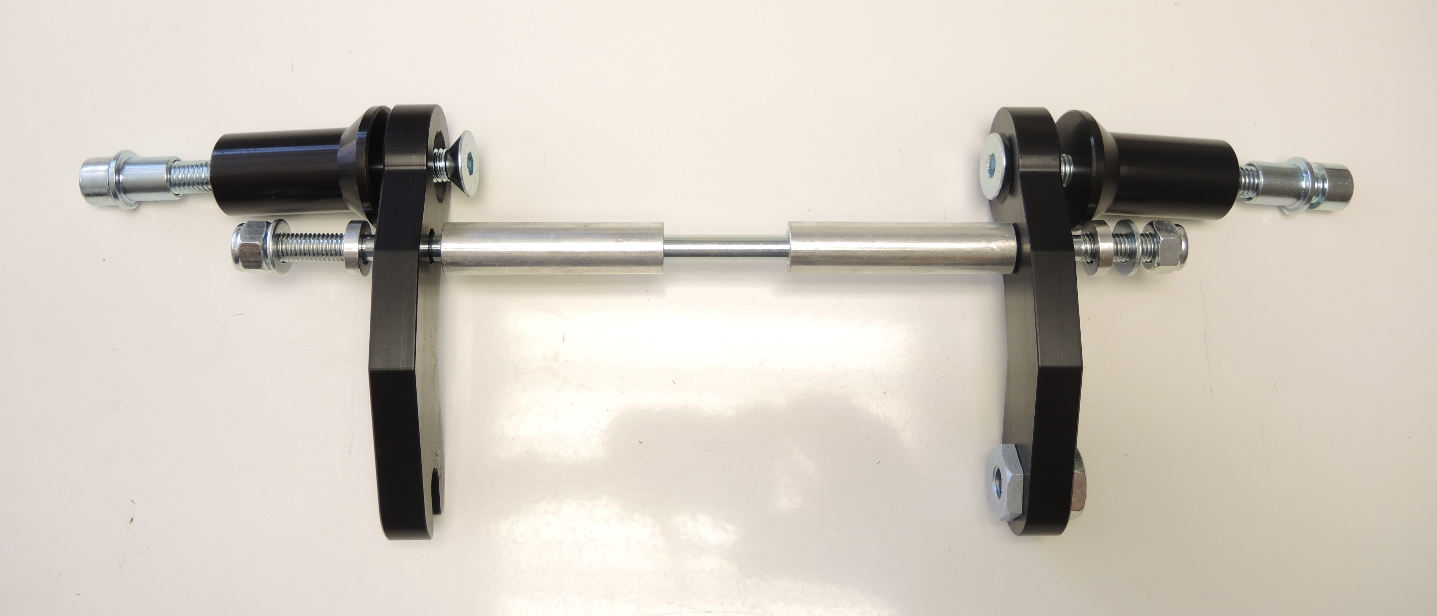
ID2
ID3
ID1
ID3

ID10
ID4.2
ID4.1

ID6.1
ID6.2
ID8
ID7
ID5
ID9
ID12
ID11
ID6.1
3
1
8
7
5
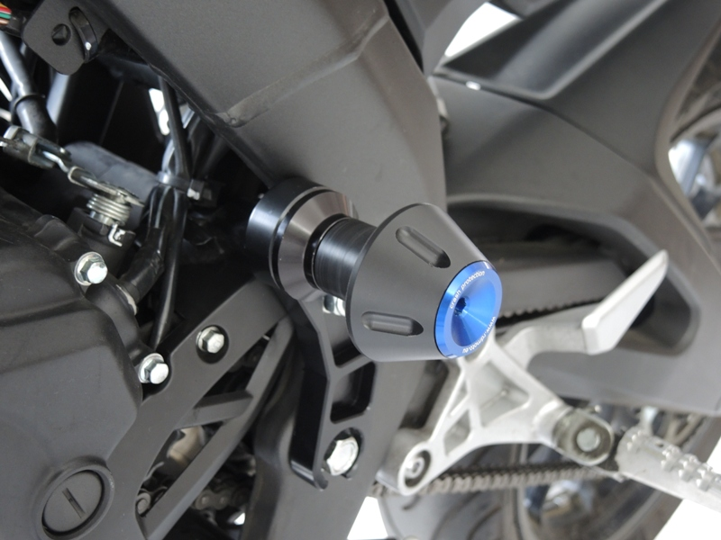
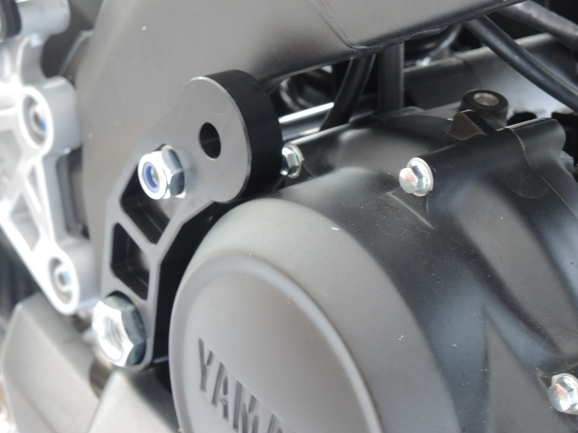

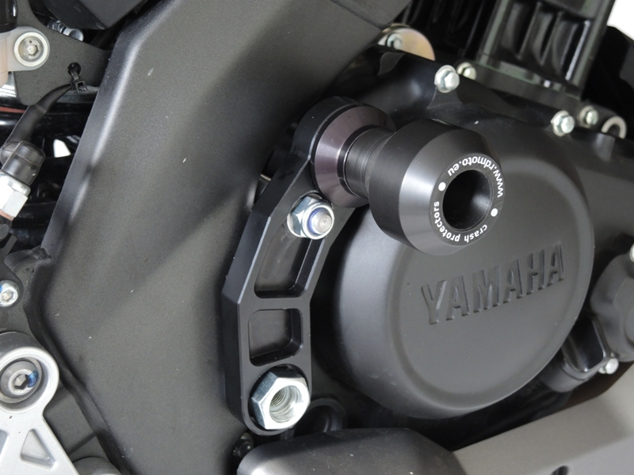

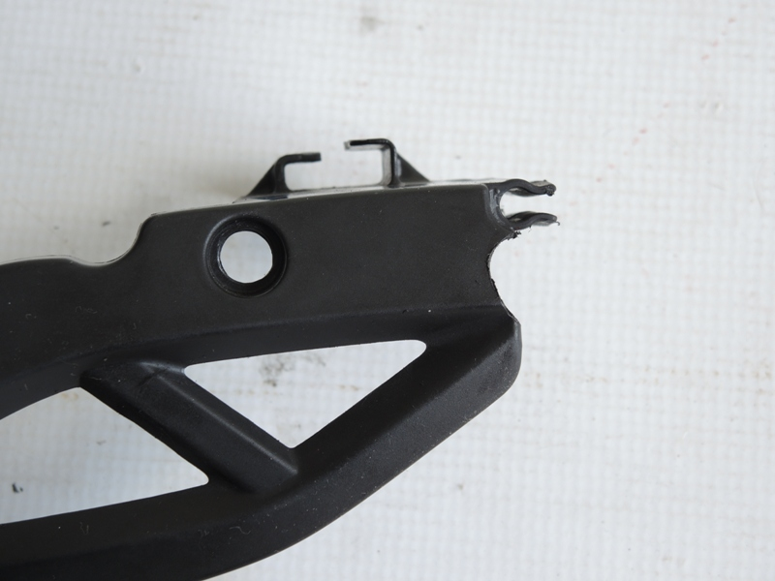
Modify here
We recommend use the glue for all threads. Medium strong.

