Y24SDM
Yamaha FJR1300
2006-2012

Fitting kit left side: Fitting kit right side:
ID | Description | Cat.N | Qty
1 | Bolt M12x110x1,25 | 910 | 1
2 | SLDM adapter | 537/B | 1
3 | Dural. cylinder 15mm | 93 | 1
4 | Cylinder adapter (black) | 171 | 1
5 | Bolt M6x20 | 1024 | 2
6 | Washer M6 | 1023 | 2
ID | Description | Cat.N | Qty
1 | Bolt M12x120x1,25 | 913 | 1
2 | SLDM adapter | 537/B | 1
3 | Dural. cylinder 25mm | 94 | 1
4 | Cylinder adapter (black) | 171 | 1
5 | Bolt M6x20 | 1024 | 2
6 | Washer M6 | 1023 | 2

Instructions:

- Remove original bolt M10 from the frame.
- Prepare bolt ID1 and put SLDM adapter ID2, cylinder adapter ID4 and dural. cylinder ID3 on it. On the right side belongs longer cylinder ID3.
- Mount this kit into the frame of motorcycle.
- Fit slider using two bolts ID5 and washers ID6.

We recommend to use the glue on all threads (medium strong).

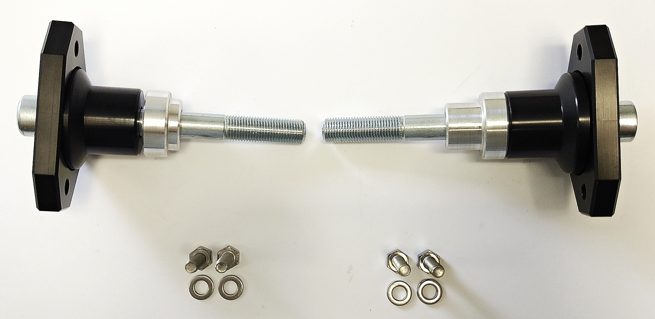

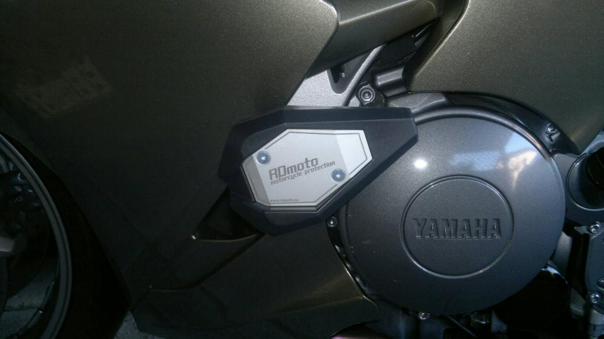
Ilustation picture, aprox. place for protector gripping.

