Y24
Yamaha FJR1300
2006-2012
Kit for right side: Kit for left side:

No. | Description | Cat.no. | Quant.
2 | Steel box | X2 | 1
3 | Duralumin cylinder d=15mm | 93 | 1
4 | Bolt M12x95 | 900 | 1

No. | Description | Cat.no. | Quant.
2 | Steel box | X2 | 1
3 | Duralumin cylinder d=25mm | 94 | 1
4 | Bolt M12x105mm | 912 | 1

Installation – the right side:

1. remove the original bolt
2. insert steel box (no.2) to the protector
3. into the frame insert duralumin cylinder (no.3)
4. through the protector insert bolt (no.4) and mounting on the motorcycle frame

Installation – the left side:

1. remove the original bolt
2. insert steel box (no.2) to the protector
3. into the frame insert duralumin cylinder (no.3)
4. through the protector insert bolt (no.4) and mounting on the motorcycle frame

Warning – we recommend to use safety glue on threads of all bolts (moderate strong – blue colour).

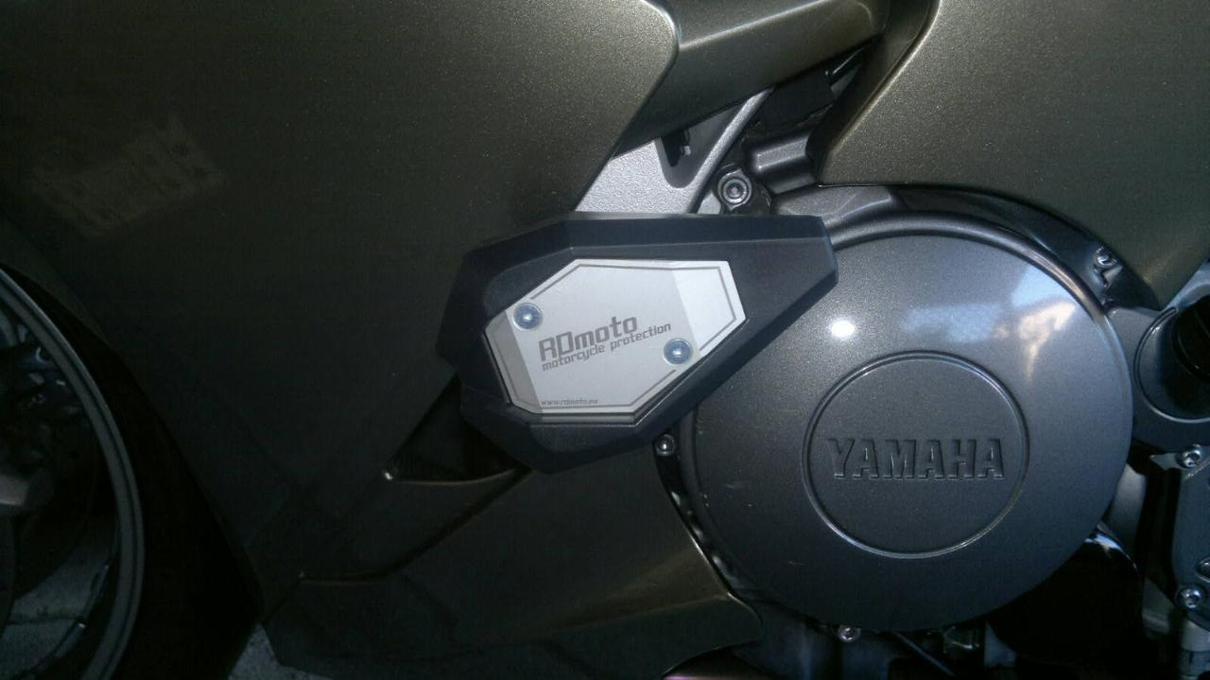
Ilustation picture, aprox. place for protector gripping.

