Y27SD
Yamaha FZ-8 2010-
Right side kit: Left side kit:
ID | Description | Cat.no. | Pcs
1 | SLD adapter | 537 | 1
2 | Dural. cylinder 10mm | 10 | 1
3 | Dural. cylinder 32mm | 55 | 1
4 | Bolt M10x105x1,25 | 893 | 1
5 | Washer M8 | 800 | 2
6 | Bolt M8x25 | 815 | 2
7 | Washer (spring) M10 | 801 | 1
ID | Description | Cat.no. | Pcs
1 | SLD adapter | 537 | 1
2 | Dural. cylinder 10mm | 10 | 1
3 | Dural. cylinder 32mm | 55 | 1
4 | Bolt M10x105x1,25 | 893 | 1
5 | Washer M8 | 800 | 2
6 | Bolt M8x25 | 815 | 2
7 | Washer (spring) M10 | 801 | 1
Instructions:

- Dismantle original bolt from the frame of motorcycle.
- Put bolt ID4 through washer ID7, SLD adapter ID1, 10mm cylinder ID2 and 32mm cylinder ID3. Mount this kit into the frame of motorcycle.
- Fit slider using two bolts M8 and washers M8 (ID6 and ID7).

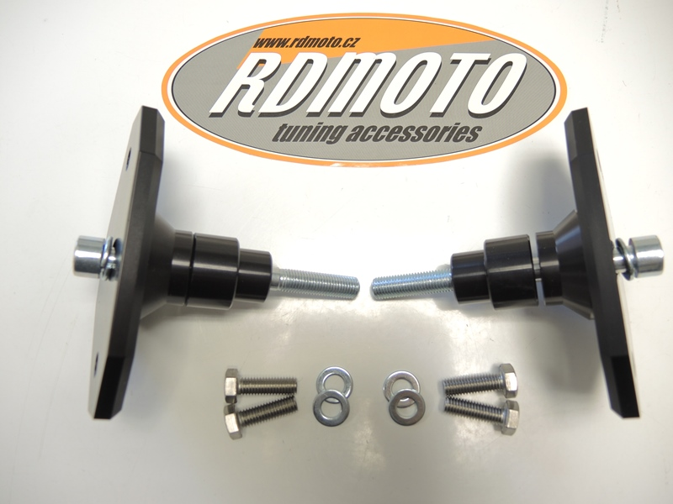
1
2
2
3
3
4
4
1
5
1
1
6

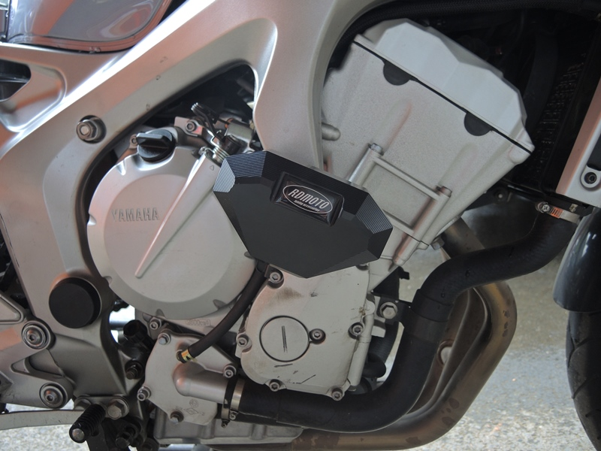

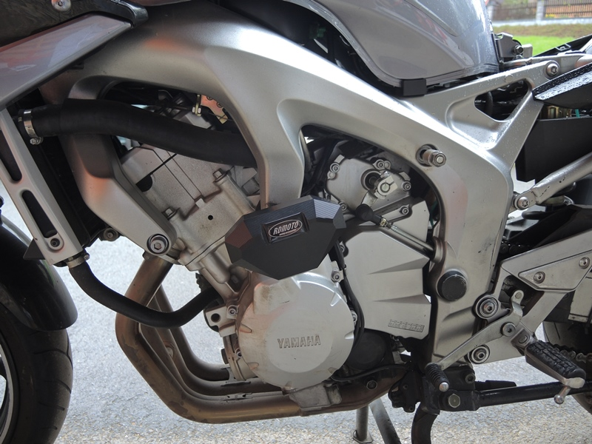

We recommend to use medium strong glue on all threads.

