Y27S
Yamaha FZ-1 2006-
Yamaha FZ-8 2010-

Fitting kit:
ID. | Description | Cat.N | Qt
1 | Alu. adapter for slider | DV-304 | 2
2 | Bolt M6x25 | 877 | 6
3 | Bolt M4x16 | 876 | 4
4 | Bolt M10x75x1,25mm | 938 | 2
5 | Washer M10 | 801 | 2

Assembly first side and after make assembly sekond side.
- Dismantle original bolt from the chassi.
- Insert bolt ID.4 into the adapter ID.1. and mounting it on the frame.
- Place slide rand tighten it by bolts ID.2. Place alu cover and bolt ID.3
Warning - the threads of all bolts recommend the use of premium adhesive moderate (blue).
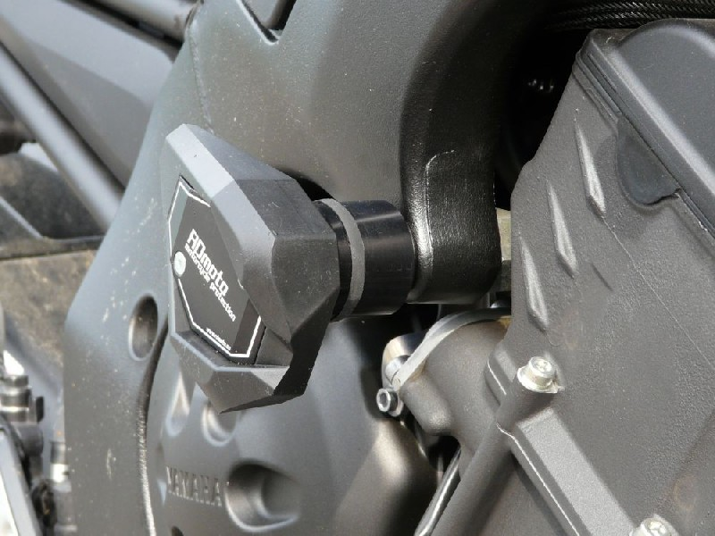
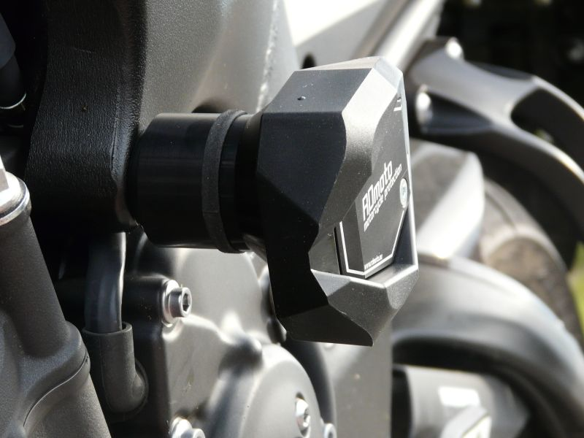

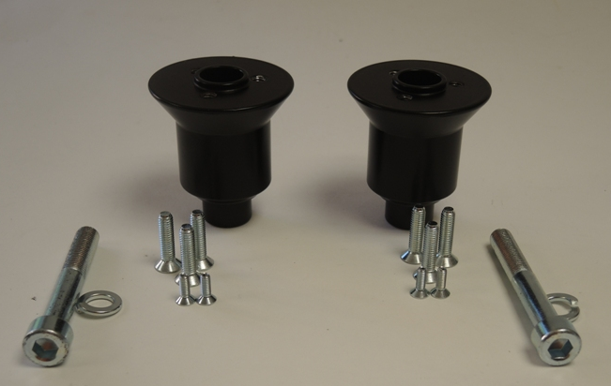
4
4
3
2
2
1
5
5

