Y27
Yamaha FZ-1 2006-
Yamaha FZ-8 2010-

Fitting kit:
ID. | Description | Cat.N | Qt
1 | Steel box | X1 | 2
2 | Bolt M10x95x1,25 | 927 | 2
3 | Spacer d=32mm | 55 | 2

Assembly first side and after make assembly sekond side.
- Dismantle original bolt from the chassi.
- Insert ID.1 into the protector. Place spacer ID.3 into the frame. Mount protector on the chassi.

Warning - the threads of all bolts recommend the use of premium adhesive moderate (blue).

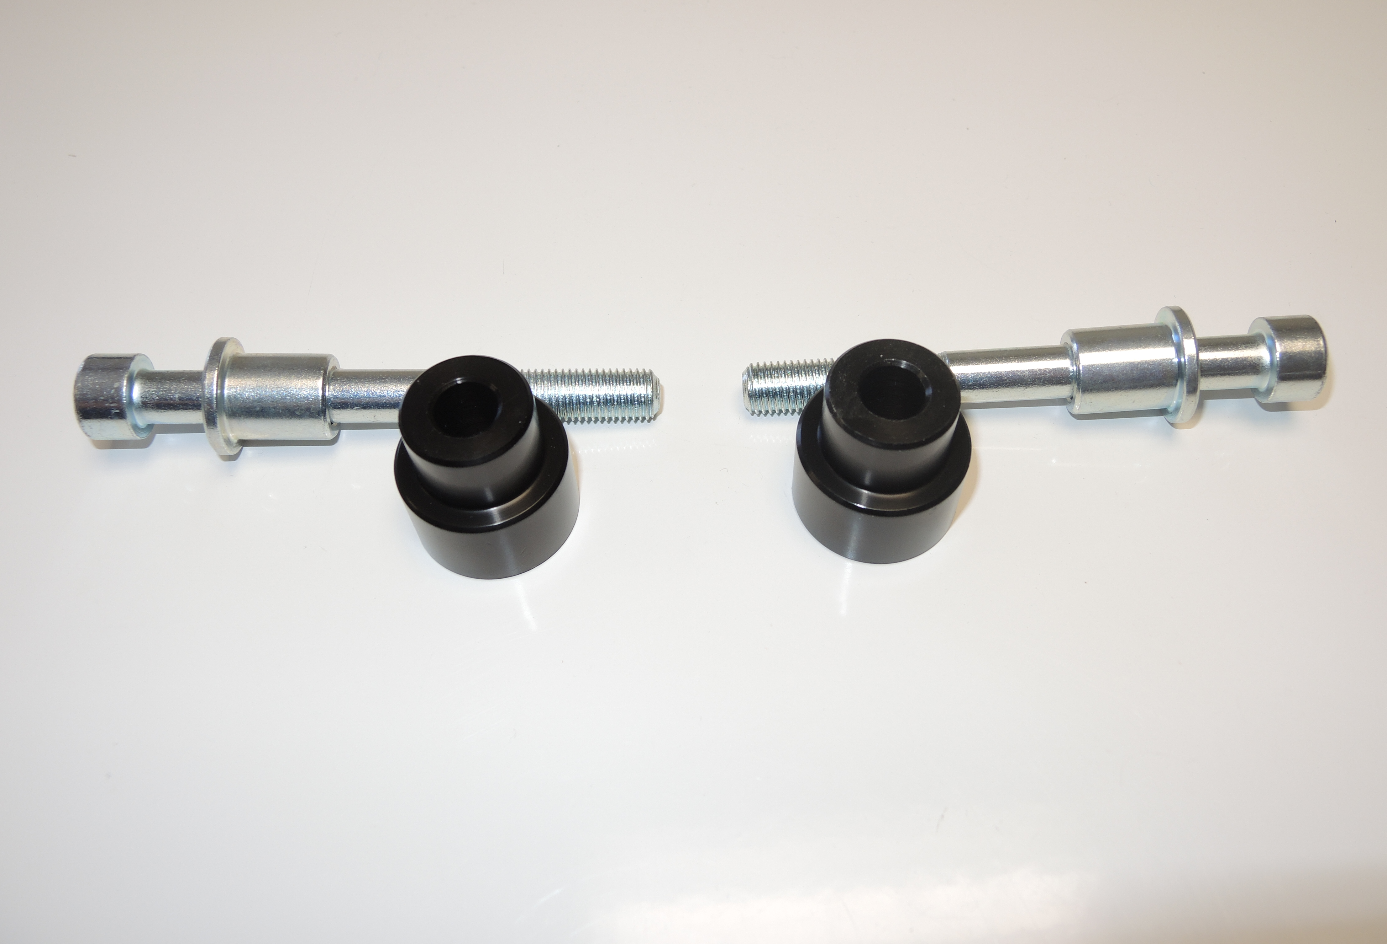

1
2

3

4
4
3
2
5
5

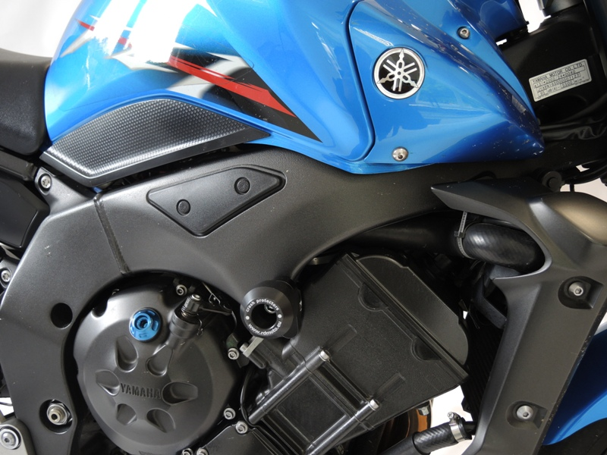

2
1

