Y28SDM
Yamaha XJ6 Diversion F 2010-

Kit for the left side |  |  |  |  | Kit for the right side
No. | Description | Cat.no. | Pcs |  |  | No. | Description | Cat.no. | Pcs
1 | Drual. Cylinder 30mm | DV11 | 1 |  |  | 1 | Drual. Cylinder 30mm | DV11 | 1
2 | Bolt M10x50x1,25mm | 921 | 1 |  |  | 2 | Bolt M10x50x1,25mm | 921 | 1
3 | Bolt M10x50mm | 849 | 1 |  |  | 3 | Bolt M10x50mm | 849 | 1
4 | Duralumin adapter | 615 | 1 |  |  | 4 | Duralumin adapter | 616 | 1
5 | Tape 3M | - | - |  |  | 5 | Tape 3M | - | -
6 | Plastic cap | X4 | 1 |  |  | 6 | Plastic cap | X4 | 1
7 | Washer M10 (spring) | 801 | 1 |  |  | 7 | Washer M10 (spring) | 801 | 1
8 | SLDM adapter | 537/B | 1 |  |  | 8 | SLDM adapter | 537/B | 1
9 | Bolt M6x20mm | 1024 | 2 |  |  | 9 | Bolt M6x20mm | 1024 | 2
10 | Washer M6 | 1023 | 2 |  |  | 10 | Washer M6 | 1023 | 2

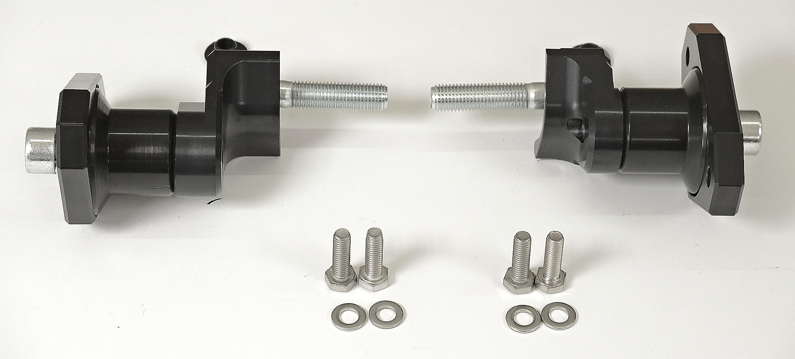
ID1
ID8
ID4
ID2
ID3

Instructions

- We recommend to use medium strong glue on all threads.
- Dismantle side fairing and original bolt from the frame according to the picture below.
- Stick 3M tape on the frame of motorcycle to prevent its damage.
- Fit adapter ID4 on the frame using bolt ID2.
- Prepare SLD adapter ID8 and dural. cylinder ID1 and fit it on the steel adapter using bolt M10 (ID3) and washer ID7.
- Fit slider using two bolts ID9 and washers ID10.
- In the end place plastic caps on both bolts.

ILLUSTRATIVE PHOTOS OF Place of the installation

