Y28S
Yamaha XJ6 Diversion F 2010-

Kit for the left side |  |  |  |  | Kit for the right side
No. | Description | Cat.no. | Pcs |  |  | No. | Description | Cat.no. | Pcs
1 | Slider |  | 1 |  |  | 1 | Slider |  | 1
2 | Cover for slider |  | 1 |  |  | 2 | Cover for slider |  | 1
3 | Adapter slider | DV-292 | 1 |  |  | 3 | Adapter slider | DV-292 | 1
4 | Bolt M10x30mm | 882 | 1 |  |  | 5 | Bolt M10x25mm | 868 | 1
5 | Bolt M6x25 | 877 | 3 |  |  | 6 | Bolt M6x25 | 877 | 3
6 | Bolt M4x16 | 876 | 2 |  |  | 7 | Bolt M4x16 | 876 | 2
7 | Bolt M10x50x1,25mm | 921 | 1 |  |  | 8 | Bolt M10x50x1,25mm | 921 | 1
8 | Duralumin adapter | 615 | 1 |  |  | 9 | Duralumin adapter | 616 | 1
9 | Tape 3M |  | 1 |  |  | 10 | Tape 3M |  | 1
10 | Plastic cap | X4 | 1 |  |  | 11 | Plastic cap | X4 | 1

7
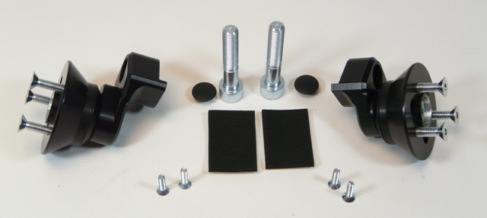
8
5
6
7
8
3
3
4
5
4
6
10
10

Installation – the left side:

- remove the original side plastic and the bolt M10 in the frame of the motorcycle
- use the tape 3M (No. 9) on the frame of the motorcycle in the place of the installation
- use the bolt (No. 7) for the gripping of the adapter (No. 8) to the frame of the motorcycle
- use the bolt (No. 4) for the mounting of the duralumin adapter (No. 3), screw all up
- use the bolts (No. 5) for the gripping of the slider (No. 1)
- use the bolts (No. 6) for the gripping of the cover of the slider (No. 2)

Installation – the right side:

- remove the original side plastic and the bolt M10 in the frame of the motorcycle
- use the tape 3M (No. 9) on the frame of the motorcycle in the place of the installation
- use the bolt (No. 7) for the gripping of the adapter (No. 8) to the frame of the motorcycle
- use the bolt (No. 4) for the mounting of the duralumin adapter (No. 3), screw all up
- use the bolts (No. 5) for the gripping of the slider (No. 1)
- use the bolts (No. 6) for the gripping of the cover of the slider (No. 2)

Warning – we recommend to use safety glue on threads of all bolts (moderate strong – blue colour).

ILLUSTRATIVE PHOTOS OF Place of the installation

