Y28
Yamaha XJ6 Diversion F 2010-

Kit for the left side |  |  |  |  | Kit for the right side
No. | Description | Cat.no. | Pcs |  |  | No. | Description | Cat.no. | Pcs
1 | Steel box M10 | X1 | 1 |  |  | 1 | Steel box M10 | X1 | 1
2 | Bolt M10x50x1,25mm | 921 | 1 |  |  | 2 | Bolt M10x50x1,25mm | 921 | 1
3 | Bolt M10x35mm | 847 | 1 |  |  | 3 | Bolt M10x30mm | 882 | 1
4 | Duralumin adapter | 615 | 1 |  |  | 4 | Duralumin adapter | 616 | 1
5 | Tape 3M |  | 1 |  |  | 5 | Tape 3M |  | 1

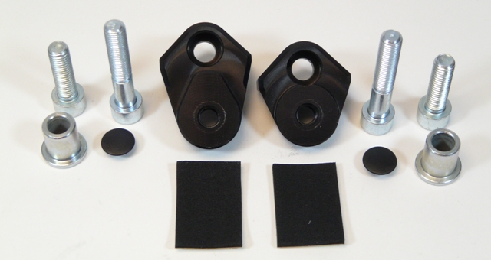

Installation – the left side:

- remove the original side plastic and the bolt M10 in the frame of the motorcycle
- use the tape 3M (No. 5) on the frame of the motorcycle in the place of the installation
- use the bolt (No. 2) for tightening of the adapter (No. 4) to the frame of the motorcycle
- give the steel box (No. 1) together with the bolt (No. 3) into the protector
- all this set you can mount into the adapter

Warning – we recommend to use safety glue on threads of all bolts (moderate strong – blue colour).

Installation – the right side:

- remove the original side plastic and the bolt M10 in the frame of the motorcycle
- use the tape 3M (No. 5) on the frame of the motorcycle in the place of the installation
- use the bolt (No. 2) for tightening of the adapter (No. 4) to the frame of the motorcycle
- give the steel box (No. 1) together with the bolt (No. 3) into the protector
- all this set you can mount into the adapter

Warning – we recommend to use safety glue on threads of all bolts (moderate strong – blue colour).

ILLUSTRATIVE PHOTOS OF Place of the installation

