Y29
Yamaha MT03

Kit for left side |  |  |  |  | Kit for right side
ID. | Description | Cat.No | Qt |  |  | ID. | Description | Cat.No | Qt
1 | Polyamid protector PM | 633 | 1 |  |  | 1 | Dural. adapter | 623 | 1
2 | Cap PM_1_2 | - | 1 |  |  | 2 | Bolt M10x12mm | 967 | 2
3 | Bolt M5x16 | 817 | 3 |  |  | 3 | Washer M10-spring | 801 | 2
 |  |  |  |  |  | 4 | Steel box M10 | X1 | 1
 |  |  |  |  |  | 5 | Bolt M10x45mm | 848 | 1
 |  |  |  |  |  | 6 | Bolt M12x80x1,25mm | 908 | 1
 |  |  |  |  |  | 7 | Dural.cylinder d=10mm | 1 | 1

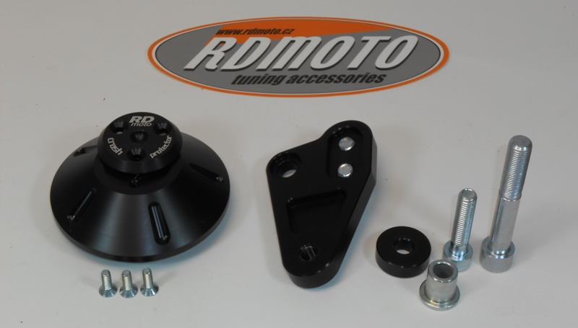

Instruction to assembly - left side:

- Take out original bolt from engine.
- Replace orignal bolt polyamid engine protector RDmoto ID.1. Don´t forget put original O-ring.
- Insert aluminium cover, for mounting use bolts ID.3

Instruction to assembly - right side:

- Take out original bolt from frame M12.
- Make assembly bolts M10x12 from back side with washers ID.3 into the dural. adapter.
- This set put on the frame and fitting it by bolt ID.6.
- Into the protector insert steel box ID.4, under the protector put dural. cylinder ID.7 and this set mounting on the adapter, use bolt ID.5

