Y2*
Yamaha YZF-R 6 1999-2002

Kit for left side: | Kit for right side:

ID | Description | Cat.N | QTY
1 | Steel sleeve | X2 | 1
2 | Al. spacer d=10mm | 174 | 1
3 | Bolt M12x80x1,25 | 908 | 1
ID | Description | Cat.N | QTY
1 | Steel sleeve | X2 | 1
2 | Al. spacer d=20mm | 175 | 1
3 | Bolt M12x100x1,25 | 911 | 1

Instruction for left side:

- Take off original bolt M12 from frame and make hole into the fairing
- Insert ID. 1 into the protector.
- Under the protector place alu. spacer ID.2. This kit mount on the frame and tighten it by bolt ID.3

Instruction for right side:

- Take off original bolt M12 from frame and make hole into the fairing
- Insert ID. 1 into the protector.
- Under the protector place alu. spacer ID.2. This kit mount on the frame and tighten it by bolt ID.3
We recomanded use glue on threads. Medium strong.
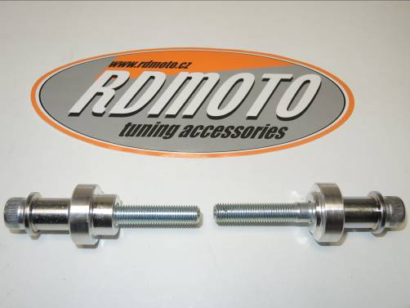
- *Is necessary to drill hole into the fairing for protectors.

1
2
2
1
3
3
