Y31SDM
Yamaha MT-09 ´14
Fittng kit left side: Fitting kit right side:
ID | Description | Cat.n | QTY
1 | Dural. bracket | 537/B | 1
2 | Dural. adapter | 12 | 1
3 | Aluminium spacer | 1127 | 1
4 | Bolt M10x110x1,25 | 928 | 1
5 | Washer M6 | 1023 | 2
6 | Bolt M6x20 | 1024 | 2
ID | Description | Cat.n | QTY
1 | Dural. bracket | 537/B | 1
2 | Dural. adapter | 10 | 1
3 | Aluminium spacer | 1127 | 1
4 | Bolt M10x85x1,25 | 934 | 1
5 | Washer M6 | 800 | 2
6 | Bolt M6x20 | 815 | 2

Instruction to assembly:
- Take out original bolt from frame.
- Insert bolt ID.4 through the dural. bracket ID.1 and dural. adapter ID.2. Into the frame insert alu spacer ID.3
- This kit assembly on the frame.
- Place slide and tighten it by bolts ID.6 and washers ID.5.

Instruction to assembly right side:
- Take out original bolt from frame.
- Insert bolt ID.4 through the dural. bracket ID.1 and dural. adapter ID.2. Into the frame insert alu spacer ID.3
- This kit assembly on the frame.
- Place slide and tighten it by bolts ID.6 and washers ID.5.

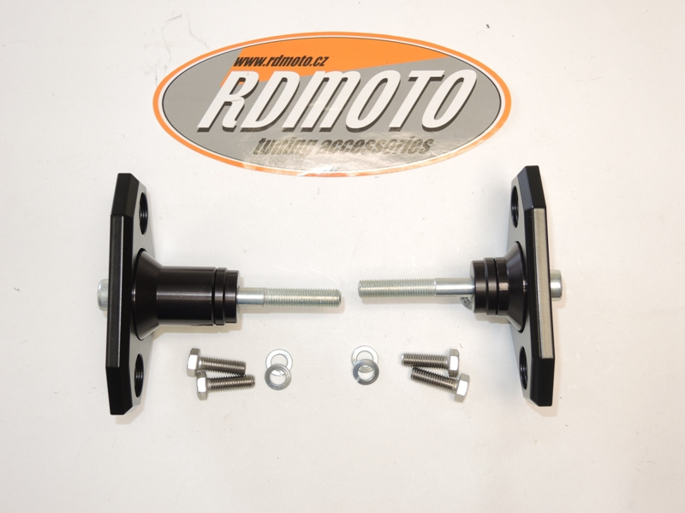

1
1

2
3
2
3
4
4

1
5

1
6

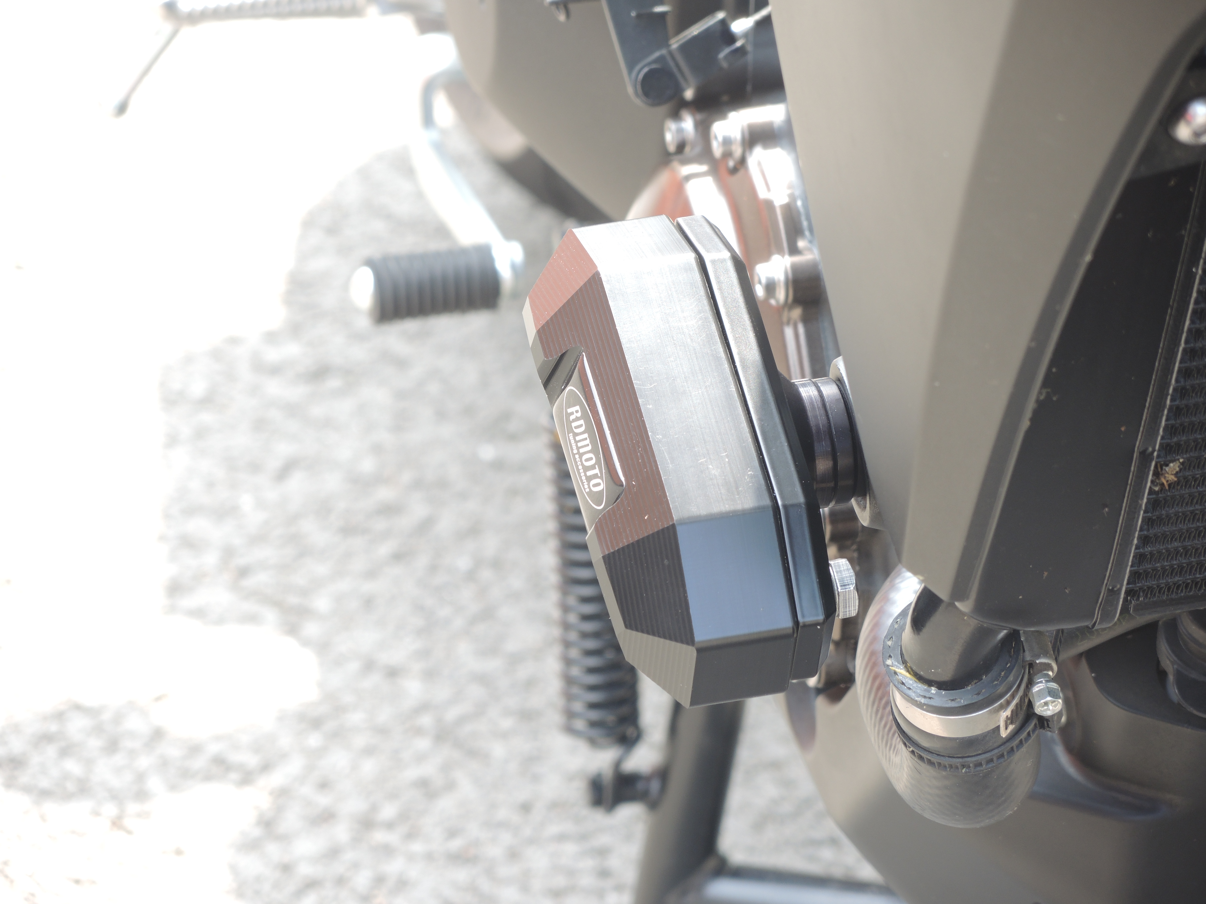

Warning: Use the glue of all threads. Medium strong.

