Y32S
Yamaha FJR1300 2013-
Kit for right side: Kit for left side:

No. | Description | Cat.no | Qt.
1 | Alu.adapter | 1137 | 1
2 | Duralumin cylinder d=62mm | 1111 | 1
3 | Bolt M12x125x1,25 | 952 | 1
4 | Bolt M4x12 | 876 | 2
5 | Bolt M6x25 | 877 | 3

No. | Description | Cat.no | Qt.
1 | Alu.adapter | 1137 | 1
2 | Duralumin cylinder d=49mm | 1110 | 1
3 | Bolt M12x115x1,25mm | 918 | 1
4 | Bolt M4x12 | 876 | 2
5 | Bolt M6x25 | 877 | 3

5
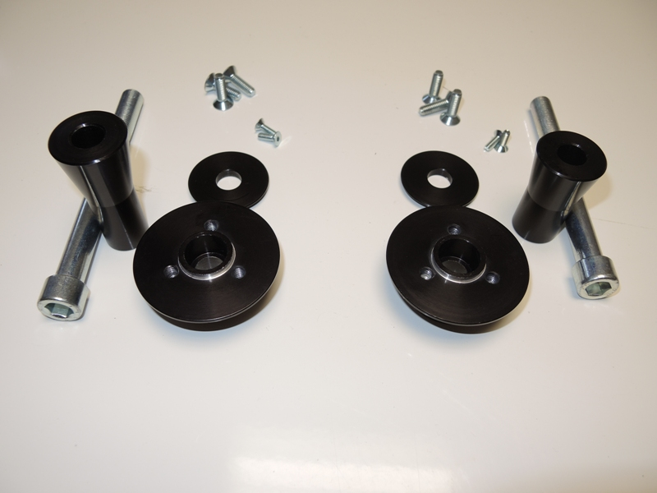
5
4
3
3

4
2

1
1

2

Installation – the right side:

1. remove the original bolt from frame
2. under the protector place dural.adapter ID.1
3. through the these adapters insert bolt ID.3 place dural. adapter ID.2 on the bolt from the back side of adapters.
4. this set mount on the frame, place sliders and tighten it by bolts ID.5. place cover and tighten it by bolt ID.4

Installation – the left side:

1. remove the original bolt from frame
2. under the protector place dural.adapter ID.1
3. through the these adapters insert bolt ID.3 place dural. adapter ID.2 on the bolt from the back side of adapters.
4. this set mount on the frame, place sliders and tighten it by bolts ID.5. place cover and tighten it by bolt ID.4

Warning – we recommend to use safety glue on threads of all bolts (moderate strong – blue colour).

(illustration photo)
