Y33SDM
Yamaha MT07 2014
Kit for leesft side: Kit for right side:
ID | Description | Cat.no | QTY
2 | Dural. Cylinder | 1115 | 1
3 | Bracket for SLD | 537 | 1
4 | Bolt M6x20 | 1024 | 2
5 | Washer M6 | 1023 | 2
6 | Bolt M12x110x1,25 | 910 | 1
ID | Description | Cat.no | QTY
2 | Dural. Cylinder | 1115 | 1
3 | Bracket for SLD | 537 | 1
4 | Bolt M6x20 | 1024 | 2
5 | Washer M6 | 1023 | 2
6 | Bolt M12x110x1,25 | 910 | 1

Instruction to assemble left side:
- Dismantle original bolt from frame.
- Insert duralumin cylinder ID2 into the frame.
- On the dural. Cylinder assemble bracket for SLD (ID3) use the bolt (ID6).
- Mounting slider (ID1) use the bolt (ID4) amd washer (ID5).

Instruction to assemble right side:
- Dismantle original bolt from frame.
- Insert duralumin cylinder ID2 into the frame.
- On the dural. Cylinder assemble bracket for SLD (ID3) use the bolt (ID6).
- Mounting slider (ID1) use the bolt (ID4) amd washer (ID5).

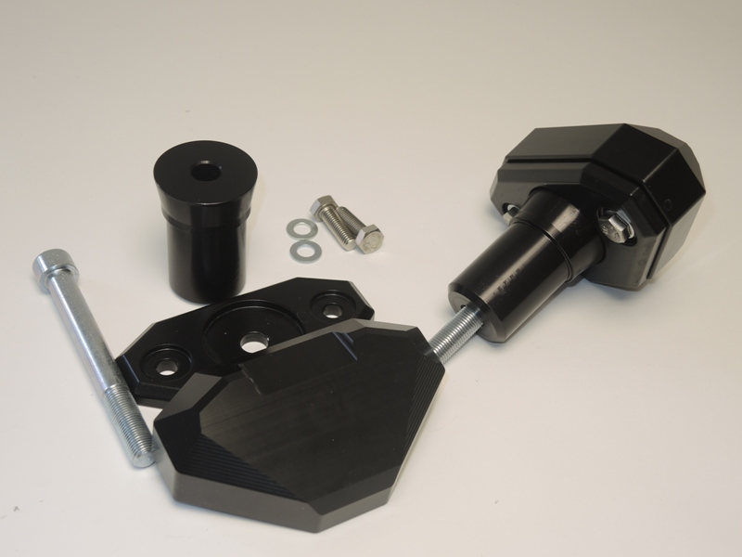
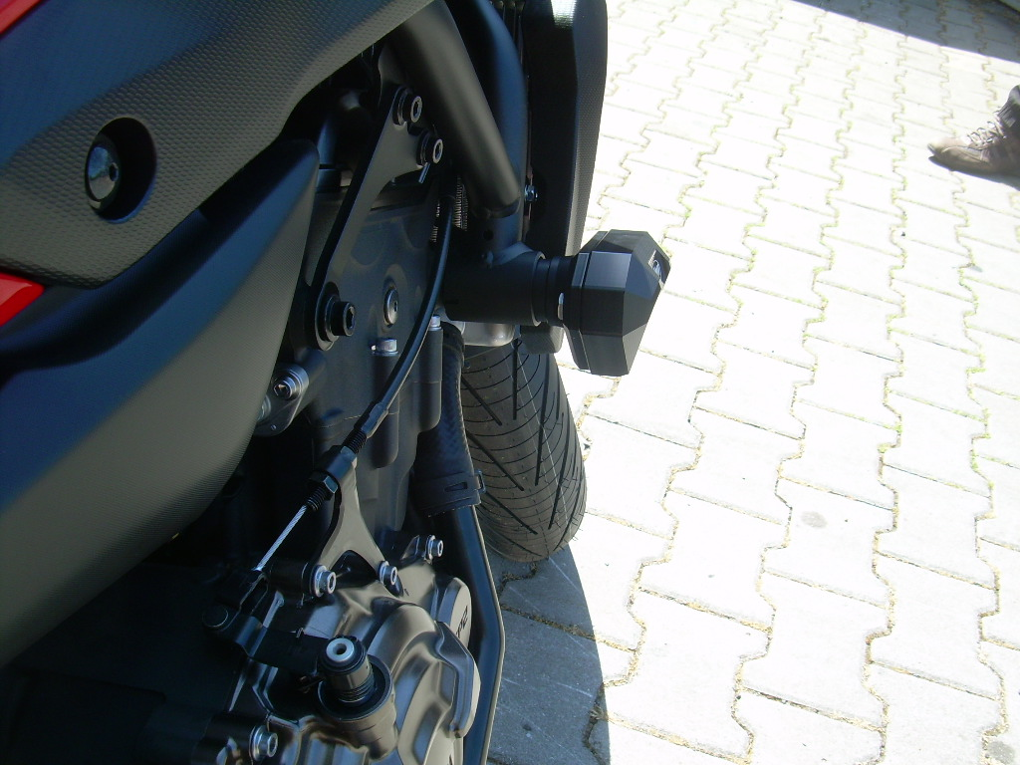
Use the glue on the all threads.
3
2
4,5
6

