Y33S
Yamaha MT07 2014
Kit for left side: Kit for right side:
ID. | Description | Cat.no | QTY
1 | Slider | SL01 | 1
2 | Dural. Cylinder | DV341 | 1
3 | Bolt M12x80x1,25 | 908 | 1
4 | Bolt M6x25 | 877 | 3
5 | Bolt M4x16 | 876 | 2
6 | Cover | cap | 1
ID. | Description | Cat.no | QTY
1 | Slider | SL01 | 1
2 | Dural. Cylinder | DV341 | 1
3 | Bolt M12x80x1,25 | 908 | 1
4 | Bolt M6x25 | 877 | 3
5 | Bolt M4x16 | 876 | 2
6 | Cover | cap | 1
Instructions to assemble left side:
- Dismantle original bolt from frame.
- Insert the dural.cylinder (ID2) into the frame .
- Use the bolt M12x80 (ID3) and mounting slider (ID1) for this mounting use bolts (ID4).
- Cover (ID6) into the slider and use the bolts M4 (ID5).

Instruction to assemble right side:
- Dismantle original bolt from frame.
- Insert the dural.cylinder (ID2) into the frame .
- Use the bolt M12x80 (ID3) and mounting slider (ID1) for this mounting use bolts (ID4).
- Cover (ID6) into the slider and use the bolts M4 (ID5).
3
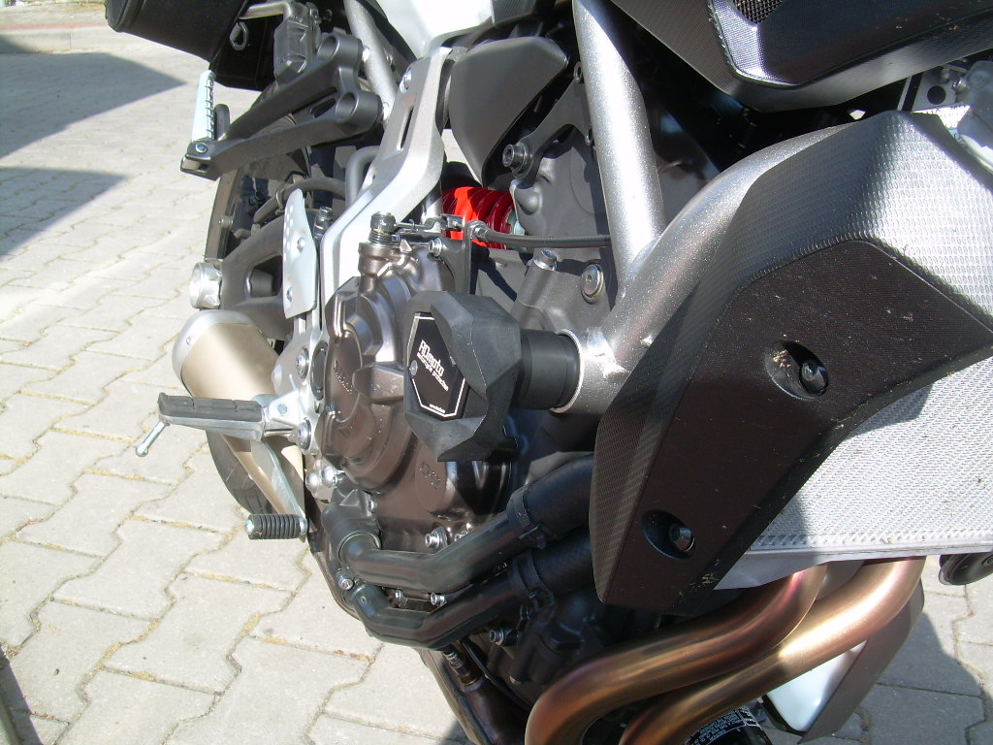
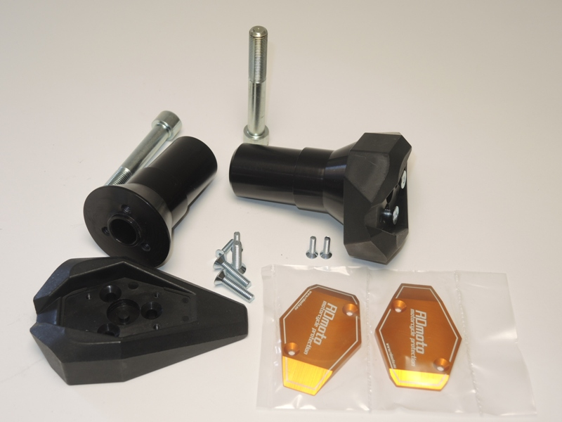
Use the glue on threads for all connects.
2
1
4

