Y34SD
Yamaha R3/250 ´14-

Kit for left side: Kit for right side:
ID | Description | Cat.N | QTY
1 | Bolt M10x90x1,25 | 890 | 1
2 | Bolt M10x85x1,25 | 934 | 1
3 | Dural. spacer 21mm | 1163 | 1
4 | Dural. spacer 30mm | DV3 | 1
5 | Dural. bracket | 686 | 1
6 | Dural. adapter 60mm | DV14 | 1
7 | Dural holder pro SLD | 537 | 1
8 | Bolt M10x85 | 981 | 1
9 | Bolt M8x25 | 815 | 2
10 | Washer M8 | 800 | 2
ID | Description | Cat.N | QTY
1 | Bolt M10x90x1,25 | 890 | 1
2 | Bolt M10x85x1,25 | 934 | 1
3 | Dural. spacer 21mm | 1163 | 1
4 | Dural. spacer 30mm | DV3 | 1
5 | Dural. bracket | 687 | 1
6 | Dural. adapter 60mm | DV14 | 1
7 | Dural holder pro SLD | 537 | 1
8 | Bolt M10x85 | 981 | 1
9 | Bolt M8x25 | 815 | 2
10 | Washer M8 | 800 | 2

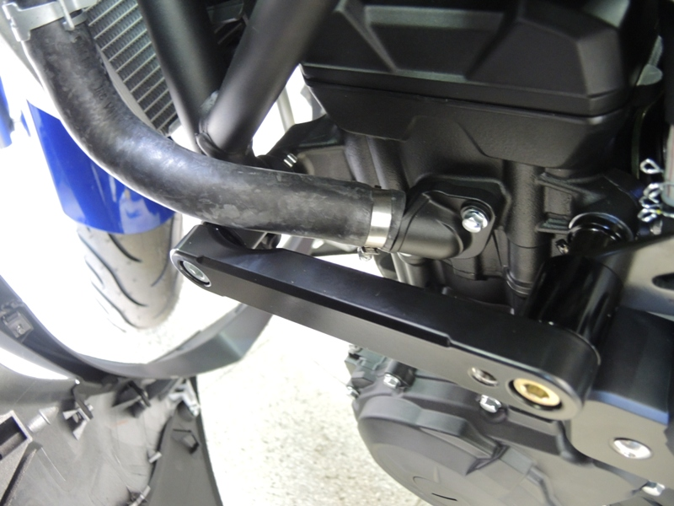
1

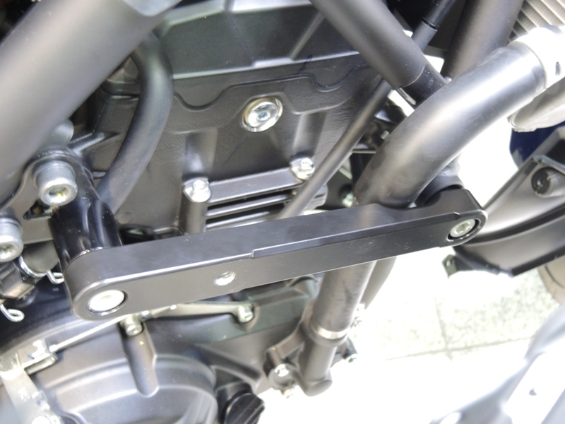

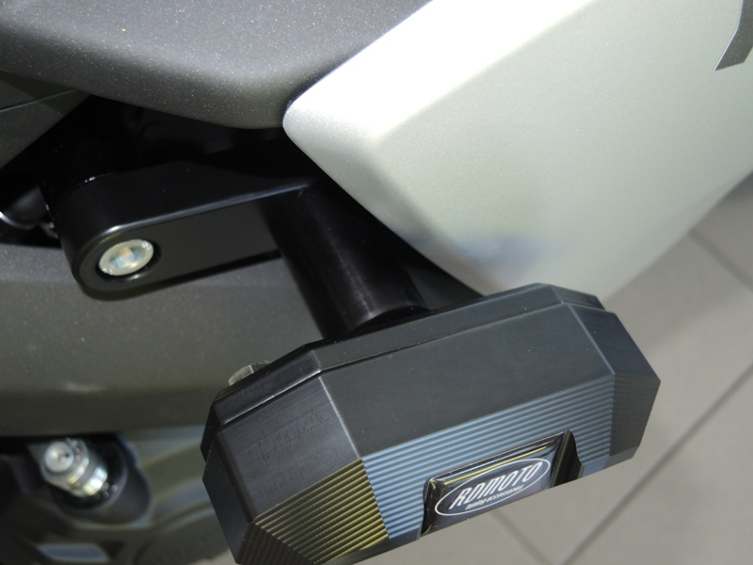

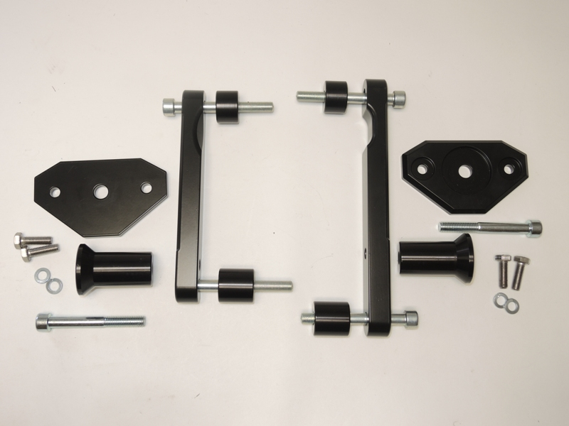
1
3
3
5
5
7
7
1
9,10
6
6
2
4
2
8
8
4
9,10

Instructions:

- Remove fairing from the left side. Remove left side original bolts from the frame according to the picture.
- Prepare dural spacer ID3 and ID4. Insert these dural spacers between frame and dural bracket ID5. Tighten dural bracket using screws ID1 and ID2 according to the picture.
- Put fairing back.
- Remove fairing from the right side. Remove right side original bolts from the frame according to the picture.
- Prepare dural spacer ID3 and ID4. Insert these dural spacers between frame and dural bracket ID5. Tighten dural bracket using screws ID1 and ID2 according to the picture.
- Thighten both bolts and put fairing back of the bike.
- For both sides:
  - Fit dural adapter ID6 and dural holder for SLD ID7 on the bracket ID7 using one bolt ID8.
  - In the end fit slider using bolts ID9 and washers ID10.

Warning: We recommend use the glue of all threads. Medium strong.

