Y34S
Yamaha R3/250 ´14-

Kit for left side: Kit for right side:
ID | Description | Cat.N | QTY
1 | Bolt M10x90x1,25 | 890 | 1
2 | Bolt M10x85x1,25 | 934 | 1
3 | Dural. spacer 21mm | 1163 | 1
4 | Dural. spacer 30mm | DV3 | 1
5 | Dural. bracket | 686 | 1
6 | Dural. adapter | 318 | 1
7 | Bolt M10x30 | 882 | 1
8 | Bolt M6x25 | 877 | 3
9 | Bolt M4x16 | 876 | 2
ID | Description | Cat.N | QTY
1 | Bolt M10x90x1,25 | 890 | 1
2 | Bolt M10x85x1,25 | 934 | 1
3 | Dural. spacer 21mm | 1163 | 1
4 | Dural. spacer 30mm | DV3 | 1
5 | Dural. bracket | 687 | 1
6 | Dural. adapter | 318 | 1
7 | Bolt M10x30 | 882 | 1
8 | Bolt M6x25 | 877 | 3
9 | Bolt M4x16 | 876 | 2

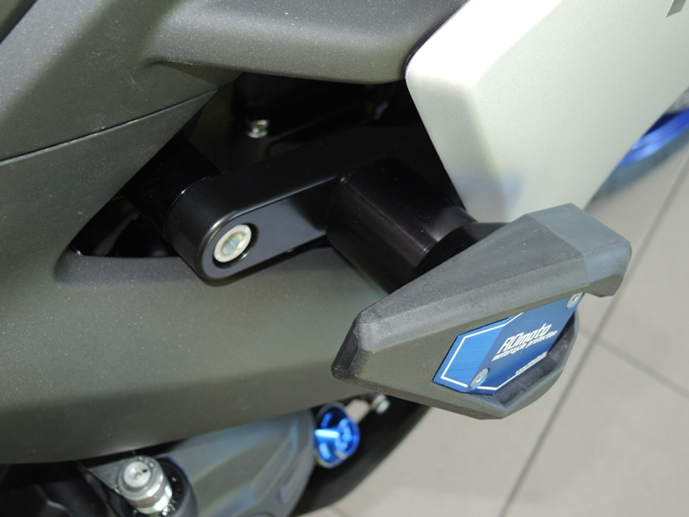
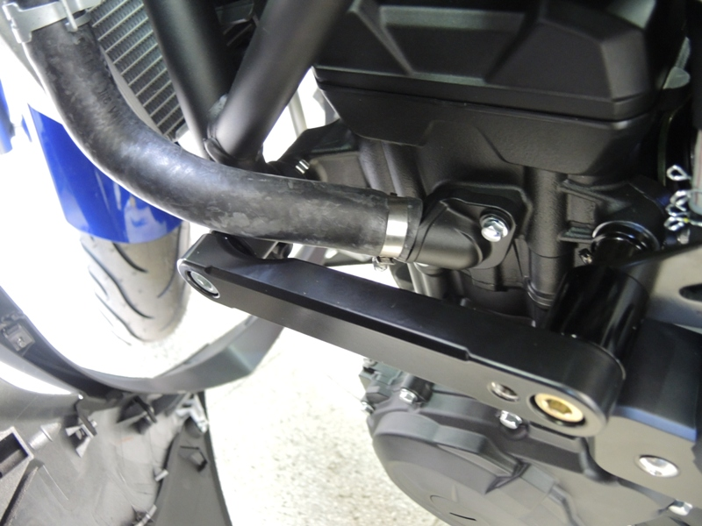
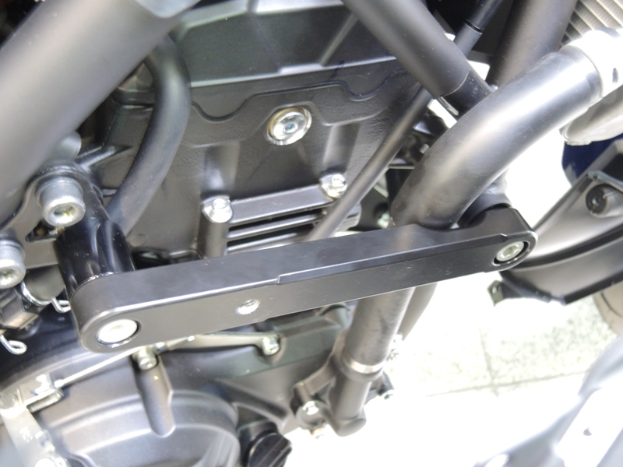
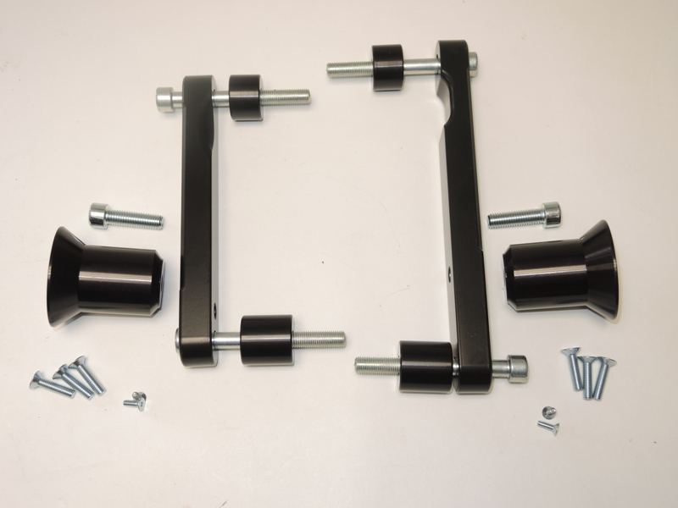
3
3
1
1

5
7
7
5
6
6

4
2

8
8
9

2

4
9

Instruction to assembly:

- Remove left side fairing of the bike. Remove left side original bolts of the frame as shown arraws on the picture.
- Put dural. spacer ID.3 into the frame (front) and sligtly tighten bolt ID.1. Between the dural. bracket ID.5 and engine bracket insert spacer ID.4. Use bolt ID.2.
- Thighten both bolts and put fairing back of the bike.
- Remove right side fairing of the bike. Remove right side original bolts of the frame as shown arraws on the picture.
- Put dural. spacer ID.3 into the frame (front) and sligtly tighten bolt ID.1. Between the dural. bracket ID.5 and engine bracket insert spacer ID.4. Use bolt ID.2.
- Thighten both bolts and put fairing back of the bike.
- Left side: For mounting dural. adapter ID.6 use bolt ID.7. Put slider on the adapter and tighten it by bolts ID.8. Insert aluminum cover and tighten it by bolts ID.9. Right side: For mounting dural. adapter ID.6 use bolt ID.7. Put slider on the adapter and tighten it by bolts ID.8. Insert aluminum cover and tighten it by bolts ID.9.
Warning: We recommend use the glue of all threads. Medium strong.

