Y34
Yamaha R3/250 ´14-

Kit for left side: Kit for right side:
ID | Description | Cat.N | QTY
1 | Bolt M10x90x1,25 | 890 | 1
2 | Bolt M10x85x1,25 | 934 | 1
3 | Dural. spacer 21mm | 1163 | 1
4 | Dural. spacer 30mm | DV3 | 1
5 | Dural. bracket | 686 | 1
6 | Dural.spacer 40mm | DV4 | 1
7 | Bolt M10x80 | 852 | 1
8 | Steel box | X1 | 1
ID | Description | Cat.N | QTY
1 | Bolt M10x90x1,25 | 890 | 1
2 | Bolt M10x85x1,25 | 934 | 1
3 | Dural. spacer 21mm | 1163 | 1
4 | Dural. spacer 30mm | DV3 | 1
5 | Dural. bracket | 687 | 1
6 | Dural.spacer 40mm | DV4 | 1
7 | Bolt M10x80 | 852 | 1
8 | Steel box | X1 | 1

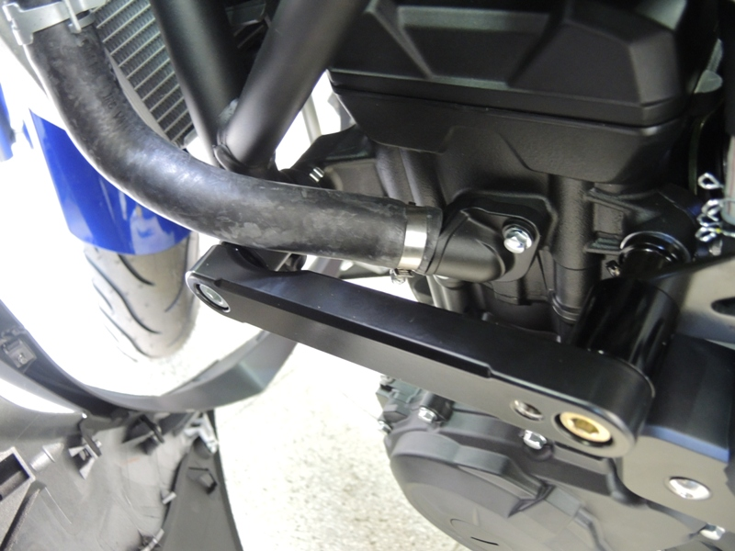
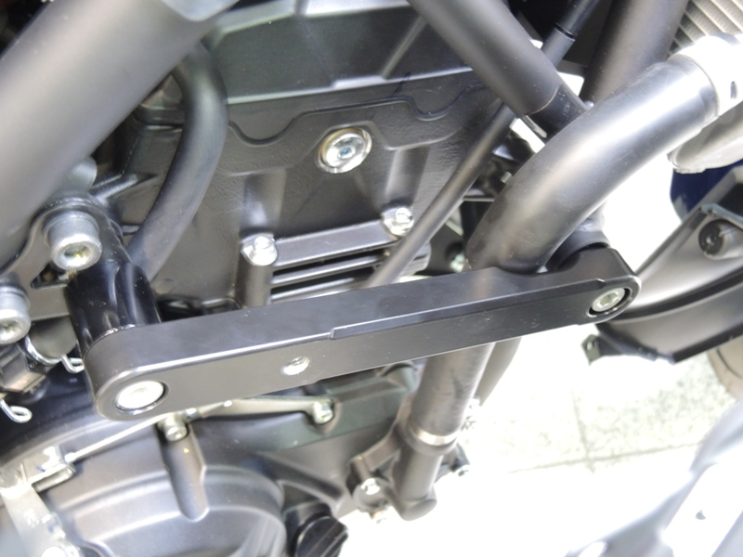
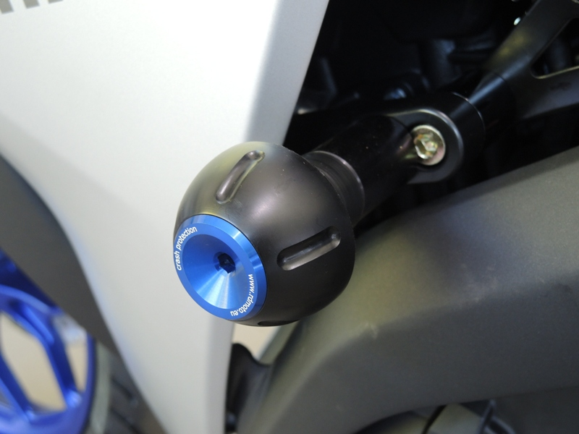
6
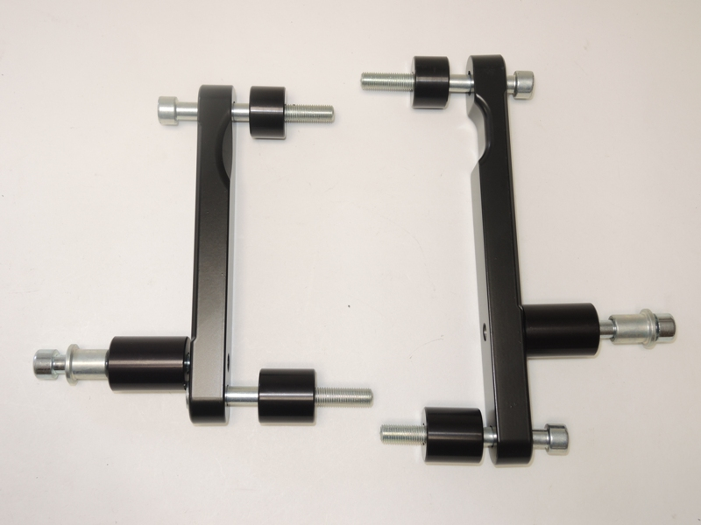
3
3
1

1

5

5

6
8
6
8
7
4
7

2

2

4

Instruction to assembly:

- Remove left side fairing of the bike. Remove left side original bolts of the frame as shown arrows on the picture.
- Put dural. spacer ID.3 into the frame (front) and slightly tighten bolt ID.1. Between the dural. bracket ID.5 and engine bracket insert spacer ID.4. Use bolt ID.2.
- Thighten both bolts and put fairing back of the bike.
- Remove right side fairing of the bike. Remove right side original bolts of the frame as shown arrows on the picture.
- Put dural. spacer ID.3 into the frame (front) and slightly tighten bolt ID.1. Between the dural. bracket ID.5 and engine bracket insert spacer ID.4. Use bolt ID.2.
- Thighten both bolts and put fairing back of the bike.
- Left side: Insert steel box ID.8 with bolt ID.7 into the protecotr, under the protector put dural. spacer ID.6. This kit assembly on the dural.bracket.
- Right side: Insert steel box ID.8 with bolt ID.7 into the protecotr, under the protector put dural. spacer ID.6. This kit assembly on the dural.bracket.

Warning: We recommend use the glue of all threads. Medium strong.

