Y35S
Yamaha MT-09 Tracer´14-

Fitting kit left side: Fitting kit right side:
ID | Description | Cat.n | Qt
1 | Bolt M6x25 | 877 | 3
2 | Bolt M4x16 | 876 | 2
3 | Dural.spacer d=25 | 1126 | 1
4 | Bolt M10x95x1,25 | 927 | 1
5 | Dural. adapter | 292 | 1
ID | Description | Cat.n | Qt
1 | Bolt M6x25 | 877 | 3
2 | Bolt M4x16 | 876 | 2
3 | Dural.spacer d=13 | 1127 | 1
4 | Bolt M10x65x1,25 | 945 | 1
5 | Dural. adapter | 292 | 1

Instruction to assembly:
- Take out off original bolt from frame.
- Left hand side:
- Bolt ID.4 insert trough the dural.adapter ID.5.
- Place dural spacer ID.3 on the bolt.
- Place spacer ID.3 into the frame.
- Assembly bolt with kit of adapters into the frame.
- Take bolts ID.1 and mounting slider. Into the protector insert alu. cap and tighten it by bolts ID.2.
- Take out off original bolt from frame.
- Right hand side:
- Bolt ID.4 insert trough the dural.adapter ID.5.
- Place spacer ID.3 into the frame.
- Assembly bolt with kit of adapters into the frame.
- Take bolts ID.1 and mounting slider. Into the protector insert alu. cap and tighten it by bolts ID.2.
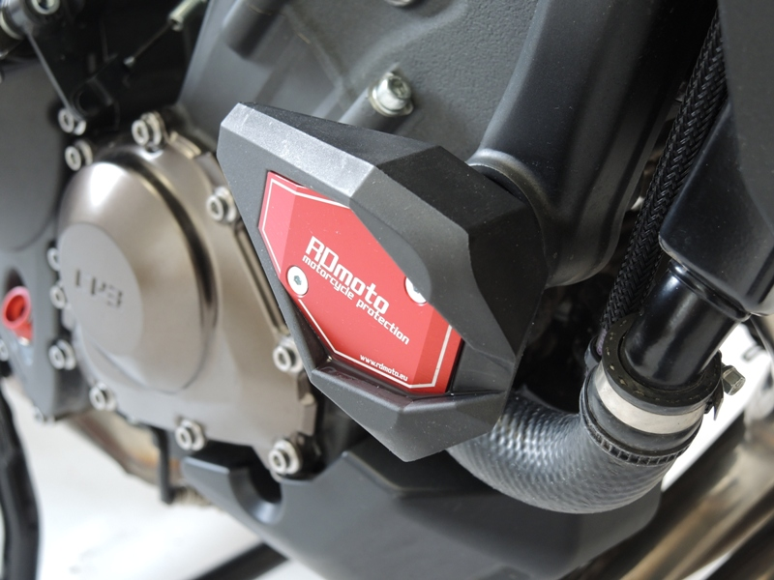

Use medium glue of all threads.

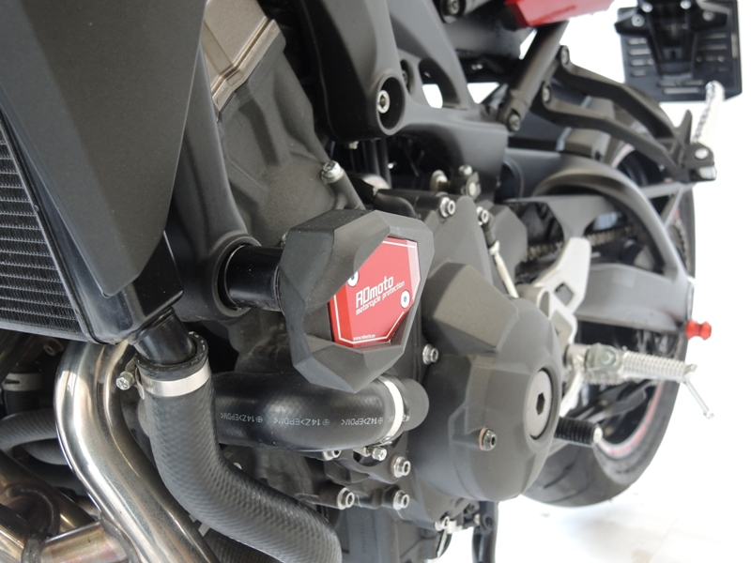

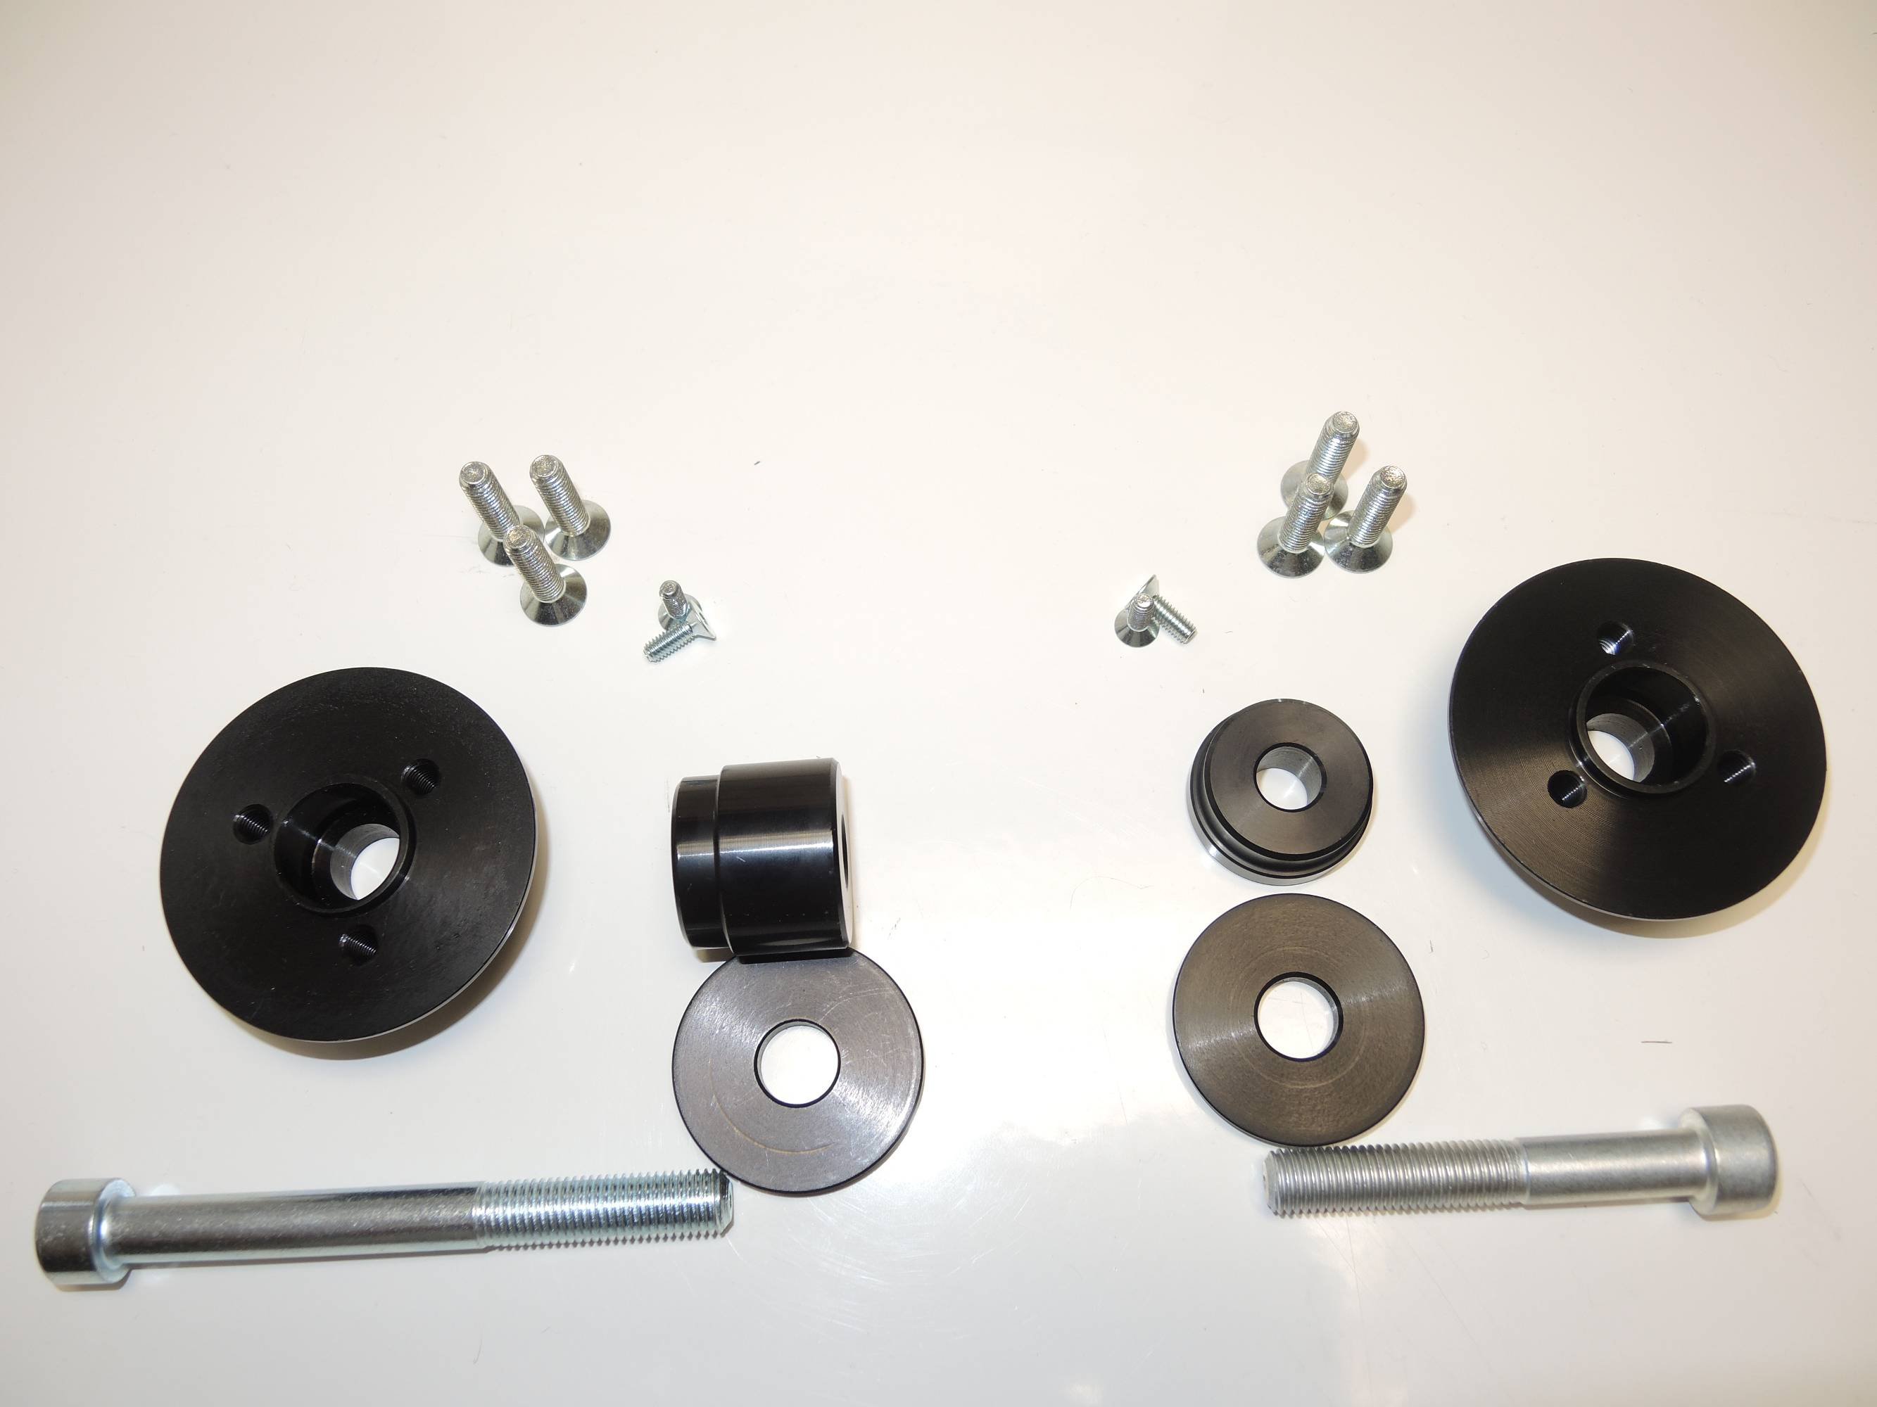
4
2
2
1
1
4
3
5
5
3

