Y36SDM
Yamaha R1 2015

Kit for left side: Kit for right side:
ID | Description | Cat.N | QTY
1 | Dural.bracket for SLD | 537/B | 1
2 | Bolt M12x110x1,25 | 910 | 1
3 | Alu.spacer d=60mm | 152 | 1
4 | Bolt M6x20 | 1024 | 2
5 | Washer M6 | 1023 | 2
ID | Description | Cat.N | QTY
1 | Dural.bracket for SLD | 537/B | 1
2 | Bolt M12x90x1,25 | 931 | 1
3 | Alu. spacer d=35mm | 153 | 1
4 | Bolt M6x20 | 1024 | 2
5 | Washer M6 | 1023 | 2
6 | Dural. roller d=5mm | 1260 | 1

Instruction to assembly:

- The first do assembly left side.
- Please leave all spacer´s/bushes in place.
- Take the dural. bracket ID.1 for left side, insert bolt ID.2 through the bracket and aluminum spacer ID.3.
- This kit gripping on the frame.
- Place slider and for tighten take bolts ID.4 and washers ID.5
- Mounting instruction for right side.
- Please leave all spacer´s/bushes in place.
- Take the dural. bracket ID.1, insert bolt ID.2 through the bracket and aluminum spacer ID.3.
- Gripping it on the frame.
- Place slider and for tighten take bolts ID.4 and washers ID.5
- For the right position and assembly check the pictures.

Warning: We recommend use the glue of all threads. Medium strong.
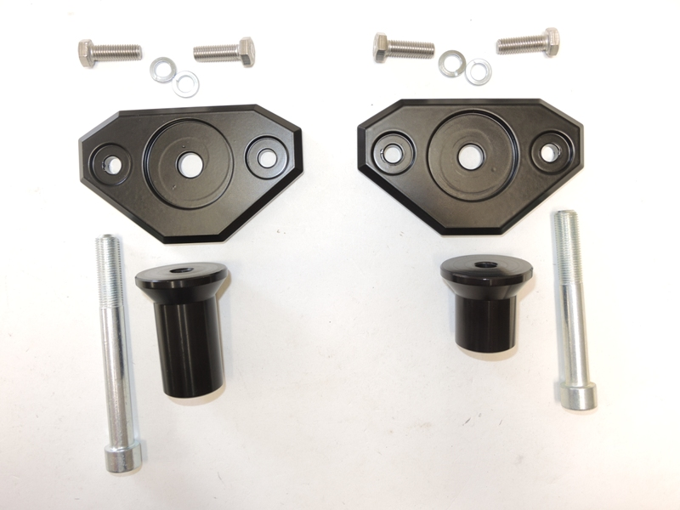
1
3
2
1
2
3
4
4
5
5
