Y36S
Yamaha R1 2015

Kit for left side: Kit for right side:
ID | Description | Cat.N | QTY
1 | Alu. spacer for SL | 348 | 1
2 | Bolt 12x95x1,25 | 900 | 1
3 | Bolt M6x25 | 877 | 3
4 | Bolt M4x16 | 876 | 2
ID | Description | Cat.N | QTY
1 | Alu. spacer for SL | 1137 | 1
2 | Bolt M12x60x1,25 | 916 | 1
3 | Bolt M6x25 | 877 | 3
4 | Bolt M4x16 | 876 | 2
5 | Alu. Roller d=5mm | 1260 | 1

Instruction to assembly:

- The first do assembly left side.
- Take off Orignal bolt.
- Leave all spacer´s/bushes in place.
- Take the alu. spacer ID.1 for left side, insert bolt ID.2 into the spacer ID.1.
- This kit gripping on the frame and tighten.
- Place slide and tighten it by bolts ID.3, place alu. cover into the slider use bolts ID.4.
- Mounting instruction for right side.
- Take off Orignal bolt.
- Please leave all spacer´s/bushes in place.
- Take the alu. spacer ID.1 for right side insert bolt ID.2 into this kit.
- This kit gripping on the frame and tighten.
- Place slide and tighten it by bolts ID.3, place alu. cover into the slider use bolts ID.4.

Warning: We recommend use the glue of all threads. Medium strong.

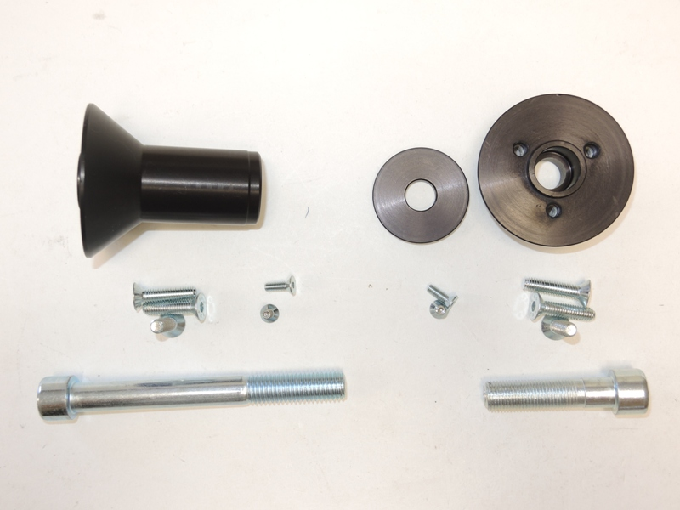

1
1

3
4
4

3
5
2
