Y37SDM
Yamaha FZ-1

Kit for left side: Kit for right side:
ID | Description | Cat.N | Qt
1 | Alu. holder | 697 | 1
2 | Spacer d=20 | 435 | 1
3 | Bolt M10x70x1,25 | 898 | 1
4 | Washer M10 | 804 | 1
5 | Plastic cap | X4 | 1
6 | 3M Tape | 3M | 1
7 | Bolt M10x35 | 847 | 1
8 | Alu. spacer for slider | 9 | 1
9 | Alu. holder for SLDM | 537/B | 1
10 | Bolt M6x20 | 1024 | 2
11 | Washer M6 | 1023 | 2
ID | Description | Cat.N | Qt
1 | Alu. holder | 696 | 1
2 | Spacer d=20 | 435 | 1
3 | Bolt M10x70x1,25 | 898 | 1
4 | Washer M10 | 804 | 1
5 | Plastic cap | X4 | 1
6 | 3M Tape | 3M | 1
7 | Bolt M10x35 | 847 | 1
8 | Alu. spacer for slider | 9 | 1
9 | Alu. holder for SLDM | 537/B | 1
10 | Bolt M6x20 | 1024 | 2
11 | Washer M6 | 1023 | 2

Assembly instruction:

- Dismantle orig. bolts M10 from chassi.
- Place alu. spacers ID.2 into the chassi hole.
- Alu. adapters ID. grip on the chassi by bolts and washers ID.3, ID.4.
- You can stick 3M tape on the chassi in touching place.
- Stainless pin has to be fixed, it´s save protector station during crash.
- Bolt ID.7 insert throught the alu. holder ID.9 and spacer ID.8. This kit assembly.
- Place slider and fix it by bolts ID.10 and washer ID.11.
Done left side first.
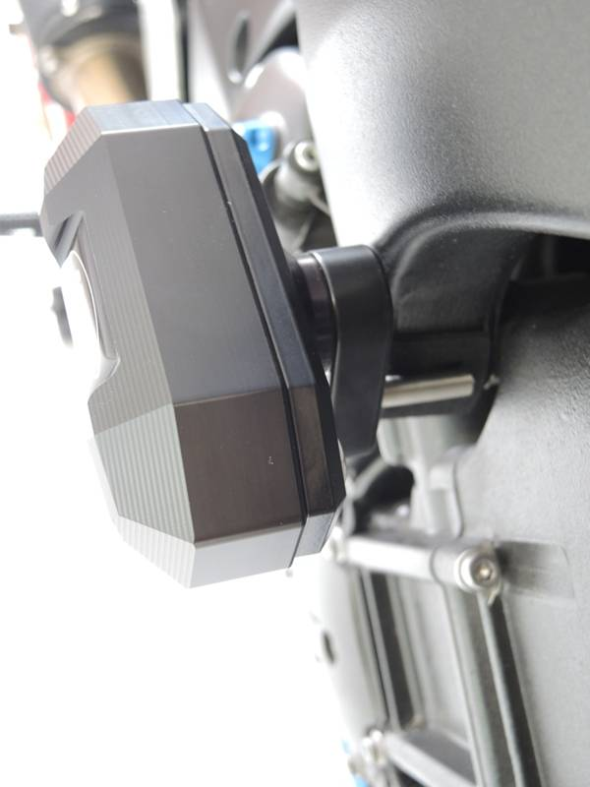
Use medium strong glue for threads during assembly.
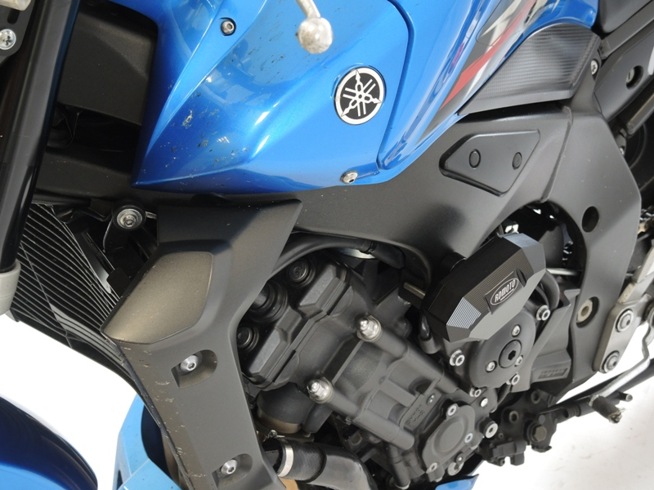
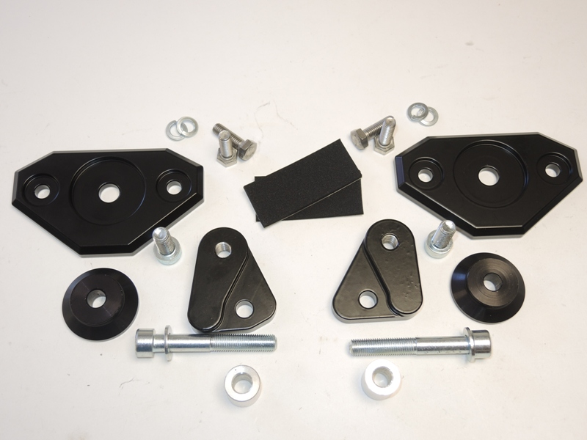
1
8
6
1
8
2
4
3
10
9
7
4
2
7
3
9
10
11
11

