Y37S
Yamaha FZ-1

Kit for the left side | Kit for the right side

ID | Description | Cat.no. | Pcs
1 | Dural. adapter | 697 | 1
2 | Dural. cylinder 20 mm | 435 | 1
3 | Bolt M10x70x1,25 | 898 | 1
4 | Washer M10 | 804 | 1
5 | Plastic cover | X4 | 1
6 | 3M tape | 3M | 1
7 | SL01 adapter | 317 | 1
8 | Bolt M10x25 | 868 | 1
9 | Bolt M6x25 | 877 | 3
10 | Bolt M4x16 | 876 | 2
ID | Description | Cat.no. | Pcs
1 | Dural. adapter | 696 | 1
2 | Dural. cylinder 20 mm | 435 | 1
3 | Bolt M10x70x1,25 | 898 | 1
4 | Washer M10 | 804 | 1
5 | Plastic cover | X4 | 1
6 | 3M tape | 3M | 1
7 | SL01 adapter | 317 | 1
8 | Bolt M10x25 | 868 | 1
9 | Bolt M6x25 | 877 | 3
10 | Bolt M4x16 | 876 | 2

Instructions:

- Remove original bolt M10 from the frame of motorcycle.
- Stick 3M tape on the frame.
- Insert cylinder ID2 into the frame.
- Insert bolt ID3 with washer ID4 into the adapter ID1.
- Mount this kit into the frame.
- Insert bolt ID8 into the dural adapter ID7 and mount this kit on the adapter ID1.
- Fit slider using three bolts ID9.
- Fit coloured cover using two bolts ID10.
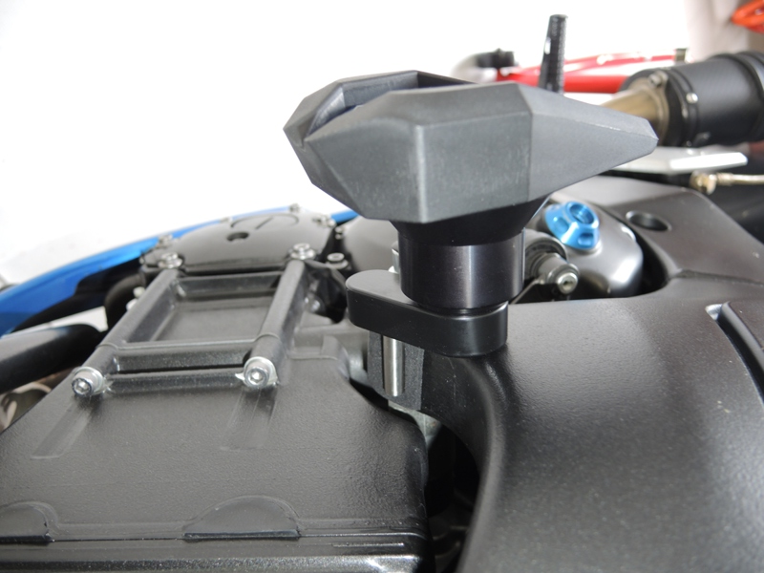

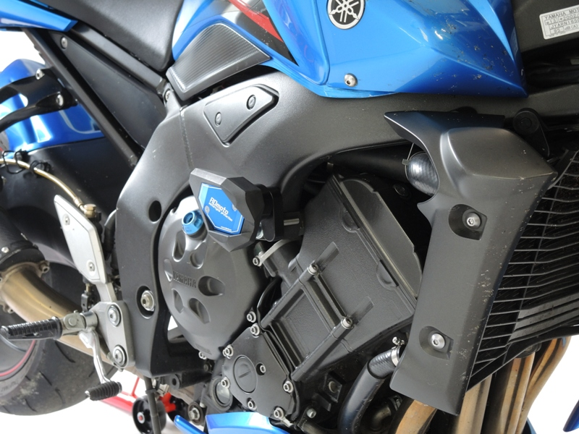

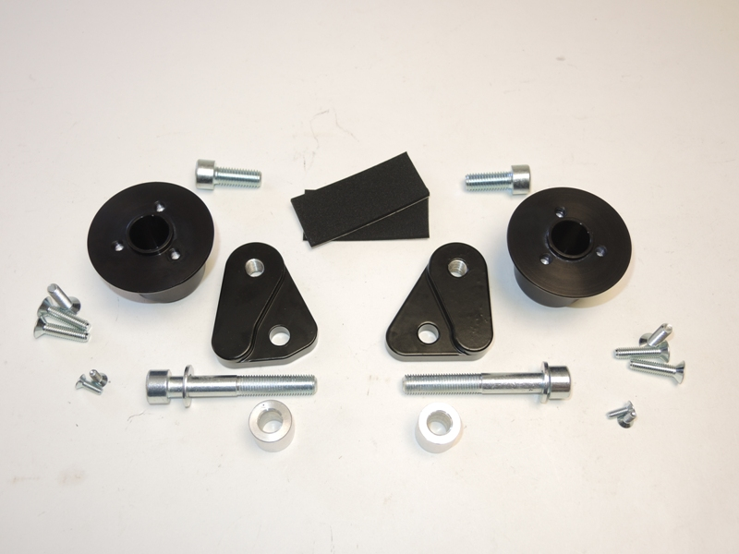
1
8
6
1
8
2
4
3
10
9
7
4
2
7
3
9
10

We recommend to use the glue on all threads (medium strong).

