Y37
Yamaha FZ-1

Kit for the left side: Kit for the right side:
ID | Description | Cat.N | Qt
1 | Alu. bracket | 697 | 1
2 | Alu. spacer d=20 | 435 | 1
3 | Bolt M10x70x1,25 | 898 | 1
4 | Washer M10 | 804 | 1
5 | Plastic cap | X4 | 1
6 | 3M tape | 3M | 2
7 | Bolt M10x35 | 847 | 1
8 | Steel box | X1 | 1
ID | Description | Cat.N | Qt
1 | Alu. bracket | 696 | 1
2 | Alu. spacer d=20 | 435 | 1
3 | Bolt M10x70x1,25 | 898 | 1
4 | Washer M10 | 804 | 1
5 | Plastic cap | X4 | 1
6 | 3M tape | 3M | 2
7 | Bolt M10x35 | 847 | 1
8 | Steel box | X1 | 1

Assembly instruction:

- Dismantle original bolt M10 from chassi. Make assembly for the left side firstly.
- Place alu. spacer ID.2 into the chassi. Wher is the alu holder touching together chassi, stick 3M tape.
- Place bolt ID.3 and washer ID.4 into the adapter ID.1.
- Wher is a steel pin touching with chassi, stick 3M tape.
- Steel pin rest on chassi and tighten bolt.
- Insert steel box into the protector ID.8 with bolt ID.7.
- Make protectors assembly.

Same assembly make on the oposite site.

Note: Use thread glue on the all bolts. Medium strong.

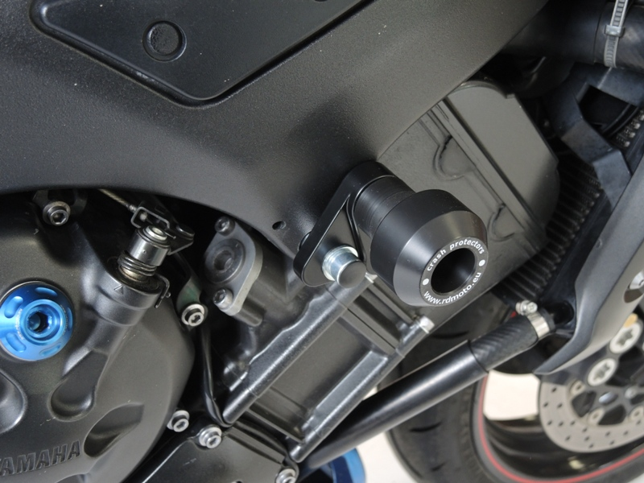
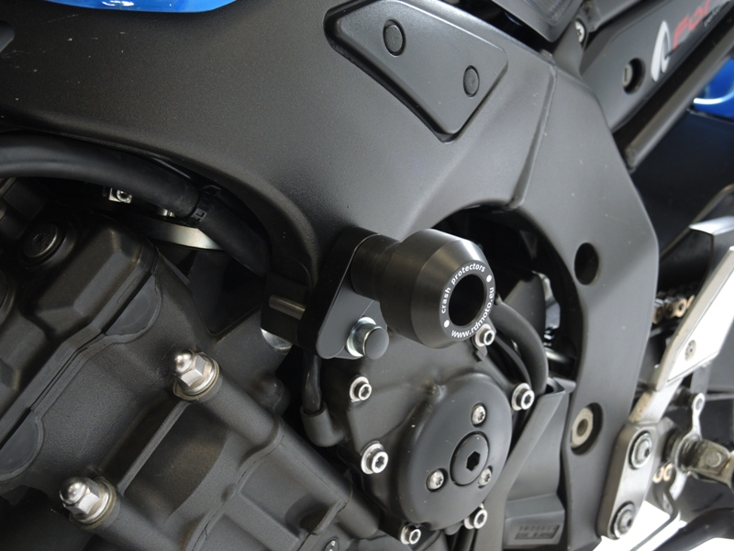

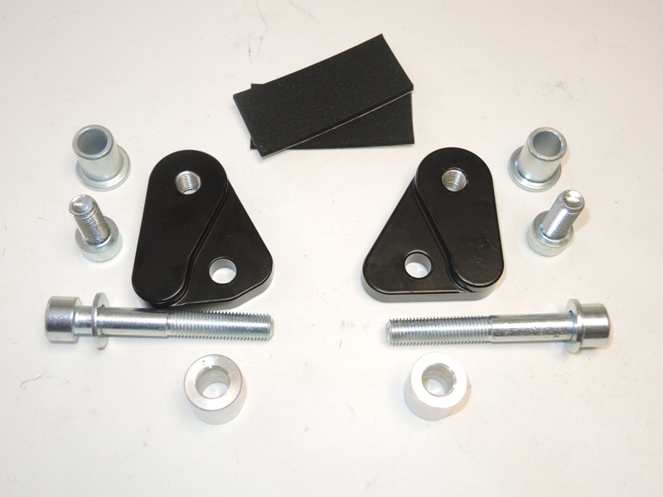
1
8
6
1
8
2
4
3
7
4
2
7
3

