Y38
Yamaha MT 125

Kit for left side: Kit for right side:
ID | Popis | Cat.no | pcs
1 | steel threaded insert | X17 | 1
2 | screw M12x45 | 859 | 1
3 | dural roller d=15 | 149 | 1
4 | dural roller d=73,5 | 1176 | 1
5 | dural roller d=5 | 16 | 1
6 | dural adapter for protector | 576 | 1
7 | washer M10 | 804 | 1
8 | nut M10 | 810 | 1
9 | stainless steel connecting rod M10x310mm |  | 1
ID | Popis | Cat.no | Pcs
1 | steel threaded insert | X17 | 1
2 | screw M12x45 | 859 | 1
3 | dural roller d=15 | 149 | 1
4 | dural roller d=80 | 1175 | 1
5 | dural roller d=5 | 16 | 1
6 | dural adapter for protector | 575 | 1
7 | washer M10 | 804 | 1
8 | nut M10 | 810 | 1
9 | Hollow screw | 219 | 1
10 | nut M16 | 994 | 1

Instructions:
- Dismantle plastic cover of chain. Modify plastic cover of chain same as in the first picture.
- Dismantle screw M10 which is placed through engine.
- Loosen the lower screw on the frame which passes through the swing arm. It is not necessary to remove from the frame.
- Through engine pass stainless steel rod ID.9. On the left side put on roller ID.4. Also on the right side put on roller ID.4. Fit chain cover back.
- On the dural adapters for protectors ID.6 fit protectors (on both sides).
- On both sides place dural reduction ID.3. Pass screw ID.2 from the back side. Tighten protectors with special steel threaded instert ID.1.
- On the lower screw on the left side place protector holder. On the right side tighten this screw with hollow screw ID.9. Place protectore holder on your motorcycle. Tighten the nut ID.10.
- Place dural rollers on both sides ID.5 on the stainless steel rod ID.9. Than place washers M10 ID.7 on the rod. Tighten all with nuts ID.8.
- Tighten all screws.

We recommend use the glue for all threads. Medium strong.

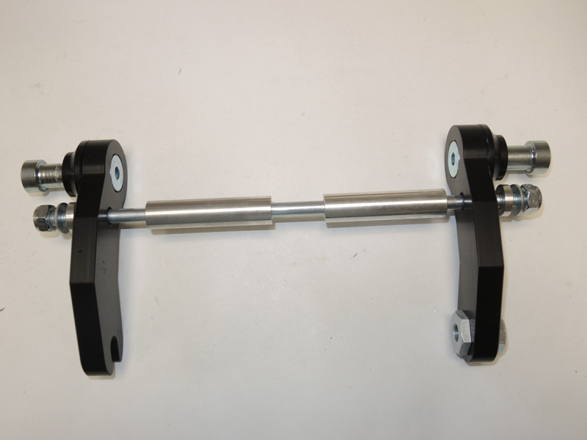
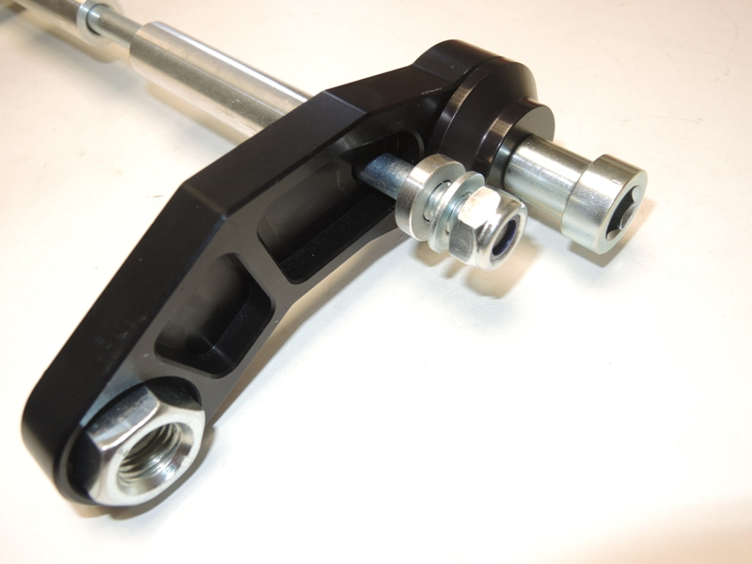
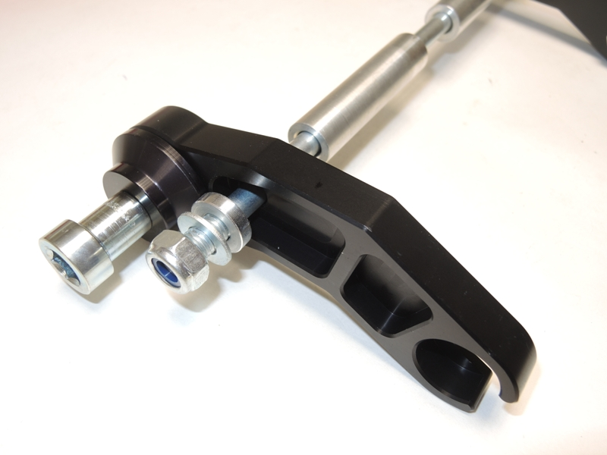
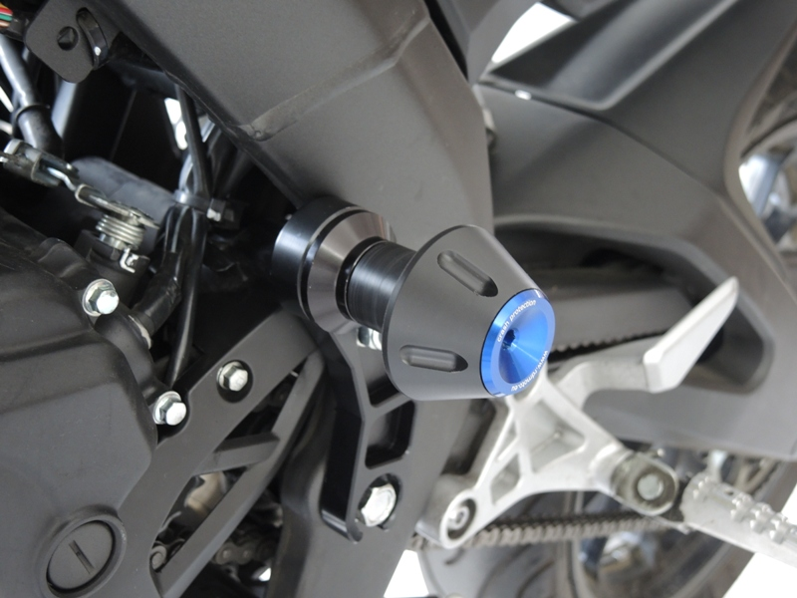
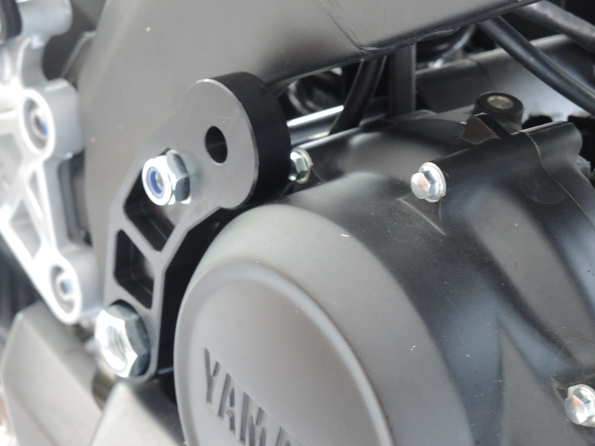
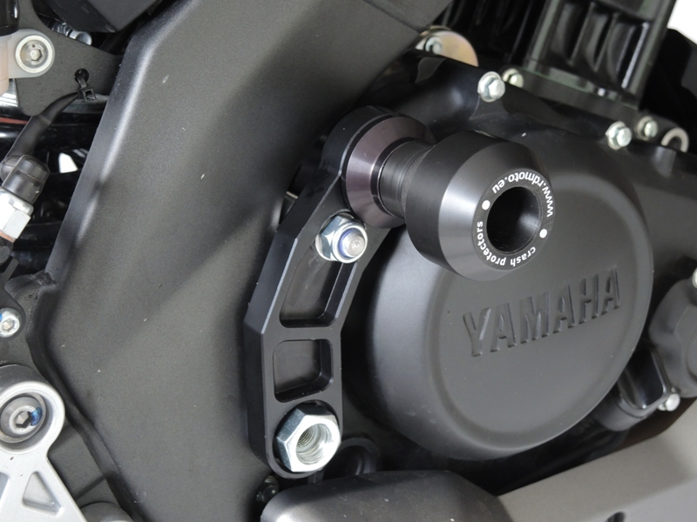
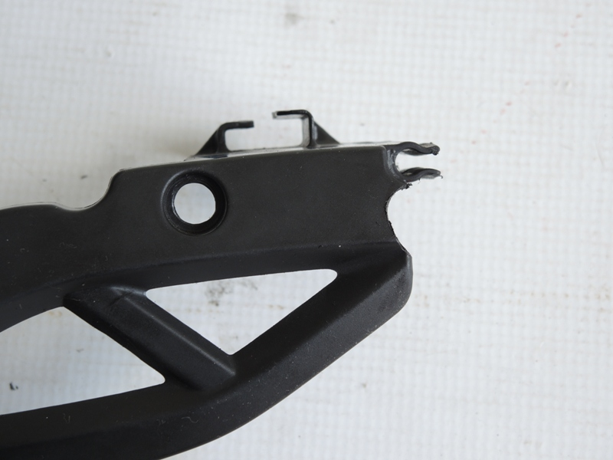
Modify here
3
1
8
7
6
5
4
2
2
4

6
3
1
8
7
5
10

9
9

