Y39
Yamaha BT 1100 Buldog

Fitting kit:

ID. | Description | Cat.N | Qty
1 | Dural.spacer | 1173 | 2
2 | Alu.roller with thread | 1174 | 2
3 | Rubber O-Ring | 25/5 | 2
4 | Bolt M10x60 | 850 | 2
5 | Washer spring M10 | 801 | 2
6 | Steel box | X1 | 2

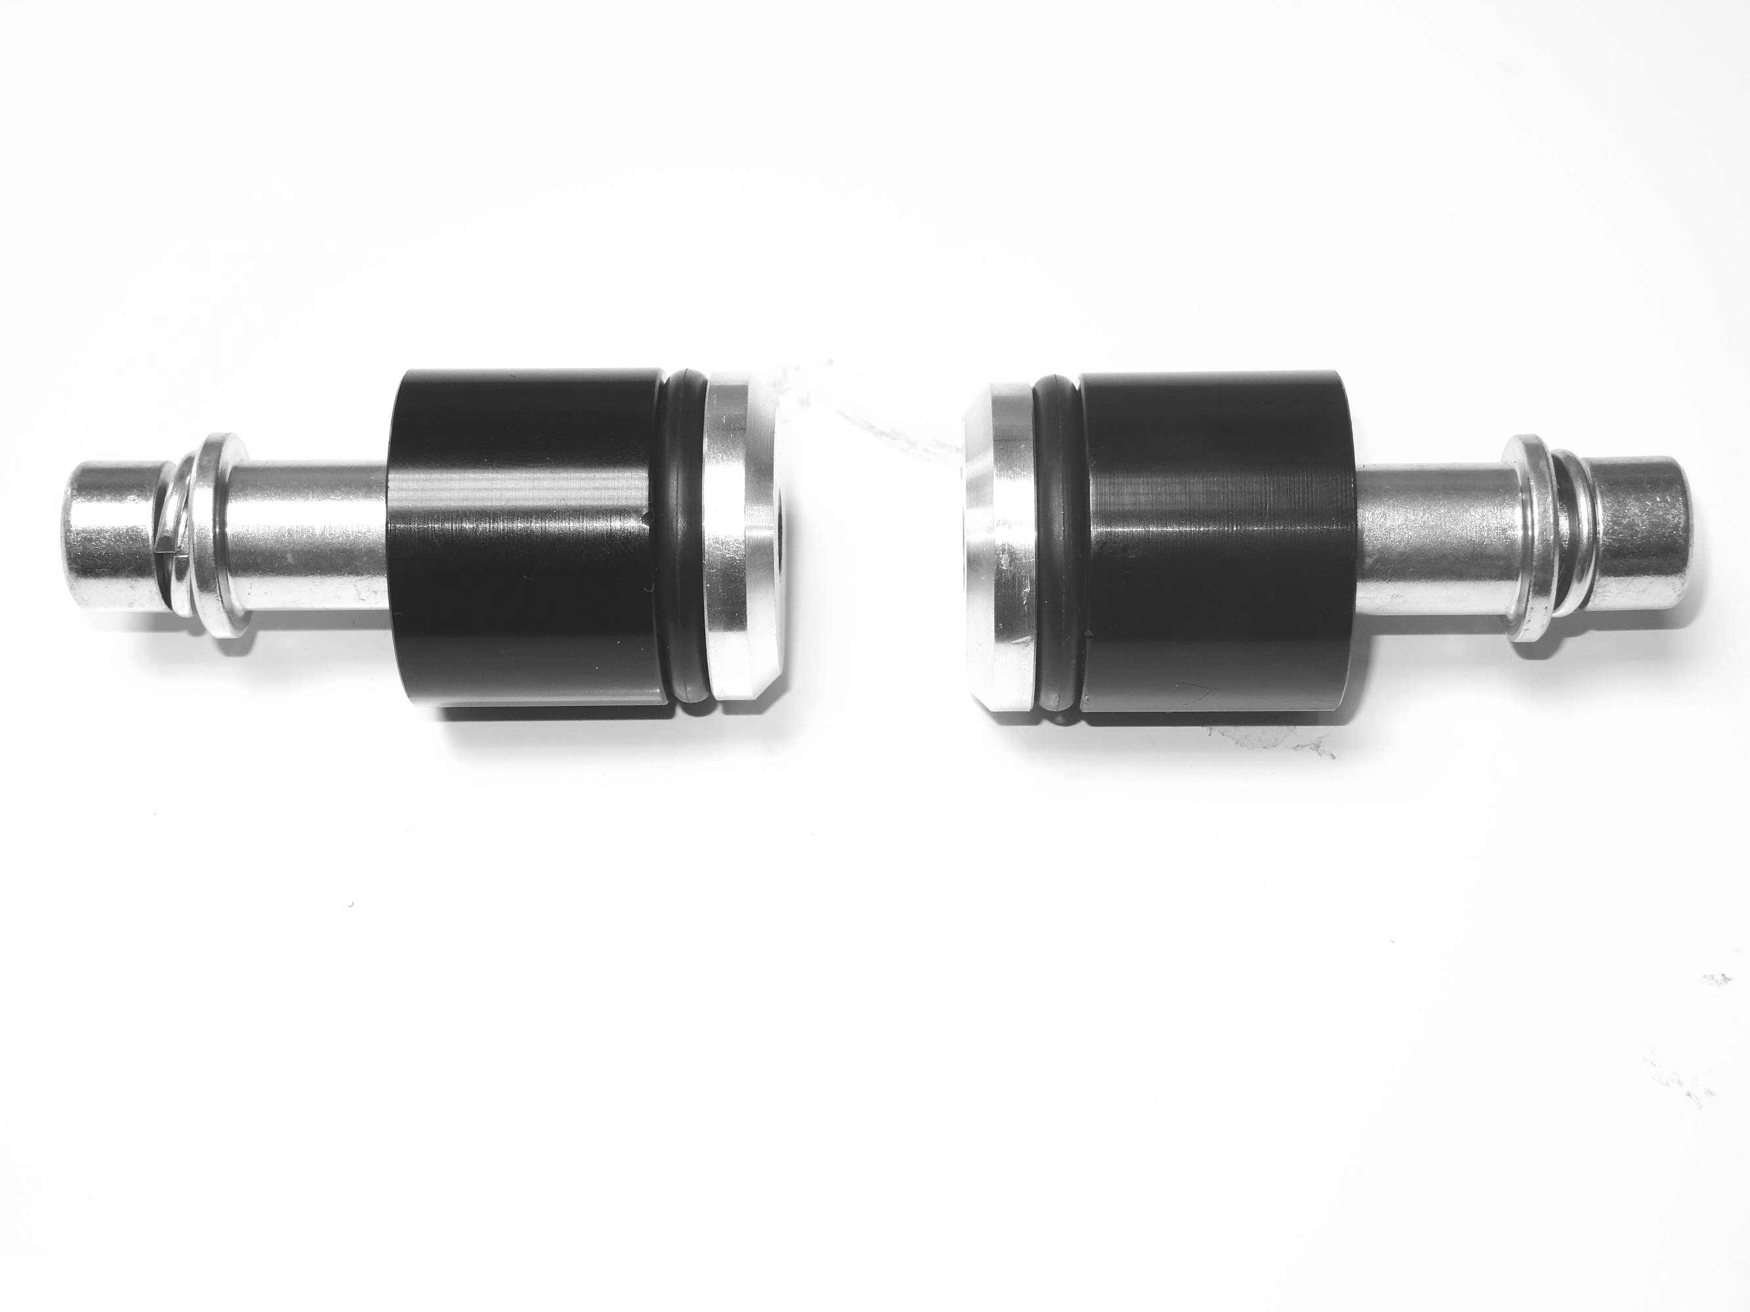
2
1
2
1
5
5

4
4
6
6
3
3

Assembly:
- Place washer ID.5 on the bolt ID.4.
- Into the protectors insert ID.6 steel box.
- Place bolt with washer into the protector. Under the protector place spacer ID.1 rubber ID.3 and alu roller with thread. Tighten bolt easily. This kit insert into the frame and tighten bolt.
