Y40S
Yamaha MT-03 ´14-

Fitting kit left side: Fitting kit right side:
ID | Description | Cat.n | Qt
1 | Bolt M6x25 | 877 | 3
2 | Bolt M4x16 | 876 | 2
3 | Dural.spacer d=48 | 1203 | 1
4 | Bolt M10x125x1,25 | 924 | 1
5 | Dural. adapter | 292 | 1
ID | Description | Cat.n | Qt
1 | Bolt M6x25 | 877 | 3
2 | Bolt M4x16 | 876 | 2
3 | Dural.spacer d=48 | 1203 | 1
4 | Bolt M10x125x1,25 | 924 | 1
5 | Dural. adapter | 292 | 1

Instruction to assembly:

- Remove original bolt from frame.

- Left side:
- Bolt ID.4 insert trough the dural.adapter ID.5.
- Place dural spacer ID.3 on the bolt.
- Place spacer ID.3 into the frame.
- Assembly bolt with kit of adapters into the frame.
- Take bolts ID.1 and mounting slider. Into the protector insert alu. cap and tighten it by bolts ID.2.
- Take out off original bolt from frame.

- Right side:
- Bolt ID.4 insert trough the dural.adapter ID.5.
- Place spacer ID.3 into the frame.
- Assembly bolt with kit of adapters into the frame.
- Take bolts ID.1 and mounting slider. Into the protector insert alu. cap and tighten it by bolts ID.2.

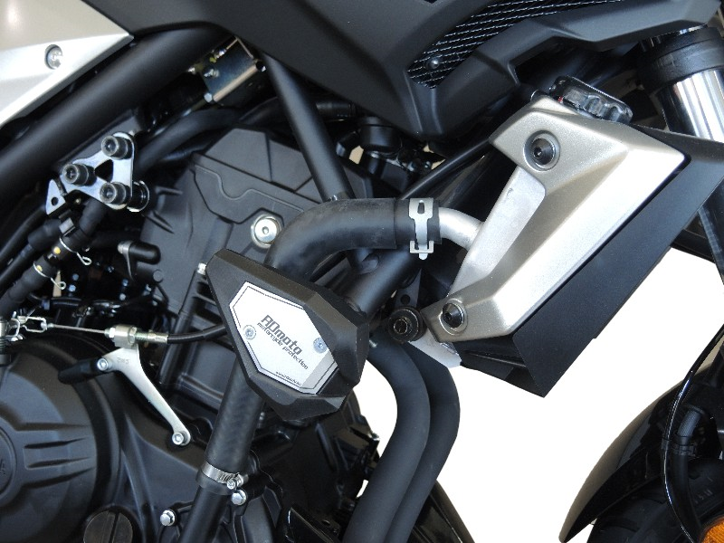

Use medium strong glue on all threads.

