Y41S
Yamaha MT-10 2016-

Kit for left side: Kit for right side:
ID | Description | Cat.N | QTY
1 | Alu. spacer for SL | 358 | 1
2 | Bolt 12x90x1,25 | 931 | 1
3 | Bolt M6x25 | 877 | 3
4 | Bolt M4x16 | 876 | 2
ID | Description | Cat.N | QTY
1 | Alu. spacer for SL | 359 | 1
3 | Bolt M12x60x1,25 | 940 | 1
4 | Bolt M6x25 | 877 | 3
5 | Bolt M4x16 | 876 | 2
6 | Alu. Roller d=4mm | 1260 | 1

Instructions:

- Left side.
  - Remove orignal bolt from the left side.
  - Leave all spacers in the frame.
  - Take the alu. spacer ID.1 for left side, insert bolt ID.2 into the spacer ID.1.
  - This kit fit on the frame and tighten.
  - Place slide and tighten it by bolts ID.3, place alu. cover into the slider use bolts ID.4.
- Right side.
  - Take off Orignal bolt.
  - Leave all spacers in frame.
  - Take the alu. spacer ID.1 for right side. Insert bolt ID.3 into this kit.
  - Fit this kit on the frame and tighten.
  - Place slider and tighten it by bolts ID.4, place alu. cover into the slider using bolts ID.5.
Warning: We recommend use the glue of all threads. Medium strong.

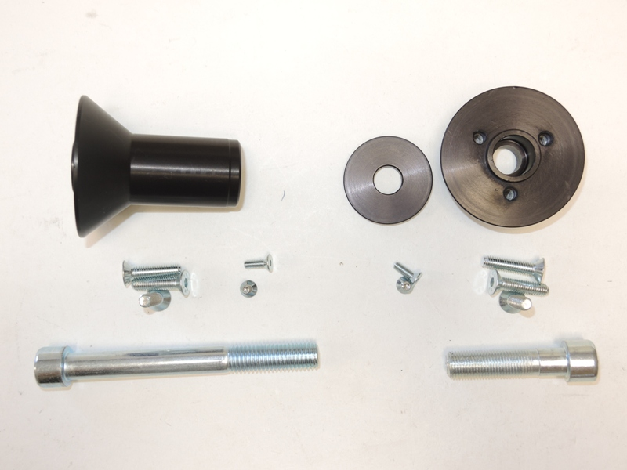

1
1

3
4
4

2
3
5

