Y42
Yamaha MT07 Tracer 2016 -
Kit for left side: Kit for right side:
ID. | Description | Cat.no | QTY
1 | Steel box | X2 | 1
2 | Dural cylinder | 1114 | 1
3 | Bolt M12x110x1,25 | 910 | 1
ID. | Description | Cat.no | QTY
1 | Steel box | X2 | 1
2 | Dural cylinder | 1114 | 1
3 | Bolt M12x110x1,25 | 910 | 1
Instruction to assemble:
(left and right side are same)
- Dismantle original bolt from frame.
- Insert the duralumin cylinder (ID2) into the frame.
- Insert the steel box (ID1) into the crash protector and mounting by bylot M12 (ID3).
- The aluminium cover use only for PHV1 a PHV2

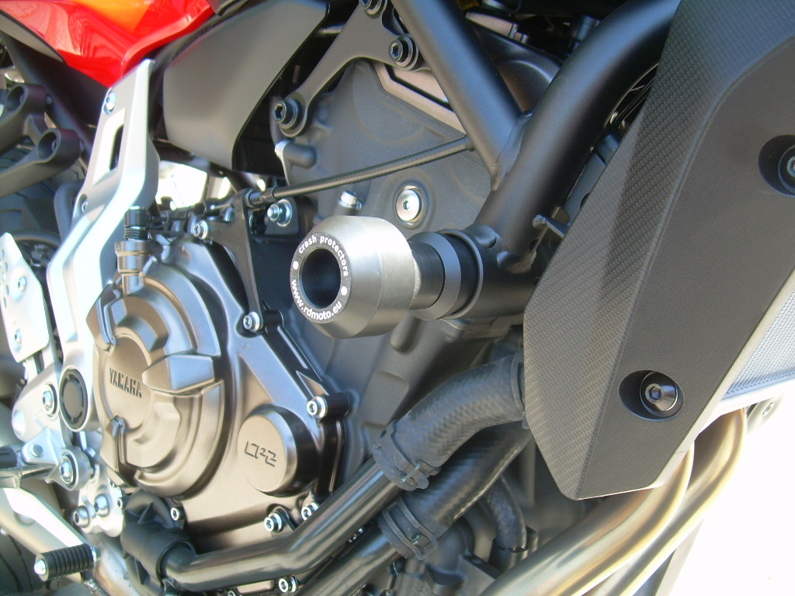
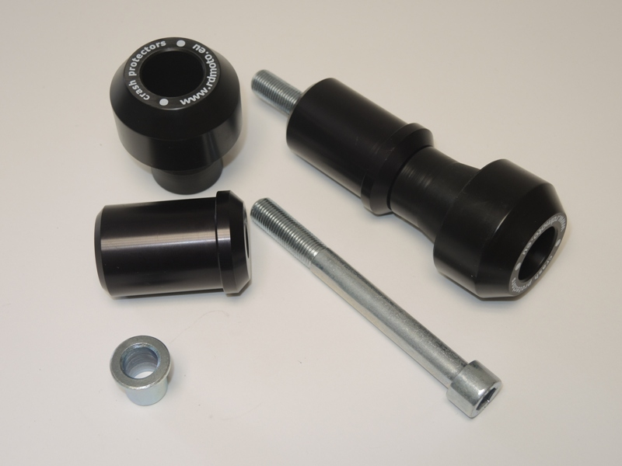
1
3
2
4

Use the glue on threads for all connects.

