Y43SDM
Yamaha MT-01
Kit for the left side |  |  |  |  |  |  |  |  | Kit for the right side
ID | Description |  | Cat.no. |  | Pcs |  |  |  | ID | Description |  | Cat.no. |  | pcs
1 | SLD adapter |  | 537/B |  | 1 |  |  |  | 1 | SLD adapter |  | 537/B |  | 1
2 | Cylinder 40mm |  | DV12 |  | 1 |  |  |  | 2 | Cylinder 40mm |  | DV12 |  | 1
3 | Bolt M10x65 |  | 943 |  | 1 |  |  |  | 3 | Bolt M10x65 |  | 943 |  | 1
4 | Washer M10 (spring) |  | 801 |  | 1 |  |  |  | 4 | Washer M10 (spring) |  | 801 |  | 1
5 | Moto Adapter |  | 706 |  | 1 |  |  |  | 5 | Moto Adapter |  | 706 |  | 1
6 | M10x40x1,25 |  | 941 |  | 2 |  |  |  | 6 | M10x40x1,25 |  | 941 |  | 2
7 | M10 cap |  | X4 |  | 2 |  |  |  | 7 | M10 cap |  | X4 |  | 2
8 | Bolt M6x20 |  | 1024 |  | 2 |  |  |  | 8 | Bolt M6x20 |  | 1024 |  | 2
9 | Washer M6 (spring) |  | 1023 |  | 2 |  |  |  | 9 | Washer M6 (spring) |  | 1023 |  | 2

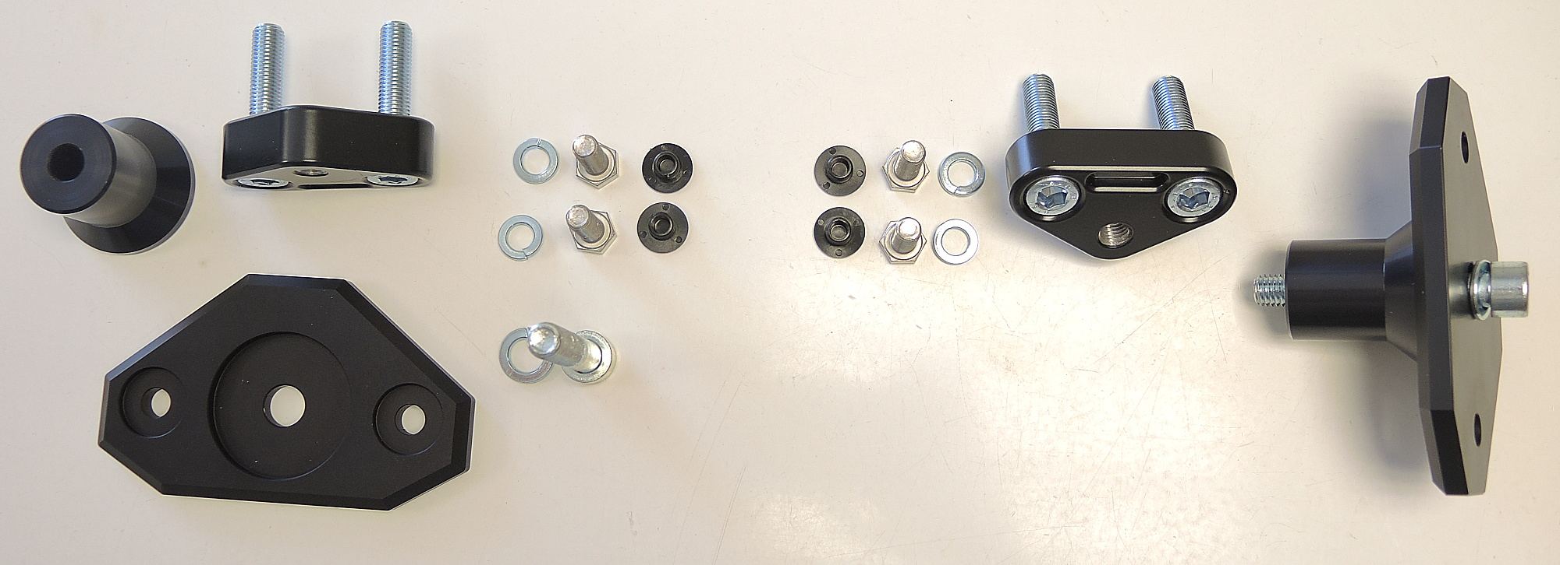
ID2
ID5
ID1
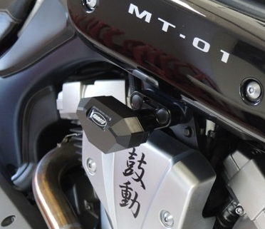
Instructions:

- Remove original bolts from the frame.
- Mount Moto adapter ID5 on the frame using two M10 bolts (ID6). Cover them using caps ID7.
- Mount SLD adapter ID1 and cylinder ID2 into the moto adapter using bolt M10 (ID3) + washer ID4.
- Fit protector on the adapter using two M8 bolts + washers.

