Y43S
Yamaha MT-01
Mounting kit – Left Side |  |  |  |  |  |  |  |  | Mounting kit – Right Side
ID | Description |  | Cat.no. |  | Pcs |  |  |  | ID | Description |  | Cat.no. |  | Pcs
1 | Dural. adapter l=60mm |  | 318 |  | 1 |  |  |  | 1 | Dural. adapter l=60mm |  | 318 |  | 1
2 | Bolt M10x30 |  | 882 |  | 1 |  |  |  | 2 | Bolt M10x30 |  | 882 |  | 1
3 | Moto Adapter |  | 706 |  | 1 |  |  |  | 3 | Moto Adapter |  | 706 |  | 1
4 | Bolt M10x40x1,25 |  | 941 |  | 2 |  |  |  | 4 | Bolt M10x40x1,25 |  | 941 |  | 2
5 | M10 cap |  | X4 |  | 2 |  |  |  | 5 | M10 cap |  | X4 |  | 2
6 | Bolt M6x25 |  | 877 |  | 3 |  |  |  | 6 | Bolt M6x25 |  | 877 |  | 3
7 | Bolt M4x16 |  | 876 |  | 2 |  |  |  | 7 | Bolt M4x16 |  | 876 |  | 2

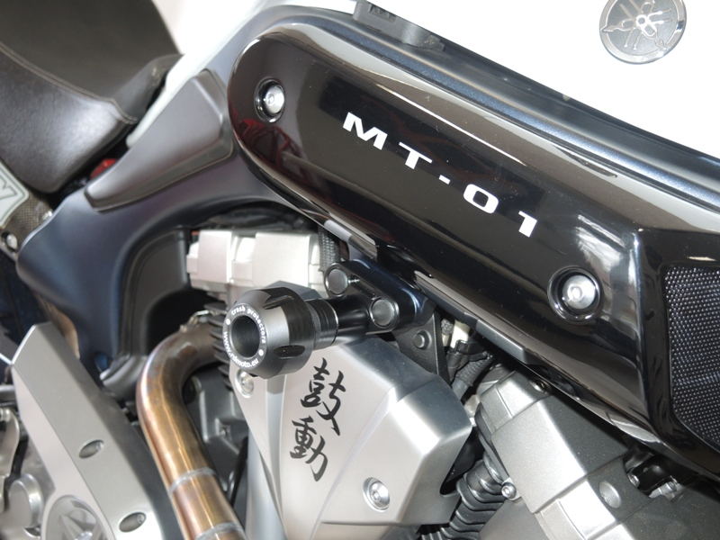
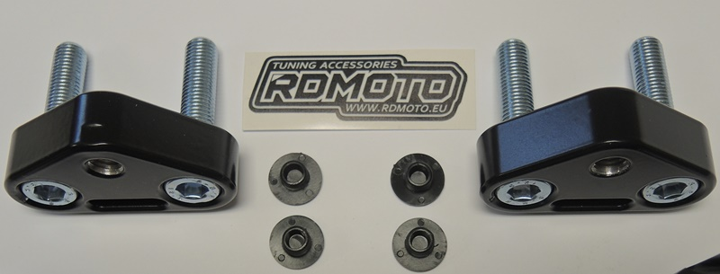
3
4

5
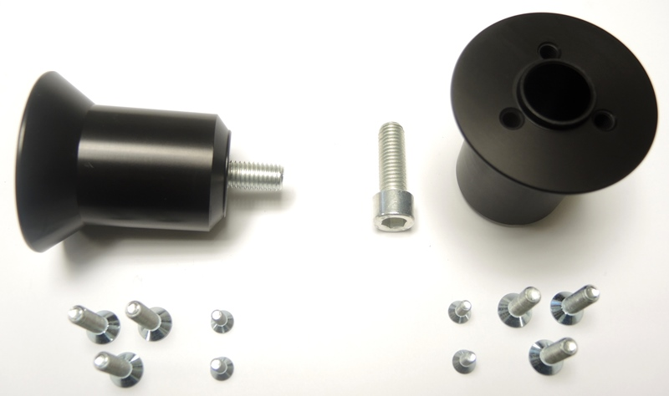
1
1

6
2
2
7

Mounting instructions – both sides:

1) Remove original bolts from the frame.
2) Mount the Moto Adapter (ID3) on the motorcycle frame using M10 bolts (ID4). Tighten the bolts and use M10 caps (ID5) on the bolt heads.
3) Insert the M10 bolt (ID2) into the Dural. Adapter (ID1).
4) Mount this assembly to the steel adapter on the motorcycle.
5) Screw the slider to the dural. Adapter using bolts (ID6)
6) Finally, secure the plate using bolts (ID7).

Warning - We recommend using medium strength thread glue during assembly.

