Y43
Yamaha MT-01
LEFT SIDE KIT |  |  |  |  |  |  |  |  | RIGHT SIDE KIT
ID | Description |  | Cat.no. |  | Pcs |  |  |  | ID | Description |  | Cat.no. |  | Pcs
1 | Steel insert |  | X1 |  | 1 |  |  |  | 1 | Steel insert |  | X1 |  | 1
2 | Dural. cylinder 30mm |  | DV3 |  | 1 |  |  |  | 2 | Dural. cylinder 30mm |  | DV3 |  | 1
3 | Bolt M10x70 |  | 851 |  | 1 |  |  |  | 3 | Bolt M10x70 |  | 851 |  | 1
4 | Washer M10 (spring) |  | 801 |  | 1 |  |  |  | 4 | Washer M10 (spring) |  | 801 |  | 1
5 | Moto Adapter |  | 706 |  | 1 |  |  |  | 5 | Moto Adapter |  | 706 |  | 1
6 | M10x40x1,25 |  | 941 |  | 2 |  |  |  | 6 | M10x40x1,25 |  | 941 |  | 2
7 | M10 krytka |  | X4 |  | 2 |  |  |  | 7 | M10 krytka |  | X4 |  | 2

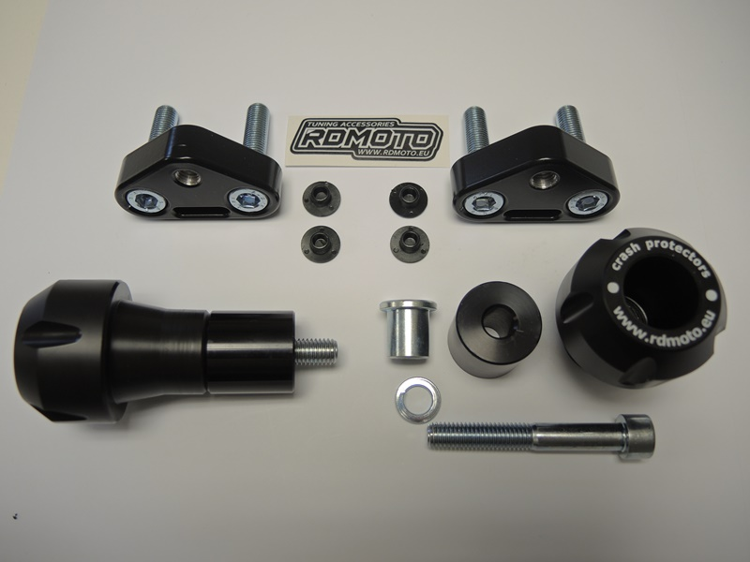
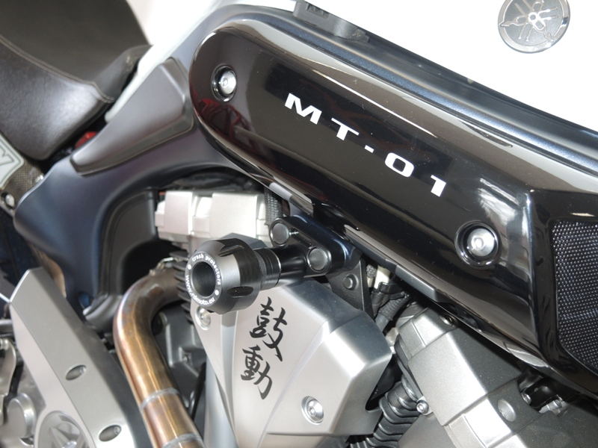
6
5

2
3

INSTRUCTIONS

- Unbolt original bolts from the frame of motorcycle.
- Fit moto adapter ID5 on the frame using bolt ID6. Place covers ID7 on the bolt.
- Place steel insert ID1, protector and dural. cylinder ID2 on the bolt ID3.
- Mount this kit into the adapter on the motorcycle.

We recommend to use safety glue on all threads (medium strong).

